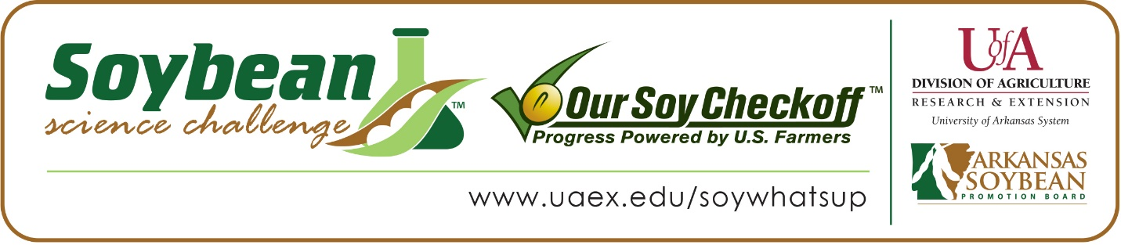

Caleb Ryan wins 2020 Arkansas Soybean Science Challenge Award at the Northwest Arkansas Regional Science and Engineering Fair
Caleb Ryan, 15, a freshman at Providence Classical Christian Academy in Rogers, won the 2020 Soybean Science Challenge at the Northwest Arkansas Regional Science and Engineering Fair held virtually at the University of Arkansas-Fayetteville STEM Center on March 23.
Ryan received a $300 cash award provided by the Arkansas Soybean Promotion Board. His science project titled “Enhancing soybean growth through the use of magnetic fields” also won first place in Plant Sciences. Ryan competed at the Arkansas State Science and Engineering Fair April 3.
Jennifer Main, Ryan’s teacher, won the $200 Soybean Science Challenge Teacher Mentor Award. Main stated that the Soybean Science Challenge is a great way to learn about the science behind soybeans and how important they are to our economy. “During a meeting with teachers to prepare for the regional science fair, we were told about the Soybean Science Challenge. I told all of my students that if they were interested in a science fair project dealing with plants, they could choose to work with soybeans since they are an important plant within the state of Arkansas,” she said.
Ryan felt privileged to win the 2020 Soybean Science Challenge. “I am extremely honored to be able to represent this region in research for the soybean industry in Arkansas.” he stated.
Aaron and Katherine Ryan, Caleb’s parents, were very happy to see him receive the award. “We are so proud of Caleb and the hard work that he put in to his experiment. We are grateful to his teacher, Ms. Main, for helping him and strengthening his interest in science,” they replied.
Caleb’s parents also expounded upon his knack for science. “Caleb has a high interest in STEM related fields. He has been discussing with us his desire to apply his passion for math to his love of science in an engineering field,” they explained. Main, Caleb’s teacher, agreed. “Caleb is one of the hardest working students I have in both my Biology class and in Science Fair. Caleb strives for excellence in all he does, whether that is his homework, extracurricular activities, or exams. During our actual class time for Science Fair, Caleb bounced many ideas around for his project, but when he heard about the Soybean Challenge, he was determined to work with soybeans. I loved his enthusiasm throughout this project. He was able to see how soybeans are important to the state of Arkansas and for the world and strives to make an impact in the world, potentially in agriculture,” she stated.
“The Soybean Science Challenge provides an opportunity for Arkansas High School students to participate in scientific research that can impact the State of Arkansas as well as the world. Soybean Science Challenge student researchers learn about this important commodity crop and its many uses including feeding the world, development of biofuels and sustainable products. The Soybean Science Challenge helps students develop an understanding of the challenges and complexities of modern farming,” said Dr. Julie Robinson, Associate Professor and director of the program.
“The goal of the Arkansas Soybean Science Challenge is to engage students in “real world” education to support soybean production and agricultural sustainability,” said Gary Sitzer, a former member of the Arkansas Soybean Promotion Board. “The program also rewards scientific inquiry and discovery that supports the Arkansas Soybean Industry.”
The Arkansas Soybean Science Challenge was launched in January 2014 to 9-12th grade science students. Students who successfully completed the online course were eligible to have their original soybean-related research projects judged at the 2020 ISEF-affiliated Arkansas Science and Engineering Fairs.
Information on the 2020-2021 Arkansas Soybean Science Challenge will be available in summer 2020. For more information, contact Dr. Julie Robinson at jrobinson@uaex.edu or Diedre Young at dyoung@uaex.edu.
The Cooperative Extension Service is part of the University of Arkansas System Division of Agriculture.

Caleb Ryan, Providence Classical Christian Academy, Rogers. Teacher: Jennifer Main
Category: Plant Sciences
Title: Enhancing Soybean growth through the use of magnetic fields
Abstract:
As the world’s population continues to grow, it is important for the agriculture industry to discover ways to keep up with this growth. This project explores how magnetic fields enhance crop growth, particularly when it comes to soybeans. The hypothesis of this experiment was that when magnets are positioned around soybean plants, creating a magnetic field, the plants’ growth will be enhanced. There has been much previous research supporting this assertion with other plant species. After five soybean seeds were placed in eight 5.5-inch tall pots, two groups were created, the control group and the variable group, each containing four pots. The control group was given no factors, while the variable group was given two disc magnets on either side of the pots and both were tested for 40 days, with data collected daily. At the end of the 40 days, the average height of the control group was 23.03 cm while the variable group had an average height of 33.15 cm. This data, along with the rest of the data from the experiment, suggested that the hypothesis was supported since the soybean plants in the variable group (group with magnets) grew far faster than those in the control group (group without magnets).

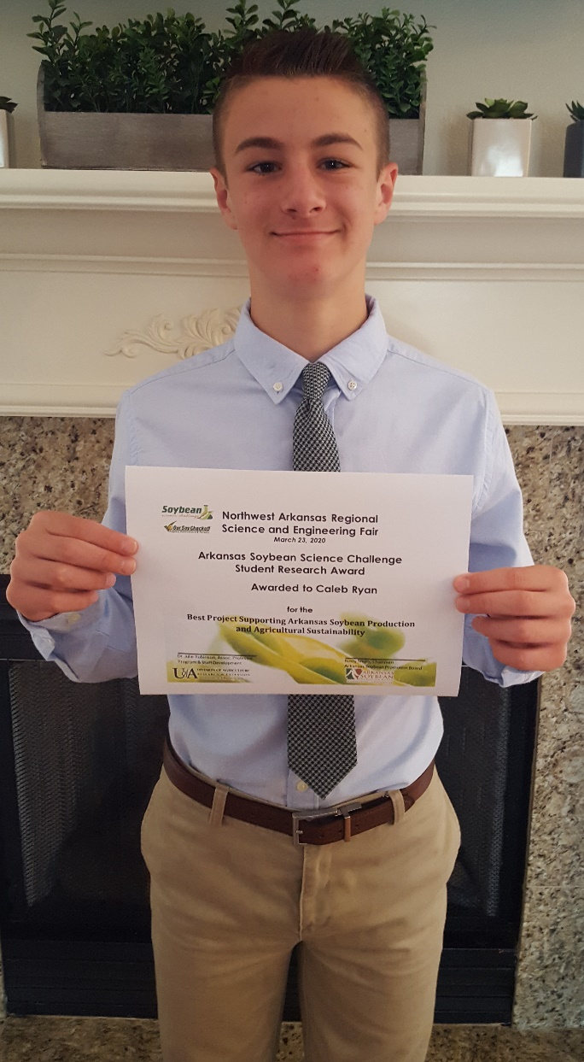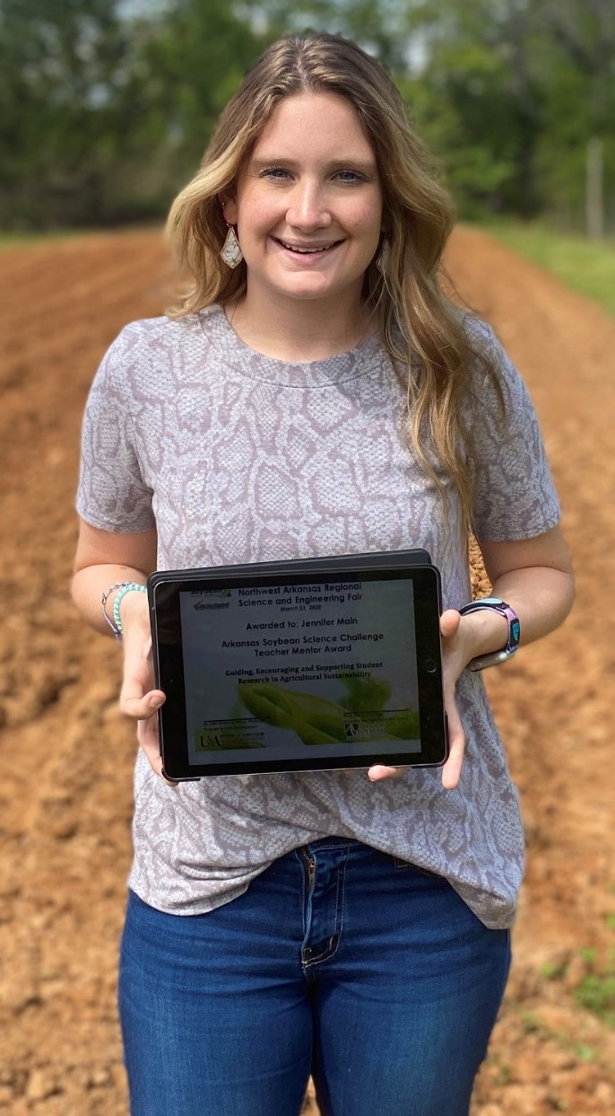
2020 Northwest Arkansas Regional Science and Engineering Fair Soybean Science Challenge Winner Caleb Ryan and Teacher-Mentor Jennifer Main

