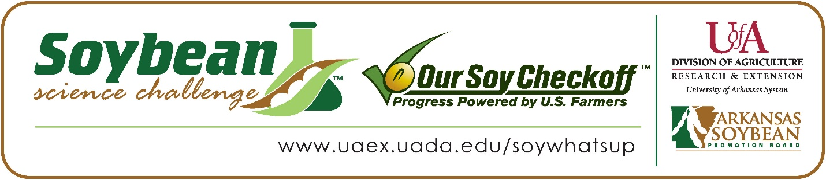

Bennet Chen wins 2026 Arkansas Soybean Science Challenge Award at the Central Arkansas Regional Science and Engineering Fair and Arkansas State Science and Engineering Fair
Bennet Chen, 16, a junior at Little Rock Central High School, won the 2026 Soybean Science Challenge First Place Award at the Arkansas State Science Fair at the University of Central Arkansas-Conway on April 3 and won the Soybean Science Challenge regional award at the Central Arkansas Regional Science and Engineering Fair at University of Arkansas-Little Rock on February 27.
Chen received a $1,000 cash award at the state fair and $400 cash award at the regional fair. The awards were provided by the Arkansas Soybean Promotion Board. His science project titled ‘Deep learning-based crop yield forecasting frameworks towards accurately predicting yields months ahead of harvest, deciphering the impacts of various environmental factors on domestic crops across different temporal periods’ also placed first in Earth and Environmental Science’ received the Air Force Achievement Award, and is an ISEF Finalist at Regional, and received first place in Earth and Environmental Science at State.

Lee Conrad, Bennet’s teacher, won the $300 Soybean Science Challenge First Place Teacher-Mentor Award at State and the $200 Teacher-Mentor Award at Regional. Conrad stated she loves promoting the Soybean Science Challenge. “I think we are missing a grand opportunity in Arkansas to highlight more agricultural topics in our classrooms. I love having the Soybean Science Challenge as one way that students can get motivated to learn more about this important industry for our state and nation,” she explained.
Bennet found the information on soybean production in the Soybean Science Challenge Online Course to be very informational. “Before my work on my project, I knew the importance of Arkansas soybeans to the state economy, and that soybeans were used in many of the foods I loved, including tofu and edamame. However, through this program, and through the Soybean Science Challenge Course, I gained a deeper understanding of the wide impact of soybeans as an agricultural staple in many fields, from biofuel to paper to animal feed,” he stated.
Bennet was thrilled to receive the 2026 Soybean Science Challenge Award. “I am so honored to be the 2026 State Science and Engineering Fair First Place Winner of the Soybean Science Challenge! There were many great projects, so I am so grateful that my project was able to get recognized and support the farmers who make this award happen,” he replied.

Bennet’s parents, Mr. and Mrs. Minjun Chen, were delighted with Bennet’s award. “We were happy to hear that Bennet won the award! He worked a lot this year, and we thought that this recognized his passion, effort, and hard work on his project, so we were extremely happy for him,” they replied.
Lee Conrad acknowledged she learned a lot about soybeans through Bennet’s, and other students’ projects at State. “Students have so many skills in areas that I know nothing about, such as Bennet’s GIS modeling and prediction methods. I hope more students will see the soybean projects and be motivated to solve problems and increase yields for our state’s producers,” she replied.
The part of the Soybean Science Challenge competition that appealed most to Bennet was the judging. “I learned that the judges aren’t just there to give you a score; they want to hear about your project and really understand it. Being able to explain your research and how your project impacts farmers, and just having a conversation about your work, will take you far,” he replied.

“The Soybean Science Challenge provides an opportunity for Arkansas junior high school and high school students to participate in scientific research that can impact the State of Arkansas as well as the world. Soybean Science Challenge student researchers learn about this important commodity crop and its many uses including feeding the world, development of biofuels and sustainable products. The Soybean Science Challenge helps students develop an understanding of the challenges and complexities of modern farming,” said Dr. Julie Robinson, Professor, and director of the program.
“The goal of the Arkansas Soybean Science Challenge is to engage students in “real- world” education to support soybean production and agricultural sustainability,” said Gary Sitzer, a former member of the Arkansas Soybean Promotion Board. “The program also rewards scientific inquiry and discovery that supports the Arkansas soybean industry.”
The Arkansas Soybean Science Challenge was launched in January 2014 for 9-12th grade science students. Students who successfully completed the online course are eligible to have their original soybean-related research projects judged at the 2026 ISEF-affiliated Arkansas Science and Engineering Fairs.
Information on the 2026-2027 Arkansas Soybean Science Challenge will be available in summer 2026. For more information, contact Dr. Julie Robinson at jrobinson@uada.edu or Keith Harris at krharris@uada.edu or Diedre Young at dyoung@uada.edu.
The Cooperative Extension Service is part of the University of Arkansas Division of Agriculture.

Bennet Chen, Little Rock Central High School, Little Rock, Arkansas; Teacher: Lee Conrad
Category: Earth and Environmental Science
Project Title: Deep learning-based crop yield forecasting frameworks towards accurately predicting yields months ahead of harvest, deciphering the impacts of various environmental factors on domestic crops across different temporal periods.
Abstract: Climate change continues to disrupt agricultural systems, making crop yield forecasting a critical component towards enabling climate resilience in agriculture. This project aims to develop and apply deep learning-based crop-yield forecasting frameworks toward accurately predicting yields months ahead of harvest and toward deciphering the impacts of various environmental factors on domestic crops across different temporal periods. Here, 388 climate, soil, elevation, and yield attributes were collected from a ~100-year time span, forming one of the most comprehensive county level environmental datasets compiled for yield forecasting. After preprocessing, Shapley Additive Explanation (SHAP) values were computed for each attribute. Through this, extreme temperature factors during later summer months (DX90, EMXT) were found to have outsized negative contributions towards soybean yields. Then, a deep learning model was meticulously turned using significant factors, resulting in an end-of-year-county-level-yield prediction model with an R^2 of 0.86 for soybeans. Using monthly climate attributes, AgriCast was also able to produce yield forecasts in May, June, July, and August, with R^2 of 0.83, 0.83, 0.84, and 0.86 respectively, showing that AgriCast can accurately predict yields up to five months ahead of harvest. Furthermore, this framework was able to be applied to other crops, including corn, achieving similar metrics (R^2=0.90) for in-season forecasts, and validating its applicability toward broader crop yield forecasting. With implications towards long-term food security, AgriCast allows farmers and policymakers to reliably forecast future yields, enabling more informed decisions to support sustainable agriculture.

Arkansas State Science Fair First Place Winner and Central Arkansas Regional Science and Engineering Fair Senior Division Soybean Science winner Bennet Chen on the right and Teacher-Mentor Lee Conrad on the left.
