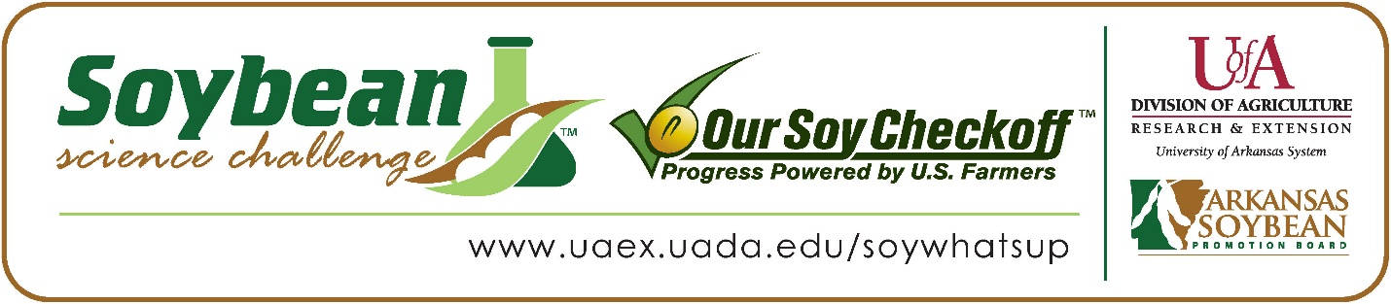

**Bennet Chen wins 2025 Arkansas Soybean Science Challenge Second Place Award at Arkansas State Science and Engineering Fair**

Bennet Chen, 16, a sophomore at Little Rock Central High School, won the 2025 Soybean Science Challenge Second Place Award at the Arkansas State Science and Engineering Fair at Central Arkansas University-Conway April 4.

Chen received a $500 cash award for his SSC Second Place finish at State. Awards were provided by the Arkansas Soybean Promotion Board. His science project titled “SoyCast: A Climate-Driven Deep Neural Network to Forecast County-Level Soybean Yields and Identify Environmentally Optimal Planting Regions,” also won the Arkansas Energy and Environmental Quest Award and is an ISEF Finalist.

Lee Conrad, Bennet’s teacher, won the $200 State Soybean Science Challenge Second Place Teacher-Mentor Award. Conrad stated that the Soybean Science Challenge is a great way to learn about this important crop. “I love to promote the Soybean Science Challenge for a few different reasons: I love agriculture (I was raised on a farm in Crittenden County), and I see the direct impact it has on the economy of our state. By encouraging my students to participate in the challenge, I am introducing many of them to agricultural science. It's important for me, as a teacher in Little Rock, to expose my students to concepts that they may not encounter in their everyday life. The importance of agriculture in general and soybeans in particular, to our state and to our greater world, is something I want to share with them. This challenge is a great way for them to learn more about soybeans, agriculture research, and sustainable practices, while also giving them a chance to earn cash prizes,” she explained.

Bennet said it is wonderful to receive Second Place in the State Soybean Science Challenge. “I feel fortunate to have had the opportunity to compete, and win, at the State-Level Soybean Science Challenge, and I hope that my research can contribute towards the farmers that help make this challenge happen,” he replied.

Mr. and Mrs. Chen, Bennet’s parents, were very proud to see him receive the award. "We are thrilled to hear that Bennet won the award! This achievement recognizes his passion, effort, and hard work on his project,” they stated.

Bennet expounded on how he prepared for the Soybean Science Challenge. “To prepare for the Arkansas State Science Fair, I went over feedback that I received during my regional fair and practiced summarizing my research in speech and text. I feel like these methods helped me to be able to better explain my research at the state fair. I also believe that the direct link between my project and how it could help farmers and the agricultural industry alike in preparing for the future was a large factor in helping me win this award,” he explained.

“The Soybean Science Challenge provides an opportunity for Arkansas junior high and high school students to participate in scientific research that can impact the State of Arkansas as well as the world. Soybean Science Challenge student researchers learn about this important commodity crop and its many uses including feeding the world, development of biofuels and sustainable products. The Soybean Science Challenge helps students develop an understanding of the challenges and complexities of modern farming,” said Dr. Julie Robinson, Professor, and director of the program.

“The goal of the Arkansas Soybean Science Challenge is to engage students in “real- world” education to support soybean production and agricultural sustainability,” said Gary Sitzer, a former member of the Arkansas Soybean Promotion Board. “The program also rewards scientific inquiry and discovery that supports the Arkansas Soybean Industry.”

The Arkansas Soybean Science Challenge was launched in January 2014 for 9-12th grade science students. Students who successfully completed the online course were eligible to have their original soybean-related research projects judged at the 2025 ISEF-affiliated Arkansas Science and Engineering Fairs.

Information on the 2025-2026 Arkansas Soybean Science Challenge will be available in summer 2024. For more information, contact Dr. Julie Robinson at [jrobinson@uada.edu](mailto:jrobinson@uada.edu), Keith Harris at [kharris@uada.edu](mailto:kharris@uada.edu), or Diedre Young at [dyoung@uada.edu](mailto:dyoung@uada.edu).

The Cooperative Extension Service is part of the University of Arkansas System Division of Agriculture.

**Bennet Chen, Little Rock Central High School, Little Rock, Arkansas; Teacher: Lee Conrad**

**Category: Environmental Science**

**Project Title: Soycast: A climate driven deep neural network to forecast county level soybean yields and identify environmentally optimal planting regions.**

**Abstract:**

With food insecurity becoming an increasingly global issue, understanding the impacts of climate change on agricultural yields through yield forecasting is critical to ensure sustainable future food production. This project aimed to develop an accurate soybean yield forecasting deep neural network (DNN) model using climatic data to analyze climate change’s impact on yields, and to identify high yield potential areas within the USA, based on those environmental factors. To accomplish this, over one million data points regarding yield and weather on 36- temperature, precipitation, and snowfall factors were collected from ̴2000 counties over a 100- year range. Initially a multivariate linear regression model utilizing backward selection (p- value <0.01) was formed as a baseline, yielding an R^2 of 0.7554 on a testing set. A deep neural network was then trained on standardized data, with hyperparameters meticulously tuned for accuracy. The final Deep Neural Network, consisting of six layers and 25 epochs on a learning rate of 0.001, achieved an R^2 of 0.8002 in predicting county level yields. This DNN was applied to project US regions with the highest climate-based yield potential.

Arkansas State Science and Engineering Fair Second Place Winner Bennet Chen on the right and Teacher-Mentor Lee Conrad on the left.