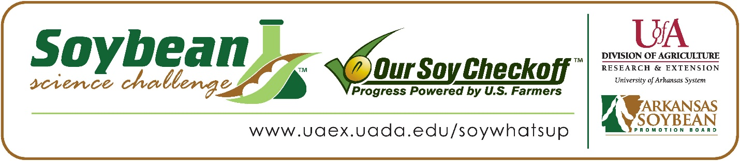
Ariana Sadiq wins 2026 Arkansas Soybean Science Challenge Honorable Mention Award at the Arkansas State Science and Engineering Fair
Ariana Sadiq, 15, a freshman at Pulaski Academy in Little Rock, won the 2026 Soybean Science Challenge Honorable Mention Award at the Arkansas State Science and Engineering Fair April 3.
Ariana received the $250 cash award for her SSC Honorable Mention placement at State. The award was provided by the Arkansas Soybean Promotion Board. Her science project titled ‘Using different priming methods on Glycine max to yield the best results and create a drought tolerant cost-effective solution to water depletion in the Delta Region for Arkansas farmers’ also took second place in Plant Sciences. Her teacher, Melissa Hopkins, received the $100 Honorable Mention Teacher Mentor Award.

Ariana was thrilled to receive the Honorable Mention in the State Soybean Science Challenge. “I am extremely happy to have been honored with this award as there were many amazing projects present at the State Science Fair this year. Getting this award makes me want to continue adding to my research. Hopefully, I will be working with farmers this summer to test a new theory I have in addition to my new project. I now look forward to helping expand and implement my research, adding new methods in the Arkansas Delta Region,” she replied.
Samer Usmani, Ariana’s parent, was proud to see her get this award. “I was happy my daughter’s hard work paid off, and the award helped motivate her to work even harder for next year. She was very excited to discuss certain gaps she had identified, and how her improved project would impact a real-world need for farmers regarding water and depleting water tables in the Delta Region,” Samer explained.
Ariana acknowledged she has a whole new perspective about soybeans. “I knew that soybeans were used for a lot of research projects and are one of the most cultivated crops in Arkansas. However, I learned how much water soybeans need at different growth stages. I found out that soybeans need more water at the beginning for germination, and more water during their reproductive stage. This need for water impacts farmers due to groundwater depletion and production demand, which I did not know,” she stated.

“The Soybean Science Challenge provides an opportunity for Arkansas junior high and high school students to participate in scientific research that can impact the State of Arkansas as well as the world. Soybean Science Challenge student researchers learn about this important commodity crop and its many uses including feeding the world, development of biofuels and sustainable products. The Soybean Science Challenge helps students develop an understanding of the challenges and complexities of modern farming,” said Dr. Julie Robinson, Professor, and director of the program.
“The goal of the Arkansas Soybean Science Challenge is to engage students in “real- world” education to support soybean production and agricultural sustainability,” said Gary Sitzer, a former member of the Arkansas Soybean Promotion Board. “The program also rewards scientific inquiry and discovery that supports the Arkansas soybean industry.”
The Arkansas Soybean Science Challenge was launched in January 2014 for 9-12th grade science students. Students who successfully completed the online course were eligible to have their original soybean-related research projects judged at the 2026 ISEF-affiliated Arkansas Science and Engineering Fairs.
Information on the 2026-2027 Arkansas Soybean Science Challenge will be available in summer 2026. For more information, contact Dr. Julie Robinson at jrobinson@uada.edu, or Keith Harris at krharris@uada.edu, or Diedre Young at dyoung@uada.edu.
The Cooperative Extension Service is part of the University of Arkansas Division of Agriculture.
Ariana Sadiq, Pulaski Academy, Little Rock, AR. - Teacher-Melissa Hopkins
Category: Plant Sciences
Project Title:
Abstract: Delta farmers in Arkansas have struggled with depleting water that reduces the germination rates for soybean seeds (Glycine max), making less money for farmers, and stressing the Arkansas delta with water deprivation due to data centers being built. The research this experiment aims to conduct is designed to assist farmers in rural areas of Arkansas, providing them with a stable source of income that benefits our society and economy by finding a seed priming method that is cost-effective and withstands droughts. This experiment was executed using untreated Glycine max seeds, controlled water amounts to simulate a drought, and different priming methods. The data collected from this experiment showed that moringa, hydro, and sound priming maintained the most sprouts throughout the experiment; however, magneto and moringa priming showed the most success as the Glycine max grew exponentially compared to other priming methods. The hypothesis was proven correct, stating that if soybeans are primed with different methods, then magneto or moringa will increase the germination and seed vigor most under a simulated drought. Moringa yielded the best results with an average of 23 sprouts growing to a height of around 16-17 centimeters tall. In future experiments, the experiment may be carried out in a lab to test if the oxygen and nitrogen levels in the air affect the growth rate of the bio-primed soybeans. Overall, moringa and magneto priming are the most cost-effective, drought-resistant priming methods for Glycine max.

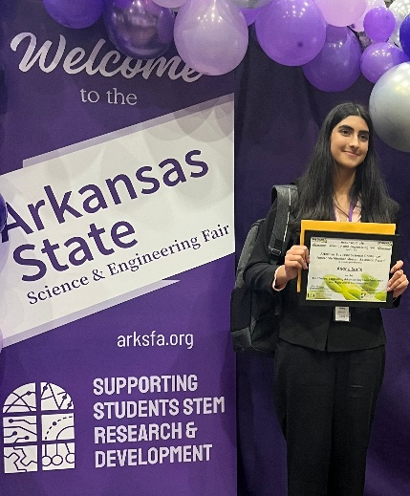

Arkansas State Science and Engineering Fair Honorable Mention Soybean Science Challenge winner Ariana Sadiq and teacher-mentor Melissa Hopkins

