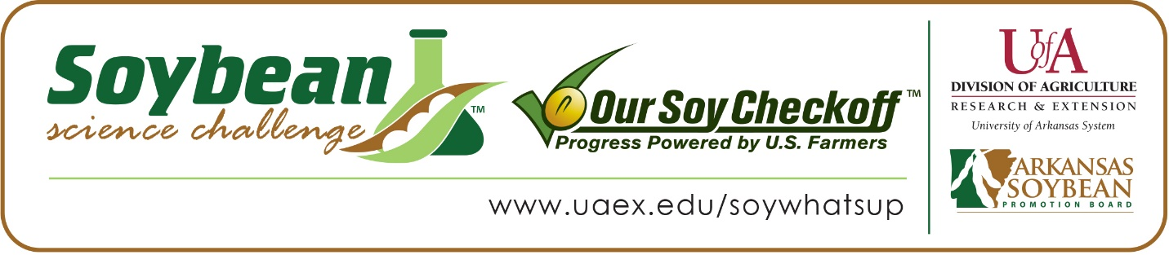

Amna Khan wins 2020 Arkansas Soybean Science Challenge Second Place Award at Southwestern Energy State Science and Engineering Fair and Regional Award at Central Arkansas Regional Science and Engineering Fair
Amna Khan, 16, a sophomore at Central High School in Little Rock won the 2020 Soybean Science Challenge (SSC) Second Place Award at the Virtual Southwestern Energy State Science and Engineering Fair, April 3. Khan also won the SSC Regional Award at the Central Arkansas Regional Science and Engineering Fair held at the University of Arkansas-Little Rock, March 6.
Khan received a $500 cash award for her second place finish at the virtual State Science Fair and a $300 cash award at Regional. Both awards were provided by the Arkansas Soybean Promotion Board. Her science project titled “Defatted Soy as a high performance energy storage material for super-capacitor” also received first place in Energy and Transportation at the regional fair and is an ISEF Finalist for winning overall third place Best of Fair.
Lee Conrad, Kahn’s teacher, won the $200 Soybean Science Challenge Teacher Mentor Award at both State and Regional. Conrad stated Amna was already knowledgeable about soybeans and had participated in The Challenge in the past, so she encouraged her to continue. “Amna has gained an even greater knowledge of soybeans and their place in our state’s economy. She has learned so much about energy and how it can be derived from soy,” she replied. Lee also believes soybean research in the classroom is vital for Arkansas. “I would love to see more Agricultural Science in the classroom and believe that getting kids more knowledgeable about Agricultural Science in high school would allow for a better skilled, more excited workforce for the farmers of our state,” she stated.
Khan was honored to receive the Soybean Science Challenge Award at both the regional and state level, “I’m glad I was able to contribute to the extensive research being done on the applications for soybeans. This unforgettable experience has encouraged me to continue my involvement in research to improve agricultural industries and, in general, benefit the earth. I know it is not easy to win this prestigious competition, so I had to work very hard! I am happy my hard work was acknowledged and rewarded,” she replied.
Mr. and Mrs. Moazzam Khan, Amna’s parents, were hoping and praying Amna would win since she had put a lot of effort and sweat into this project. “The real reward for us was to see Amna so happy and proud of her accomplishment! We are glad and thankful to the Soybean Science Challenge and State Fair administrators for arranging this competition despite the mass cancellations of almost every event around the globe due to COVID-19.” they said. Lee Conrad also acknowledged Amna’s dedication, “Amna is a top student in both my PAP chemistry class and my AP seminar class. She’s conscientious and an active participant in class. Anna’s research was really top-notch. The analysis she did was much advanced among our high school students.”
The part of the Soybean Science Challenge course that appealed most to Khan were the quizzes and videos. They helped her to absorb information easily and made the course very interesting.
“I learned a lot about soybeans from the Soybean Science Challenge. I learned that soybean products have several advantages for our bodies. I want to thank Arkansas Soybean Farmers for this award. I am very excited to continue my soybean-related research,” replied Anma.
Both Conrad and Amna’s parents agree that the Soybean Science Challenge made a big difference in Amna’s confidence in her research. “This award has made a huge impact on Amna’s confidence. She shows great eagerness to go back into the lab and improve on the performance of soybean materials. This award will surely make her a STEM student,” her parents remarked.
“The Soybean Science Challenge provides an opportunity for Arkansas High School students to participate in scientific research that can impact the state of Arkansas as well as the world. Soybean Science Challenge student researchers learn about this important commodity crop and its many uses including feeding the world, development of biofuels and sustainable products. The Soybean Science Challenge helps students develop an understanding of the challenges and complexities of modern farming,” said Dr. Julie Robinson, Associate Professor and director of the program.
“The goal of the Arkansas Soybean Science Challenge is to engage students in “real world” education to support soybean production and agricultural sustainability,” said Gary Sitzer a former member of the Arkansas Soybean Promotion Board. “The program also rewards scientific inquiry and discovery that supports the Arkansas Soybean Industry.”
The Arkansas Soybean Science Challenge was launched in January 2014 to 9-12th grade science students. Students who successfully completed the online course are eligible to have their original soybean-related research projects judged at the 2020 ISEF-affiliated Arkansas Science and Engineering Fairs.

Information on the 2020-2021 Arkansas Soybean Science Challenge will be available in summer 2020. For more information, contact Dr. Julie Robinson at jrobinson@uaex.edu or Diedre Young at dyoung@uaex.edu.
The Cooperative Extension Service is part of the University of Arkansas System Division of Agriculture.

Amna Khan: Little Rock Central High School, Little Rock, AR - Teacher: Ms. Lee Conrad
Category: Energy and Transportation
Project Title: Defatted Soy as a high performance energy storage material for super-capacitors
Abstract: Soybeans are the largest crops in Arkansas and therefore, its application in the energy sector is vital for the state’s economic health. Several soy-based materials (soy meal and defatted form of soymeal soy flour and soy protein) were examined as carbon-based energy storage materials for super-capacitors. A prompt, low cost, single step, green and facile microwave-assisted process was utilized to prepare the carbonized materials. The concentration of doping elements (P and N) was altered by varying the mole ratio of ammonium polyphosphate (APP) in the reaction mixture. The un-doped and doped carbon materials of fatted and defatted soy samples were characterized both physically via BET, XPS and SEM analysis and electrochemically via cyclic voltammetry in both 1M H₂SO₄ and 6M NAOH. Pore size, surface area and elemental compositions of each material were analyzed to investigate the critical parameter of super-capacitor performance of the materials. Furthermore, the capacitance of phosphorus and nitrogen co-doped carbon materials derived from soy samples were calculated and compared. Results suggest that the removal of fats from soy samples improves the capacitance of the materials. Among all materials, defatted soy protein doped with 0.8 g APP exhibited an exceptionally high surface area and high concentration of dope elements. Moreover, the hypothesis is supported that the removal of fat is essential to improve the conductivity of the substance which consequently impacts the specific capacitance of the material.
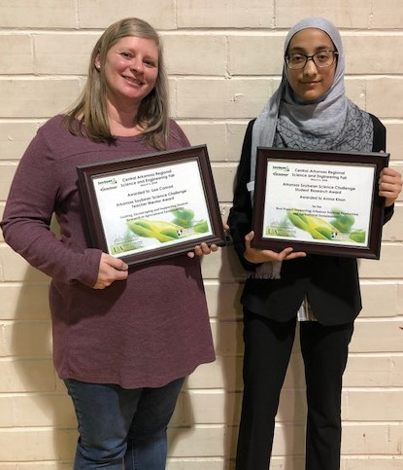
2020 Southwestern Energy Arkansas State Science and Engineering Fair Second Place Winner and Central Arkansas Regional Science and Engineering Fair Winner Amna Khan and Teacher-Mentor Lee Conrad.

