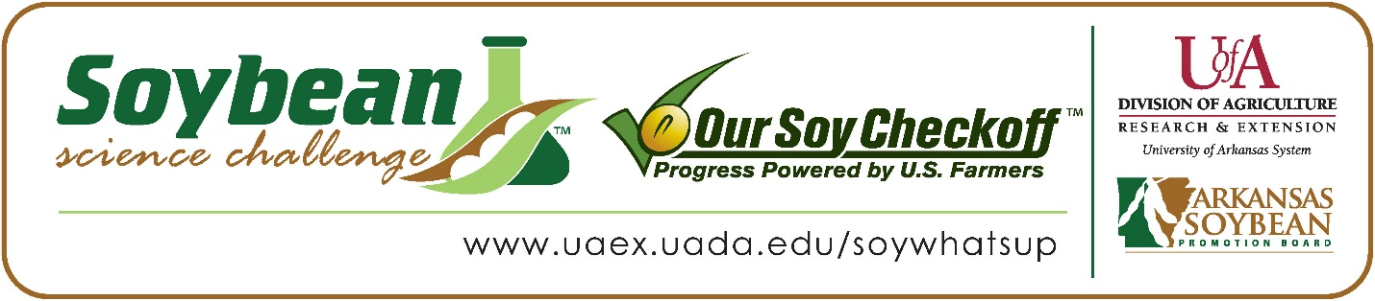

**Drew Johnson and Alyssa Thomas win 2023 First Place Arkansas Soybean Science Challenge Award at Arkansas State Science Fair**

Drew Johnson and Alyssa Thomas, 17, seniors at Arkansas School for Mathematics, Sciences, and the Arts (ASMSA) in Hot Springs, Arkansas won the Soybean Science Challenge First Place award at the Arkansas State Science Fair held March 31.

Johnson and Thomas split the $1,000 cash award for their First-Place finish at State. The award was provided by the Arkansas Soybean Promotion Board at the award ceremony. Their science fair project titled “Examination of Variability of Fall Armyworm Infestations in Arkansas and the potential for biopesticide treatment of soybeans” also took First Place in Animal Science, the Mark Welch Excellence in Animal Research Award, the Arkansas Department of Energy and Environment Quest Award and 4th Place Overall ISEF Finalist for the AR State Science Fair.

Dr. Lindsey Waddell, Johnson’s and Thomas’ teacher won the $300 first place Soybean Science Challenge Teacher-Mentor Award. She believes the Soybean Science Challenge is a wonderful opportunity for students to earn recognition for their work. “The Challenge was a huge motivating factor for the effort Alyssa and Drew put into their research project this year. They have seen students place in the Soybean Science Challenge at the Arkansas State Science Fair the past few years, and while I do not think they felt like they could be selected as ISEF Finalists, they did feel that they could potentially win the Soybean Science Challenge. Ultimately, they put so much work into the Challenge that they were also selected as ISEF Finalists at State! I have students at ASMSA ask me every year now how they can enter the Soybean Science Challenge. Thank you for offering a competition that encourages students to pursue plant science research,” she stated.

Johnson and Thomas were honored that their project was chosen to win the Soybean Science Challenge. “We are extremely happy that we won First Place in the Arkansas Soybean Challenge State Fair Competition. Moreover, we are very proud that we could tackle many problems that our state is facing and present thorough solutions,” they explained.

LaWanda Harper, Alyssa’s mother, was excited they won the Soybean Science Challenge Award. “I was very happy to hear the wonderful news. When she called me and informed me of the great news, I was very proud, and I knew Alyssa and Drew could do it, “she noted.

Waddell talked about Johnson’s and Thomas’ dedication “Before my students chose their project topic last year, I had never heard of fall army worm, let alone the damage to agriculture it causes during its annual northward migration through the United States. My role as Alyssa and Drew’s adviser was to help them obtain the materials they needed and refine their experimental design and analysis despite the many twists and turns that came with a project involving live fall army worms. Their initial plans to collect fall army worms from the field failed when the Summer 2022 migration was significantly less than the Summer 2021 migration that had inspired their project. Rather than give up, they were able to carry out an analysis that identified significant climatic differences between the summers of 2021 and 2022 that might have influenced the size of the migration. We also ordered live fall army worms from an agricultural research supplier and, rather than trying to develop a viral insecticide for fall army worm using dead worms collected in the field as Alyssa and Drew had originally hoped, they were able to turn to the ecological knowledge they had gained from volunteering in Hot Springs National Park and in our campus native pollinator garden in order to create and test plant-based pesticides on fall army worm,” she stated.

The part of the Soybean Science Challenge course that appealed most to the team was learning about soybean growth. “I learned how to grow soybeans efficiently and effectively. I also learned what specific portion of soybean plants that fall armyworms target,” they replied.

“The Soybean Science Challenge provides an opportunity for Arkansas High School students to participate in scientific research that can impact the state of Arkansas as well as the world. Soybean Science Challenge student researchers learn about this important commodity crop and its many uses including feeding the world, development of biofuels and sustainable products. The Soybean Science Challenge helps students develop an understanding of the challenges and complexities of modern farming,” said Dr. Julie Robinson, Associate Professor, and director of the program.

“The goal of the Arkansas Soybean Science Challenge is to engage students in “real world” education to support soybean production and agricultural sustainability,” said Gary Sitzer a former member of the Arkansas Soybean Promotion Board. “The program also rewards scientific inquiry and discovery that supports the Arkansas Soybean Industry.”

The Arkansas Soybean Science Challenge was launched in January 2014 to 9-12th grade science students. Students who successfully completed the online course were eligible to have their original soybean-related research projects judged at the 2023 ISEF-affiliated Arkansas Science and Engineering fairs.

Information on the 2023-2024 Arkansas Soybean Science Challenge will be available in summer 2023. For more information, contact Dr. Julie Robinson at [jrobinson@uada.edu](mailto:jrobinson@uada.edu) or Diedre Young at [dyoung@uada.edu](mailto:dyoung@uada.edu).

The Cooperative Extension Service is part of the University of Arkansas System Division of Agriculture.

**Drew Johnson and Alyssa Thomas: Arkansas School for Mathematics, Sciences and the Arts, Hot Springs, AR. Teacher-Dr. Lindsey Waddell**

**Category: Plant Science**

**Project Title: Examination of Variability of Fall Armyworm Infestations in AR and the potential for biopesticide treatment of soybeans**

**Abstract:** Fall armyworms cause around 500 million dollars in economic damage each year in the United States, and pesticidal treatments are becoming increasingly ineffective. Meanwhile, management solutions have been employed to rid Hot Springs National Park (HOSP) of its invasive plant species, but none have been wholly successful. To remedy these problems, biopesticides were made from Nandina domestica and Wisteria sinensis, two especially problematic invasive species in HOSP, and Callicarpa americana, a native species abundant within the Ouachita Mountain region. This study will map and collect data on fall armyworms across Arkansas counties. The average temperature in 2022 was 85.77°, up from last year’s average of 79.5°, while 2022 average precipitation (in.) was 0.5, down from 2.07 last year. The multiple linear regression resulted in 0.005, meaning hotter and drier climates have less fall armyworms. 32.23% of the variation in infestations are explained by temperature and precipitation. Biopesticides were successfully made, however ANOVA results were not significant. Possible reasons include armyworm cannibalism and enclosure size. The third portion of this study aims to test the toxicity of the biopesticide oil, with nandina and wisteria killing 62.5% and 75%, respectively, as opposed to Sevin and Control killing 100% and 12.5%, respectively. The Chi-Sq. results supported nandina and wisteria being the most toxic, 0.2. Overall, this experiment opens the door to more environmentally friendly biopesticides synthesis to combat fall armyworm populations in Arkansas using invasive plants that need to be eradicated.

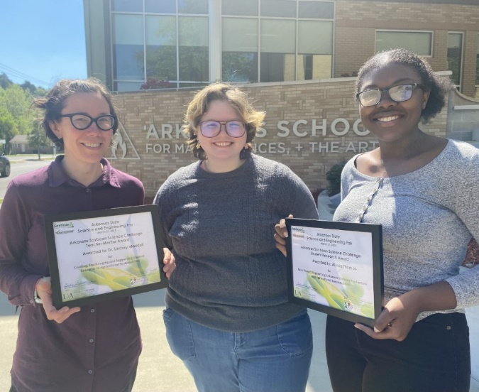

Arkansas State Science Fair first place Soybean Science Challenge winners Drew Johnson and Alyssa Thomas, and Teacher-Mentor Dr. Lindsey Waddell