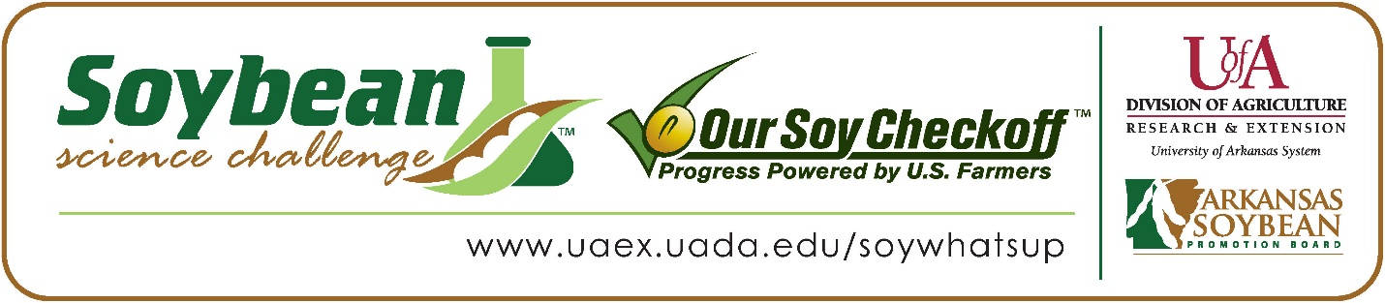

Alyssa Butler wins 2021 Arkansas Soybean Science Challenge First Place Award at the Southwestern Energy Arkansas State Science and Engineering Fair and Regional Award at Central Arkansas Regional Science and Engineering Fair

Alyssa Butler, 17, a senior at Carlisle High School in Carlisle, won the 2021 Soybean Science Challenge 1st Place Award at the virtual Southwestern Energy Arkansas State Science and Engineering Fair April 1 and the Regional award at the virtual Central Arkansas Regional Science and Engineering Fair March 5.
Butler received a $1,000 cash award for her 1st Place state win and $300 for her regional win. Funds were provided by the Arkansas Soybean Promotion Board. Her science project titled “Greenhouse Host Resistance Rate Study on Soybean Cultivars to Southern Root-knot Nematode” also received 2nd Place in plant science at regional and 3rd Place in plant science at the State Science Fair.
Carly Bokker, Alyssa’s teacher, won the $300 State Soybean Science Challenge 1st Place state award and the $200 Regional Teacher-Mentor Award. Bokker stated that since Alyssa has a passion for plants, it was a natural fit for her to do the Soybean Science Challenge. “Alyssa learned so much in her project in 2019-2020 that it was a natural fit for her to pick up another Soybean project to do. She has a passion for plant pathology and will pursue a degree in that field after graduation in May 2021,” she replied.
Butler was excited she won the 2021 1st Place State Soybean Science Challenge. “Becoming the 2021 State Science and Engineering Fair 1st Place winner of the Soybean Science challenge is so exciting not only because it means so much to me but also because of what it means to my parents, Ag teacher, and school. I’m so happy I can represent my school and the people back home in this way,” she stated.
Nicole and Michael Emerson, Alyssa’s parents, were thrilled to see her receive the award. “We are so proud of Alyssa for continuing to work hard and put forth the effort to enter these Soybean Science Challenges. Winning this challenge shows that hard work and dedication pays off,” they said.
Butler also expounded on what she learned as she labored through her project. “I learned that growing soybeans isn’t as easy as I previously thought. There are so many different factors that play into the production of soybeans from making sure they get all the sunlight and water they need to grow to the different pests that can prevent them from reaching their potential,” she explained.
Bokker, Alyssa’s teacher, commented on Alyssa’s winning the 1st Place Award two years in a row at the State Soybean Science Challenge. “Alyssa has excelled in Plant Pathology in the last few years. Her knowledge of soybeans and soybean nematodes surpasses what most college students entering their first year of work even know. She has dedicated her last two years to learning as much as she can, and her receiving this award two years in a row corroborates that,” she stated.
“The Soybean Science Challenge provides an opportunity for Arkansas Junior High and High School students to participate in scientific research that can impact the State of Arkansas as well as the world. Soybean Science Challenge student researchers learn about this important commodity crop and its many uses including feeding the world, development of biofuels and sustainable products. The Soybean Science Challenge helps students develop an understanding of the challenges and complexities of modern farming,” said Dr. Julie Robinson, Associate Professor and director of the program.
“The goal of the Arkansas Soybean Science Challenge is to engage students in “real- world” education to support soybean production and agricultural sustainability,” said Gary Sitzer, a former member of the Arkansas Soybean Promotion Board. “The program also rewards scientific inquiry and discovery that supports the Arkansas Soybean Industry.”
The Arkansas Soybean Science Challenge was launched in January 2014 to 9-12th grade science students. Students who successfully completed the online course were eligible to have their original soybean-related research projects judged at the 2021 ISEF-affiliated Arkansas Science and Engineering Fairs.
Information on the 2021-2022 Arkansas Soybean Science Challenge will be available in summer 2021. For more information, contact Dr. Julie Robinson at jrobinson@uada.edu or Diedre Young at dyoung@uada.edu.
The Cooperative Extension Service is part of the University of Arkansas System Division of Agriculture.

Alyssa Butler, Carlisle High School, Carlisle, Arkansas; Teacher, Carly Bokker
Category: Plant Science
Title: Greenhouse Host Resistance Rate Study on Soybean Cultivars to Southern Root-knot Nematode.
Abstract: The southern root-knot nematode (Meloidogyne incognita) is one of the most important yield-limiting plant-parasitic nematodes that affect soybeans (Glycine max) in Arkansas. One of the best management tools that farmers have is host resistance; however, limited information about the host is available. The objective of this study is to evaluate host resistance to different inoculation rates of southern root-knot nematode. Plants were planted in a split plot design with a factorial arrangement of nematode inoculum rates and soybean cultivars. There were five replications per inoculum rate x soybean cultivar. Soybean cultivars that have proven resistant to root-knot nematodes (Pioneer P45A29L and Pioneer P46T59R), along with one susceptible check (Delta Grow 4880) were used to test nematode resistance and egg reproduction. Each cultivar was artificially inoculated 14 days after planting (DAP) with 10,000 and 20,000 eggs. Soybeans were rated at 48 days after inoculation, roots were processed to determine eggs per gram root, and egg reproduction was calculated. There was no inoculum rate interaction within varieties for eggs per gram of root; however, there was a cultivar interaction. One of the resistant cultivars had a significantly lower eggs per gram root at the lower inoculation rate when compared to the susceptible check at the higher inoculation rate. There was also an inoculum rate x soybean cultivar interaction for egg reproduction factor. The Liberty Link Pioneer cultivar at both inoculation rates and the Roundup Ready Pioneer cultivar at the higher inoculation rate were statistically different when compared to the lower inoculated susceptible check for egg reproduction factor. Pioneer P45A29L and Pioneer P46T59R showed to have lower egg reproduction when inoculated at higher nematode levels when compared to the susceptible check and would be good choices for farmers’ fields with damaging populations of southern root-knot nematodes.

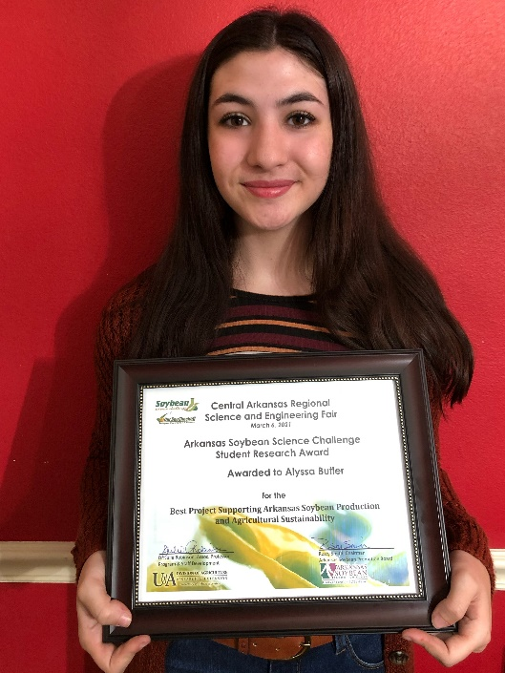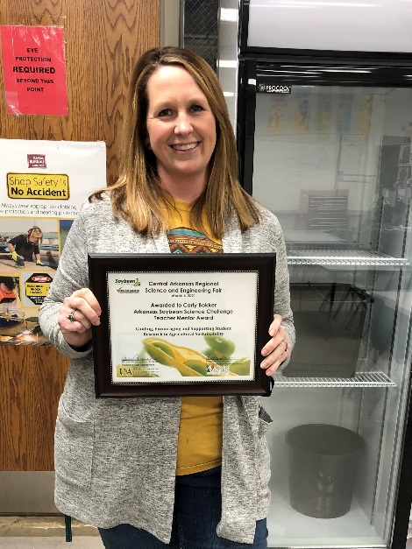
Alyssa Butler, 2021 State Science and Engineering Fair Soybean Science Challenge 1st Place Winner and Central Arkansas Regional Science and Engineering Fair winner with teacher- mentor, Carly Bokker.

