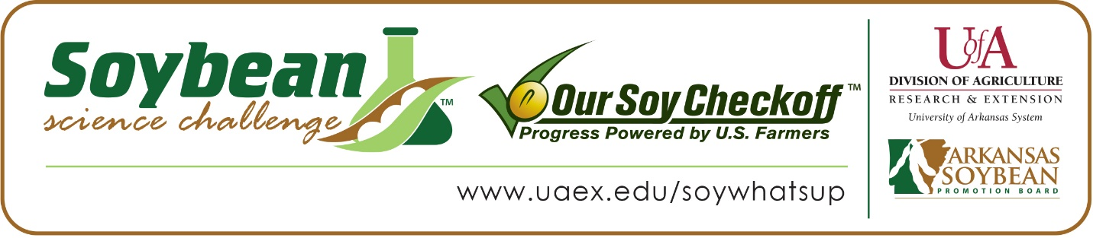

Alyssa Butler wins 2020 Arkansas Soybean Science Challenge First Place Award at the Southwestern Energy Arkansas State Science and Engineering Fair
Alyssa Butler, 16, a junior at Carlisle High School in Carlisle, won the 2020 Soybean Science Challenge First Place Award at the virtual Southwestern Energy Arkansas State Science and Engineering Fair April 3.
Butler received a $1,000 cash award provided by the Arkansas Soybean Promotion Board. Her science project is titled “Greenhouse comparison of genetically similar soybean varieties and resistance to the Southern Root-Knot Nematode.”
Carly Bokker, Alyssa’s teacher, won the $300 State Soybean Science Challenge First Place Teacher Mentor Award. Bokker stated that the Soybean Science Challenge is a great way to learn about the science behind soybeans in the classroom. “Being in a rural Lonoke County school, farmers are the backbone of our community. Students need to understand in a Plant Science pathway that you can’t just decide to plant a bean one day and wait for it to grow. It is such a process, and all the decision making and planning that goes in to producing our crops is a valuable learning tool for students. The Soybean Science Challenge has brought my classroom a new learning tool, not only on the research side but also through information in the learning modules,” she said.
Butler was shocked she won the 2020 First Place State Soybean Science Challenge. “It’s incredible. I didn’t think I had a chance to be THE winner especially since I wasn’t a regional winner. My Ag teacher, Mrs. Bokker actually got the news first and told me… I screamed and my mom thought I had been stung by a wasp. Let’s just say we were all super excited,” she replied.
Nicole and Michael Emerson, Alyssa’s parents, were very proud to see her receive the award. “We thought our daughter’s project was very well thought out and was well organized. Her project stood out to us because it is a project that relates to a problem that soybean producers have in Arkansas,” they said.
Butler also expounded on what she learned as she labored through her project. “There were many things I learned while participating in the state fair but I think one of the most important ones was to not give up. A few times during my project I would get frustrated and want to quit but looking back I’m so glad I didn’t! Working with this project has definitely given me a better understanding of agriculture and a deeper respect for not only growers but the extension services and chemical companies who work with them. I hope that one day I can build a career on plant sciences and become a plant pathologist/Nematologist,” she replied.
Bokker, Alyssa’s teacher, was thrilled one of her students won the First Place Award at the State Soybean Science Challenge. “Alyssa is the first student from Carlisle to compete in the Soybean Science Challenge, and she has set the bar high with a great project. Her initiative to start this project was based on real-world problems for soybean farmers in Arkansas. My back ground is in soybean research, and having a student who is driven to learn the research process and to help solve problems is very encouraging as a teacher,” she stated.
“The Soybean Science Challenge provides an opportunity for Arkansas High School students to participate in scientific research that can impact the State of Arkansas as well as the world. Soybean Science Challenge student researchers learn about this important commodity crop and its many uses including feeding the world, development of biofuels and sustainable products. The Soybean Science Challenge helps students develop an understanding of the challenges and complexities of modern farming,” said Dr. Julie Robinson, Associate Professor and director of the program.
“The goal of the Arkansas Soybean Science Challenge is to engage students in “real world” education to support soybean production and agricultural sustainability,” said Gary Sitzer, a former member of the Arkansas Soybean Promotion Board. “The program also rewards scientific inquiry and discovery that supports the Arkansas Soybean Industry.”
The Arkansas Soybean Science Challenge was launched in January 2014 to 9-12th grade science students. Students who successfully completed the online course were eligible to have their original soybean-related research projects judged at the 2020 ISEF-affiliated Arkansas Science and Engineering Fairs.
Information on the 2020-2021 Arkansas Soybean Science Challenge will be available in summer 2020. For more information, contact Dr. Julie Robinson at jrobinson@uaex.edu or Diedre Young at dyoung@uaex.edu.
The Cooperative Extension Service is part of the University of Arkansas System Division of Agriculture.

Alyssa Butler, Carlisle High School, Carlisle. Teacher: Carly Bokker
Category: Plant Science
Title: Greenhouse Comparison of Genetically Similar Soybean Varieties and Resistance to the Southern Root-Knot Nematode
Abstract:
The southern root-knot nematode (Meloidogyne incognita) is one of the most important yield-limiting plant-parasitic nematodes that affect soybeans (Glycine max) in Arkansas. One of the best management tools that farmers have is host resistance; however, limited information about the host is available. The objective of this study was to evaluate a greenhouse comparison of genetically similar soybean seed varieties. Soybean seeds varieties with similar genetic backgrounds, all manufacturer claimed to be moderately resistant to root-knot nematodes, along with one susceptible check (Delta Grow 4880) and one resistant check (Forrest) were used to test nematode resistance and egg reproduction. Plants were planted in a randomized complete block design with five reps and artificially inoculated with 5,000 eggs per plant. Soybeans were rated at 48 days after inoculation, roots were processed to determine eggs per gram. Pioneer P45A45L, Pioneer P43A42X, Pioneer P46T59R and Forrest all were statistically different when compared to the susceptible check (Delta Grow 4880) for root gall ratings; P45A29L and Pioneer P43A42Z were the only two with significant differences in egg/gram root and egg reproduction factor. These varieties were confirmed to be moderately resistant when compared to the resistant check and would be good options for farmers’ fields with damaging populations of root-knot nematodes.
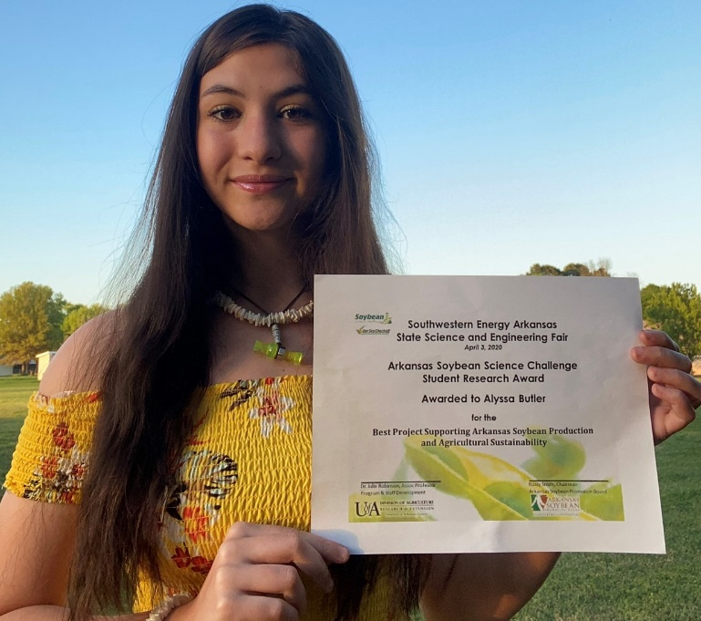 Alyssa Butler, 2020 State Science and Engineering Fair Soybean Science Challenge First Place Winner.
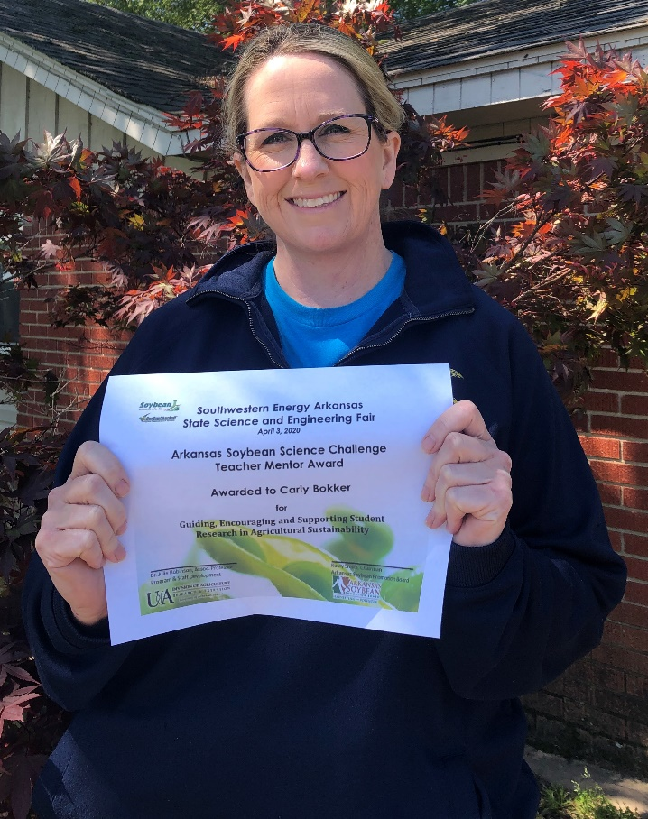 Carly Bokker, Teacher-Mentor

