Alisa 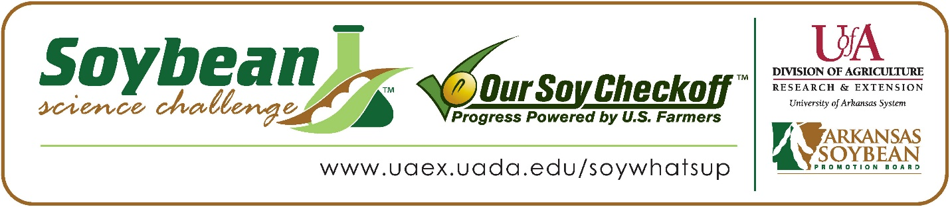
Alisa Menyaeva wins 2026 Arkansas Soybean Science Challenge Second Place Award at Arkansas State Science and Engineering Fair
Alisa Menyaeva, 16, a sophomore at Little Rock Central High School, won the 2026 Soybean Science Challenge Second Place Award at the Arkansas State Science and Engineering Fair at Central Arkansas University-Conway April 3.
Alisa received a $500 cash award for her SSC Second Place finish at State. Awards were provided by the Arkansas Soybean Promotion Board. Her science project titled ‘Effects of various cooking methods on soybean antioxidant retention with DPPH evaluation” also won first place in the Plant Science category at the Central Arkansas Regional Science Fair.
Beth Maris, Alisa’s teacher, won the $200 State Soybean Science Challenge Second Place Teacher-Mentor Award. Maris stated that the Soybean Science Challenge was a great way for Alisa to learn about this important crop. “Through participating in the Soybean Science Challenge, Alisa gained knowledge about the role of soybeans in the Arkansas economy, the importance of agriculture, and various uses for soybeans. She also gained valuable hands-on research experience,” she explained.
Alisa said it is wonderful to receive Second Place in the State Soybean Science Challenge. “I am very proud to have won this award because lots of time and effort went into this project. From doing the experiment, to accidentally breaking my microwave, this award made everything worth it,” she replied.
Evgeniya Fedorova, Alisa’s mother, was very excited to see her receive the award. "I was so very proud,” she stated.
Alisa expounded on how preparing for the Soybean Science Challenge made her realize how important soybeans are to the world. “My aspect of the project gave a new insight into the nutritional value of soybeans. Many jobs utilize that nutrition by farming soy and then implementing it in food products. So many people in Arkansas and across the world rely on this crop without realizing it,” she explained.
Aleya also discussed how the Soybean Science Challenge introduced her to careers in Agriculture. “Soybean related careers have a wide range of jobs, and I would like to continue researching about soy’s nutritional value and how to maximize that value, thus opening the door to a career in Agriculture,” she replied.
“The Soybean Science Challenge provides an opportunity for Arkansas junior high and high school students to participate in scientific research that can impact the State of Arkansas as well as the world. Soybean Science Challenge student researchers learn about this important commodity crop and its many uses including feeding the world, development of biofuels and sustainable products. The Soybean Science Challenge helps students develop an understanding of the challenges and complexities of modern farming,” said Dr. Julie Robinson, Professor, and director of the program.
“The goal of the Arkansas Soybean Science Challenge is to engage students in “real- world” education to support soybean production and agricultural sustainability,” said Gary Sitzer, a former member of the Arkansas Soybean Promotion Board. “The program also rewards scientific inquiry and discovery that supports the Arkansas Soybean Industry.”
The Arkansas Soybean Science Challenge was launched in January 2014 for 9-12th grade science students. Students who successfully completed the online course were eligible to have their original soybean-related research projects judged at the 2026 ISEF-affiliated Arkansas Science and Engineering Fairs.
Information on the 2026-2027 Arkansas Soybean Science Challenge will be available in summer 2026. For more information, contact Dr. Julie Robinson at jrobinson@uada.edu, Keith Harris at krharris@uada.edu, or Diedre Young at dyoung@uada.edu.
The Cooperative Extension Service is part of the University of Arkansas Division of Agriculture.
Alisa Menyaeva, Little Rock Central High School, Little Rock, Arkansas; Teacher: Beth Maris
Category: Plant Science
Project Title: Effects of various cooking methods on soybean antioxidant retention with DPPH evaluation.
Abstract: In this project, soybean antioxidant retention was measured after three various cooking methods: steaming, boiling, and baking. Based on prior research, it is known the antioxidants are water-soluble compounds. Thus, baking and steaming were expected to provide the best results because soybeans will not be submerged in water, like in boiling. The antioxidants will be unable to dissolve into the cooking water and remain inside the bean. Two different brands of soybeans were experimented upon, each having a sample for each cooking method, and an additional control (soaking the soybeans in water for nine hours). After an hour of cooking, samples were soaked in 90% ethanol for antioxidant extraction, and the liquid was taken to a laboratory for proper filtration. A DPPH (2,2-diphenyl-1-picrylhydazyl) kit was used for evaluation. The DPPH solution mimics unstable free radicals (found in unhealthy cells) in a deep purple color. In simpler terms, the more antioxidant present, the lighter the purple DPPH reagent post radical scavenging. Lighter color results in a lower absorbance number identified by a spectrophotometer, indicating a stronger antioxidant concentration. The Anova test provided a p-value of roughly 0.000017, showing a statistically significant difference between the three cooking groups. As hypothesized, baking and steaming had the greatest antioxidant retention with lowest absorbance and higher inhibitory ratio (ratio required to inhibit 50% of the free radicals). Boiling depleted the content, increasing the absorbance drastically, and decreased inhibitory ratio since the water-soluble antioxidants leaked into the cooking water.
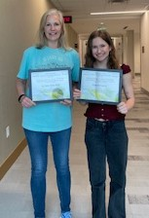

Teacher Mentor Dr. Beth Maris and Arkansas State Science and Engineering Fair Second Place Winner Alisa Menyaeva

