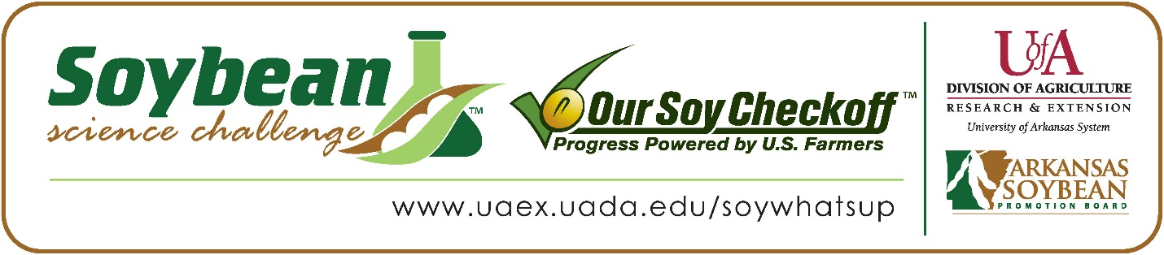

Abby Berger wins 2022 Arkansas Soybean Science Challenge Award at Arkansas State Science Fair and ASMSA-West Central Arkansas Science Fair
Abby Berger, 17, a senior at Arkansas School for Mathematics, Sciences and the Arts (ASMSA) in Hot Springs won the Soybean Science Challenge First place award at the Arkansas State Science Fair held April 1, and at the 2022 West Central Science Fair regional award held at ASMSA, February 25.
Berger received a $1,000 cash award for her first-place finish at State and a $300 cash award for her regional win. Both awards were provided by the Arkansas Soybean Promotion Board at the award ceremonies. Her science fair project titled “The Potential of Forage Soybeans as a Grazing Source for Cattle” also received first place in Plant Science, Best of Fair and was chosen to be an ISEF finalist, at the regional science fair.

Dr. Brian Monson, Bryant’s teacher, won the $300 first place award at State and the $200 regional Soybean Science Challenge Teacher Mentor Award. He believes the Soybean Science Challenge is a wonderful opportunity for students to earn recognition for their work. “.” he stated.
Berger was honored that her project was chosen to win the Soybean Science Challenge. “It was very rewarding to win the Soybean Science Challenge because it felt like my hard work in the field this summer paid off, and I felt like I had made a contribution to further soybean usage in agriculture,” she explained.
Kelly Berger, Abby’s mother, was excited she won the Soybean Science Challenge Award. “I was proud of Abby for her dedication to this project, and I felt that her honor was well deserved. She spent a year and a half on this project driving to and from the farm to tend her plants,“ she noted.
Monson also talked about Abby’s dedication. “Abby was a remote student during the 2020-21 school year but still needed to find a research project to meet our graduation requirements. She has family connections to soybean farming, so it was natural that she gravitated to ag research. She worked very hard on her project. First, she conducted a proof-of- concept test in the greenhouse. Then, she conducted a very intensive field test over the summer. She did all this work on her own communicating with me only via email and weekly Zoom sessions,” he stated.
The part of the Soybean Science Challenge course that appealed most to Abby was learning about the many uses of soybeans, especially Biodiesel. “I really enjoyed learning about where soybeans go from the field and into different industries. I was fascinated by the biodiesel process and how soybeans are so influential in the world,” she stated.

Abby noted before she decided to participate in the Soybean Science Challenge, she
already possessed knowledge of how many crops in the South were grown and how they were used as forage as both her grandfather and aunt are plant geneticists. This gave her a personal connection to her project and fueled a lot of her knowledge of soybeans.

“The Soybean Science Challenge provides an opportunity for Arkansas High School students to participate in scientific research that can impact the state of Arkansas as well as the world. Soybean Science Challenge student researchers learn about this important commodity crop and its many uses including feeding the world, development of biofuels and sustainable products. The Soybean Science Challenge helps students develop an understanding of the challenges and complexities of modern farming,” said Dr. Julie Robinson, Associate Professor and director of the program.
“The goal of the Arkansas Soybean Science Challenge is to engage students in “real world” education to support soybean production and agricultural sustainability,” said Gary Sitzer a former member of the Arkansas Soybean Promotion Board. “The program also rewards scientific inquiry and discovery that supports the Arkansas Soybean Industry.”
The Arkansas Soybean Science Challenge was launched in January 2014 to 9-12th grade science students. Students who successfully completed the online course were eligible to have their original soybean-related research projects judged at the 2022 ISEF-affiliated Arkansas Science and Engineering fairs.
Information on the 2022-2023 Arkansas Soybean Science Challenge will be available in summer 2022. For more information, contact Dr. Julie Robinson at jrobinson@uada.edu or Diedre Young at dyoung@uada.edu.
The Cooperative Extension Service is part of the University of Arkansas System Division of Agriculture.

Abby Berger Arkansas School for Mathematics, Sciences and the Arts, Hot Springs, AR. Teacher-Dr. Brian Monson
Category: Plant Science
Project Title: The Potential of Forage Soybeans as a Grazing Source for Cattle
Abstract: Farmers across the nation feed their cattle some form of fibrous plant material such as wheat or alfalfa. Soybean prices are decreasing, so forage soybeans are being considered as an alternative grazing option for cattle if they can withstand grazing damage and regrow a decent crop. Soybeans’ large leaf area and protein content maximizes the activity of ruminal microorganisms in a cow’s digestive tract. Five varieties from Eagle Seed and one from a competitor were planted an inch deep in rows in a three-acre field and clipped throughout the growing season to see how the plants would hold up to simulated grazing damage. It was hypothesized that the varieties of soybeans would be similar in their regrowth after they were snipped above the V1 stage except for the MultiMaxZ soybean which would grow forage faster because MultiMaxZ grows three times the amount of leaves a normal forage soybean does. Four clippings were taken throughout the season: V1, V3, V5, and R1 growth stages. The treatments were carried out on consecutive sets of six feet of plants in their respective rows. MultiMaxZ led significantly in dry weight and fresh weight, but Big Fellow® led in leaf area although the error bars overlap. By the R1 stage, MultiMaxZ had a fresh weight of 1656 tons per acre whereas Big Fellow® had 1390 tons per acre. The results indicate that forage soybeans could be used as a nutritional grazing alternative for cattle although nutritional and cattle testing should be conducted in the future.

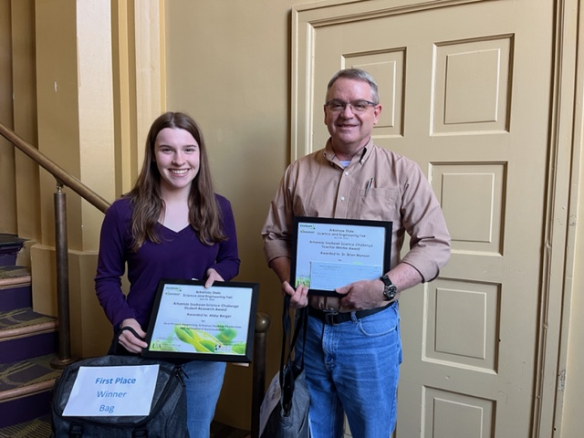

Arkansas State Science Fair first place winner and ASMSA West Central Arkansas Science Fair Soybean Science Challenge winner Abby Berger and Teacher-Mentor Dr. Brian Monson

