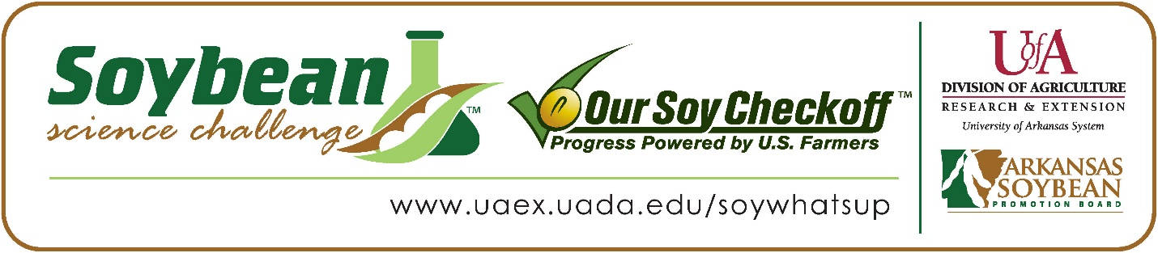

Aakash Bhattacharyya wins 2022 Arkansas Soybean Science Challenge Junior Division Award at the Central Arkansas Regional Science and Engineering Fair
Aakash Bhattacharyya, age 13, an 8th grader at Lisa Academy West Middle School in Little Rock, won the Soybean Science Challenge Junior Division award at the 2022 Central Arkansas Regional Science and Engineering Fair held virtually in Little Rock on March 4.
Aakash received a $200 cash award provided by the Arkansas Soybean Promotion Board. His science project titled “Electronic Soil Moisture Sensor: Save Water, Save the Future” also placed first in Environmental Management and was accepted to participate in the National Broadcom Masters Competition.
Erin Votaw, Aakash’s teacher, won the $100 Soybean Science Challenge Junior Division Teacher-Mentor Award. Votaw stated she is always excited for new opportunities to challenge her students. “The Soybean Science Challenge was a great way for my students to explore a new topic outside of what we are studying in class. I am passionate about sustainability, and I believe it is so important for young minds to get involved in making our state, and planet, a better place for their future,” she replied.
Aakash was delighted to win the 2022 Junior Division Soybean Science Challenge. “I am very honored and happy to be called the 2022 JR level winner of the Soybean Science Challenge. I would like to keep doing research to help soybean farmers and help the environment,” he replied.
Arpita Bhattacharyya, Aakash’s mother, was very happy to see him receive the award. “We were elated. We knew how much Aakash wanted it and how passionate he is about his science fair projects. We encouraged him to continue improving on this project next year,” she stated.
Aakash was impressed with what he learned from participating in the Soybean Science Challenge. “The part of the videos which showed me what a real soybean farm looks like, and how things work there was most appealing to me. At one point in the course, it said that soybeans put back nitrogen in the soil, helping other plants grow and making the soil better. This was interesting new information to me,“ he explained.
The Soybean Science Challenge provides an opportunity for Arkansas junior high and high school students to participate in scientific research that can impact the State of Arkansas as well as the world. Soybean Science Challenge student researchers learn about this important commodity crop and its many uses including feeding the world, development of biofuels and sustainable products. The Soybean Science Challenge helps students develop an understanding of the challenges and complexities of modern farming,” said Dr. Julie Robinson, Associate Professor and director of the program.
“The goal of the Arkansas Soybean Science Challenge is to engage students in “real- world” education to support soybean production and agricultural sustainability,” said Gary Sitzer, a former member of the Arkansas Soybean Promotion Board. “The program also rewards scientific inquiry and discovery that supports the Arkansas Soybean Industry.”
The Arkansas Soybean Science Challenge was launched in January 2014 to 9-12th grade science students and in 2019 to grades 6-8. Students who successfully completed the online course were eligible to have their original soybean-related research projects judged at the 2022 ISEF-affiliated Arkansas Science and Engineering Fairs.
Information on the 2022-2023 Arkansas Soybean Science Challenge will be available in summer 2022. For more information, contact Dr. Julie Robinson at jrobinson@uada.edu or Diedre Young at dyoung@uada.edu.
The Cooperative Extension Service is part of the University of Arkansas System Division of Agriculture.
Aakash Bhattacharyya, Lisa Academy West Middle School, Little Rock, Arkansas; Teacher, Erin Votaw.
Category: Environmental Management
Title: Electronic Soil Moisture Sensor: Save Water, Save the Future
Abstract: Access to good quality water is a growing concern. According to the U.S. Geological Survey, in 2010, approximately 29% of surface water and 65% of fresh groundwater are used for agricultural needs. 2/3 of fresh water is used in irrigation, and half of that is wasted because of irrigation inefficiency and water wastage (i.e. 108 billion gallons of water wasted per day in USA alone). Therefore, improving irrigation water usage efficiency is significant. Improving the efficiency of irrigation involves putting accurate amounts of water. In my project, I made a new and improved Soil Moisture Sensor to reduce unnecessary water consumption. I used a NAND 4011 circuit to make a soil moisture sensor. In this project, I am using a durable capacitance-based Arduino circuit board with an LCD display to make quantitative and accurate readings. To make it work, I wrote customized Adriano code to load my Arduino Circuit. It was tested with relevant soils, especially Arkansas Stuttgart soil variations. Silty Loam and Silty Clay, Loam, and Loamy soil, with different amounts of water. I observed how my circuit performed and displayed the exact moisture percentage. My control variables were soil amount, soil height, and the circuit. I tested two times for each soil type and water amount combination. After conducting the experiment and looking at my circuit, I have concluded that my circuit is indeed sensitive and accurate, fully functional and able to reduce unnecessary water consumption. My hypothesis was proven correct because my soil moisture sensor worked.

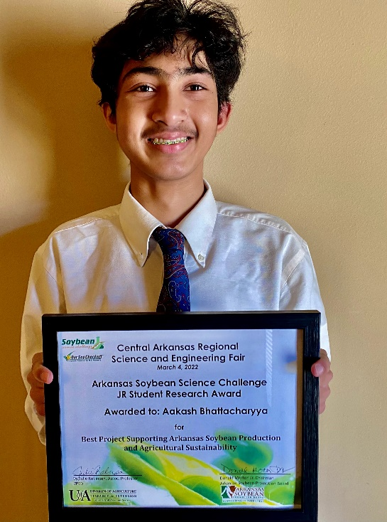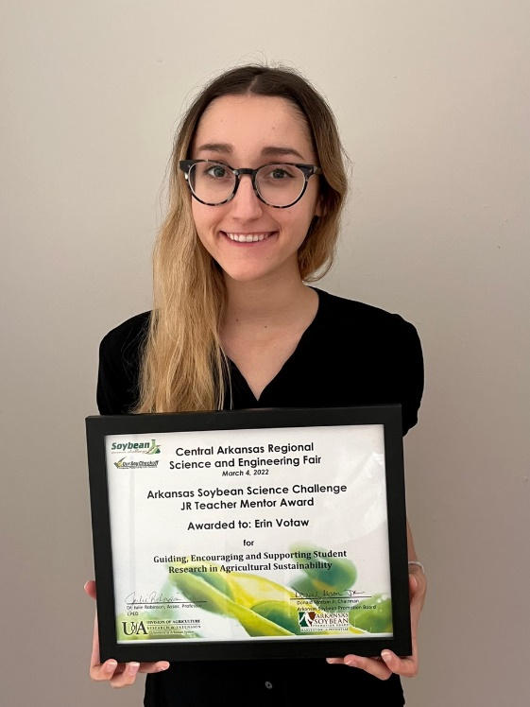
Central Arkansas Regional Science and Engineering Fair Junior Division winner Aakash Bhattacharyya and teacher-mentor, Erin Votaw

