
By Diedre Young MAT, Soybean Science Challenge Curriculum Specialist
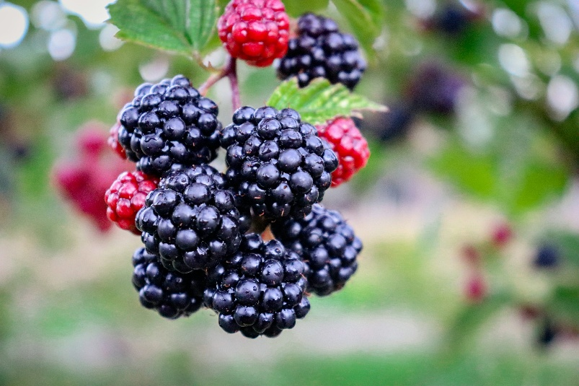
Blackberries in High Tunnels and Shade Structures Virtual Field Trip
Photos courtesy of Unsplash©


Grades 9-12 Integrated Biology, Environmental Science, and Agricultural Science

Arkansas NGSS Suggestions:

Integrated Biology:
Topic 6: Life and Earth’s Systems
B16-ETS1-3: Evaluate a solution to a complex real-world problem based on prioritized criteria and trade-offs that account for a range of constraints including cost, safety, reliability, and aesthetics, as well as possible social, cultural, and environmental impacts.
Science and Engineering Practices: Constructing Explanations and Designing Solutions (B16- ETS1-3)
Connections to Engineering, Technology and Applications of Science: Influence of Science, Engineering and Technology on Society and the Natural World. (BI16-ETS1-3)
Disciplinary Core Ideas: ETS1.B: Developing Possible Solutions
Connections to the Arkansas Disciplinary Literacy Standards: RST.11-12.7, 11-12.8, 11-12.9
Connections to the Arkansas Mathematical Standards: MP.2, MP.4

Topic 7: Human Impacts on Earth Systems
BI-ESS3-1: Construct an explanation based on evidence for how the availability of natural resources, the occurrence of natural hazards, and changes in climate have influenced human activity.
Science and Engineering Practices: Constructing Explanations and Designing Solutions (BI-ESS3-1)
Crosscutting Concepts: Cause and Effect (BI-ESS3-1)
Disciplinary Core Ideas: ESS3.A: Natural Resources, ESS3.B: Natural Hazards
Connections to the Arkansas Disciplinary Literacy Standards: RST.11-12.1, WHST.9-12.2
Connections to the Arkansas Mathematical Standards: MP.2, HSN.Q.A.1

BI-ESS3-2: Evaluate competing design solutions for developing, managing, and utilizing energy and mineral resources based on cost benefit ratios.
Science and Engineering Practices: Engaging in Argument from Evidence (BI-ESS3-2)
Connections to Engineering, Technology and Applications of Science: Influence of Science, Engineering and Technology on Society and the Natural World (BI-ESS3-2). Science Addresses Questions About the Natural and Material World (BI-ESS3-2)
Disciplinary Core Ideas: ESS3.A: Natural Resources, ETS1.B: Developing Possible Solutions Connections to the Arkansas Disciplinary Literacy Standards: RST.11-12.1, RST.11-12.8 Connections to the Arkansas Mathematical Standards: MP.2

BI-ESS3-4: Evaluate or refine a technological solution that reduces the impact of human activities on natural systems.
Science and Engineering Practices: Constructing Explanations and Designing Solutions (BI-ESS3- 4)
Crosscutting Concepts: Stability and Change (BI-ESS3-4)
Connections to Engineering, Technology and Applications of Science: Influence of Science, Engineering and Technology on Society and the Natural World (BI-ESS3-4)
Disciplinary Core Ideas: ESS3.C: Human Impacts on Earth Systems, ETS1.B: Developing Possible Solutions
Connections to the Arkansas Disciplinary Literacy Standards: RST.11-12.1, RST.11-12.8
Connections to the Arkansas Mathematical Standards: MP.2, HSN.Q.A.1
B17-ETS1-1: Analyze a major global challenge to specify qualitative and quantitative criteria and constraints for solutions that account for societal needs and wants.
Science and Engineering Practices: Asking Questions and Defining Problems (B17-ETS1-1)
Connections to Engineering, Technology and Applications of Science: Influence of Science, Engineering and Technology on Society and the Natural World (B17-ETS1-1)
Disciplinary Core Ideas: ETS1.A: Defining and Delimiting Engineering Problems Connections to the Arkansas Disciplinary Literacy Standards: RST.11-12.7-9 Connections to the Arkansas Mathematical Standards: MP.2, MP.4

Environmental Science:
Topic One: Systems
EVS1-ETS1-1: Analyze a major global challenge to specify qualitative and quantitative criteria and constraints for solutions that account for societal needs and wants.
Science and Engineering Practices: Asking Questions and Defining Problems (EVS1-ETS1-1)
Crosscutting Concepts: Influence of Engineering, Technology and Science on Society and the Natural World (EVS1-ETS1-1)
Disciplinary Core Ideas: ETS1.A: Defining and Delimiting Engineering Problems
Connections to the Arkansas Disciplinary Literacy Standards: RST.11-12.7, RST.11-12.8, RST.11- 12.9
Connections to the Arkansas Mathematic Standards: MP.2, MP.4

Topic 2: Energy
EVS-ETS1-2: Design a solution to a complex real-world problem by breaking it down into smaller more manageable problems that could be solved through engineering.
Science and Engineering Practices: Constructing Explanations and Designing Solutions (EVS- ETS1-2)
Disciplinary Core Ideas: ETS1.C: Optimizing the Design Solution

Topic 4: Sustainability
EVS-ESS3-1: Construct an explanation based on evidence for how the availability of natural resources, occurrence of natural hazards, and changes in climate have influenced human activity.
Science and Engineering Practices: Constructing Explanations and Designing Solutions (EVS- ESS3-1)
Crosscutting Concepts: Cause and Effect (EVS-ESS3-1)
Connections to Engineering, Technology and Applications of Science: Influence of Science, Engineering and Technology on Society and the Natural World (EVS-ESS3-1)
Disciplinary Core Ideas: ESS3.A: Natural Resources. ESS3.B: Natural Hazards Connections to the Arkansas Disciplinary Literacy Standards: RST.11-12.1, WHST.9-12.2 Connections to the Arkansas Mathematic Standards: MP.2, HSN.Q.A.1, 2, 3

EVS-ESS3-2: Evaluate competing design solutions for developing, managing, and utilizing
energy and mineral resources based on cost-benefit ratios.
Science and Engineering Practices: Engage an Argument from Evidence (EVS-ESS3-2)
Crosscutting Concepts: Influence of Science, Engineering and Technology on Society and the Natural World. Science Addresses Questions about the Natural and Material World. (EVS-ESS3- 2)
Disciplinary Core Ideas: ESS3.A: Natural Resources, ETS1.B: Developing Possible Solutions (EVS- ESS3-2)
Connections to the Arkansas Disciplinary Literacy Standards: RST.11-12.8
Connections to the Arkansas Mathematic Standards: MP.2

EVS-ESS3-3: Create a computational simulation to illustrate the relationships among the management of natural resources, the sustainability of human populations, and biodiversity.
Science and Engineering Practices: Using Mathematics and Computational Thinking (EVS-ESS3-3)
Crosscutting Concepts: Stability and Change (EVS-ESS3-3)
Connections to Engineering, Technology and Applications of Science: Influence of Science, Engineering and Technology on Society and the Natural World (EVS-ESS3-3)
Disciplinary Core Ideas: ESS3.C: Human Impacts on Earth Systems
Connections to the Arkansas Mathematic Standards: MP.2, MP.4

EVS-LS2-7: Design, evaluate and refine a solution for reducing the impacts of human activities on the environment and biodiversity.
Science and Engineering Practices: Constructing Explanations and Designing Solutions (EVS-LS2- 7)
Crosscutting Concepts: Stability and Change (EVS-LS2-7)
Disciplinary Core Ideas: LS2.C: Ecosystem Dynamics, Functioning, and Resilience, ESS3.A: Natural Resources, ESS3.C: Human Impacts on Earth Systems, ETS1.B: Developing Possible Solutions
Connections to the Arkansas Disciplinary Literacy Standards: RST.9-10.8, RST.11-12.1, RST.11- 12.8, WHST.9-12.7
Connections to the Arkansas Mathematic Standards: MP.2, HSN.Q.A.1, HSN.Q.A.2, HSN.Q.A.3

EVS-LS4-6: Create or revise a simulation to test a solution to mitigate adverse impacts of human activity on biodiversity.
Science and Engineering Practices: Using mathematics and computational thinking (EVS-LS4-6)
Crosscutting Concepts: Cause and Effect (EVS-LS4-6)
Disciplinary Core Ideas: LS4.C Adaptation, LS4.D Biodiversity and Humans
Connections to the Arkansas Disciplinary Literacy Standards: WHST.9-12.5, 9-12.7
Connections to the Arkansas Mathematic Standards: MP.2

EVS4-ETS1-3: Evaluate a solution to a complex real-world problem based on prioritized criteria and trade-offs that account for a range of constraints, including cost, safety reliability, and aesthetics, as well as possible social, cultural, and environmental impacts.
Science and Engineering Practices: Constructing Explanations and Designing Solutions (EVS- ESS3-4)
Crosscutting Concepts: Cause and Effect (EVS-ESS3-1)
Disciplinary Core Ideas: ESS3.A: Natural Resources
Connections to the Arkansas Disciplinary Literacy Standards: WHST.9-12.5, 9-12.7
Connections to the Arkansas Mathematic Standards: MP.2, MP.4
Objective: Students will understand the importance of soil, water, and sun on blackberry cultivation. Students will learn that these impacts indirectly influence micro-environments such as water and wind systems. Students will learn that current conservation methods can make a difference not only ecologically but also economically to a blackberry farmer.
Assessment: Students will write a half-page research paper on either blackberry tunnels or shades, explaining why they feel this practice is the most important.
Key Points: Blackberry tunnels, blackberry shades, Discovery Farms
Materials:
To watch the recorded ‘Blackberries in High Tunnels and Shade Structures Virtual Field Trip’ go to www.uaex.uada.edu/soywhatsup and click on the ‘Virtual Field Trips and Lessons’ icon to the left of the webpage.

Paper and writing utensils for students in the classroom.

Preparation: If this is to be done in class, it is highly recommended that the teacher understands the key vocabulary words below.

Time Duration: one and a half class periods.
The video is about 60 minutes long (45 minutes plus 15 minutes question/answer). Assume about 10 minutes for students to look up vocabulary, and 10 minutes to teach essential concepts. Assume 10 minutes for reflection and discussion after the video.
Elicit:
Do a KWL Chart and inquire about blackberry production. How do farmers grow blackberries? What are the advantages of practicing conservation with blackberries? What are the types of conservation practices that blackberry farmers are doing? How can these practices help blackberry farmers ecologically and economically? Where could farmers get help with these practices?

Engage:
Tell the students that they are going to watch a video titled ‘Blackberries in High Tunnels and Shade Structures Virtual Field Trip’. Before starting the video, have the students break into groups to define the following words:

Conservation
Arkansas Discovery Farms
Leaf Moisture Measurement
Blackberry High Tunnels
Blackberry Shade Structures
White Drupelet Disorder
Surface Water Irrigation
Drip Irrigation
Broad Mites
Rossette Fungus

Explain:

BEFORE THE VIDEO, be sure the students understand that agricultural conservation of blackberries not only benefits the environment, but also farmers. Blackberry farmers need to learn that water and nutrient conservation and sustainability can translate into more profit for them.
Biology Teachers: This is a suitable time to address/review human impact on ecological systems and how population dynamics/agriculture affect the local ecology and economics.
Environmental Science Teachers: This is a suitable time to explore/review human impact on ecological systems and how population dynamics/agriculture affect the local ecology and economics.
AG Teachers: This is a suitable time to cover/review human impact on ecological systems and how population dynamics/agriculture affect the local ecology, and the economics of farming profitability by using continuous agricultural improvement.
Farmers need to be continually aware of the use of their resources in farming. Blackberries, while considered a high value crop, are also a high maintenance fruit that requires constant monitoring. Blackberries are particularly vulnerable to pests and environmental factors during the berry ripening period. It is for this reason that farmers are looking to High Tunnels and Shades to help improve their crops. Farmers are realizing that high tunnels improve fruit quality and extend the harvest season, all while causing a minimum effect on the local environment.
Explore:
Show the video ‘‘Blackberries in High Tunnels and Shade Structures Virtual Field Trip’.’
Elaborate:
After the video, have the students break into three groups: the ‘High Tunnel group, the ‘Blackberry Shade’ group, and the ‘surface irrigation’ group. Each group brainstorms their area of study, explaining why their area of study is important to blackberry production.

Tell the students they need to produce at least six ways to explain why their area of study is important, and report this to the class.
Evaluate:
Students will turn in a two-paragraph reflection paper on what they learned and how these conservation efforts can affect blackberry farming in Arkansas.
Extend:
End the lesson with how the sustainability and conservation practices of blackberry farmers decreasing their dependence on water and chemicals has also had a significant impact on our personal lives through the water we use and the food we eat. Reiterate how the concern for ecological friendly products can, in turn, drive how farmers approach production.
Assign a brainstorming project that allows students to design their own alternate growing methods or have students research innovative conservation practices and how they could benefit local farmers.
Have an agent from a local company or a local extension agent come to the classroom to explain how farmers and their people can collaborate to increase profitability while decreasing herbicide and insecticide use.



