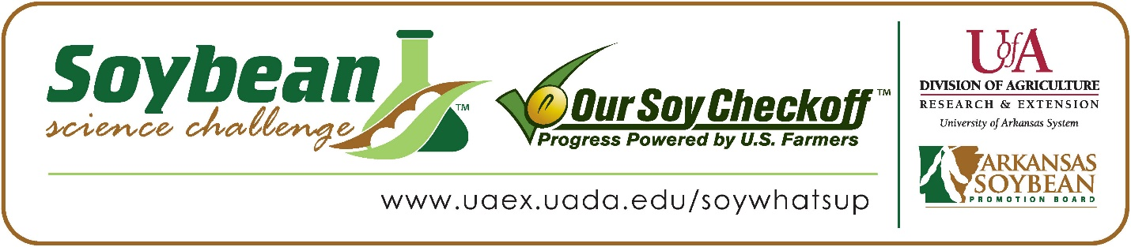

Jacob Davis wins 2026 Arkansas Soybean Science Challenge Senior Division at Northeast Arkansas Regional Science Fair
Jacob Davis, 18, a senior at Harrisburg High School, won the 2026 Senior Division award at Northeast Arkansas Regional Science Fair at Arkansas State University Jonesboro February 28.
Davis received a $400 cash award for his regional win. Awards were provided by the Arkansas Soybean Promotion Board. His science project titled ‘Can plants be assisted by better water?’ was awarded second place in plant science.
Chad Allen Lacy, Davis’s teacher, won the $200 regional teacher/mentor award. Lacy stated that the Soybean Science Challenge is a great way to learn about the science behind soybeans in the classroom. “My students learned a lot about plant science and how different chemicals can affect plants,” he explained.
Davis said he was happy to win the Senior Division Soybean Science Challenge. “I didn’t know that this was an award I could win! Even now it’s interesting to think that the people I spoke to would lead me to winning this award,” he replied. Vanessa Condray, Jacob’s mother, was very happy to see him receive the award. “I thought it was a little funny as he has never been one to be interested in plants,” she quipped.

Lacy expounded on why the Soybean Science Challenge is so important. “Through the Soybean Science Challenge, I gained knowledge of how different products can potentially affect plant health and plant growth,” he concluded.
Davis explained what he had learned about participating in The Challenge. “Before participating in the Soybean Science Challenge, I knew very little about soybeans and agriculture. I now have lots of knowledge not just about soybeans but also about agriculture in general,” he explained.

“The Soybean Science Challenge provides an opportunity for Arkansas junior high and high school students to participate in scientific research that can impact the State of Arkansas as well as the world. Soybean Science Challenge student researchers learn about this important commodity crop and its many uses including feeding the world, development of biofuels and sustainable products. The Soybean Science Challenge helps students develop an understanding of the challenges and complexities of modern farming,” said Professor Julie Robinson, director of the program.
“The goal of the Arkansas Soybean Science Challenge is to engage students in “real- world” education to support soybean production and agricultural sustainability,” said Gary Sitzer, a former member of the Arkansas Soybean Promotion Board. “The program also rewards scientific inquiry and discovery that supports the Arkansas Soybean Industry.”
The Arkansas Soybean Science Challenge was launched in January 2014 for 9-12th grade science students. Students who successfully completed the online course were eligible to have their original soybean-related research projects judged at the 2026 ISEF-affiliated Arkansas Science and Engineering Fairs.
Information on the 2026-2027 Arkansas Soybean Science Challenge will be available in summer 2026. For more information, contact Dr. Julie Robinson at jrobinson@uada.edu or Keith Harris at krharris@uada.edu, or Diedre Young at dyoung@uada.edu.
The Cooperative Extension Service is part of the University of Arkansas Division of Agriculture.
Jacob Davis, Harrisburg High School, Harrisburg, Arkansas; Teacher: Chad Allan Lacy
Category: Plant Science
Title: Can plants be assisted by better water?
Abstract:
Water is one of the most precious and vital resources on earth not just to us but to all life including plants but plants can struggle to grow especially without the right water source, but can that be changed and give plants a stronger growth performance? This is exactly what my project aims to tackle through to adding help small grow dosages of different nutrients to a plant's source of water in order stronger plants and crops. The plants were grown indoors without unbiased, any cross pollination or any outside effects being possible to gain raw, including and accurate results for this experiment. The only thing changed added three different sources of water including tap water, natural water with calcium, and natural water with added potassium to measure each plant's growth (dependent variable) in real time. My hypothesis was that water with added potassium would grow the strongest due to the mineral’s importance to the growth of a plant.

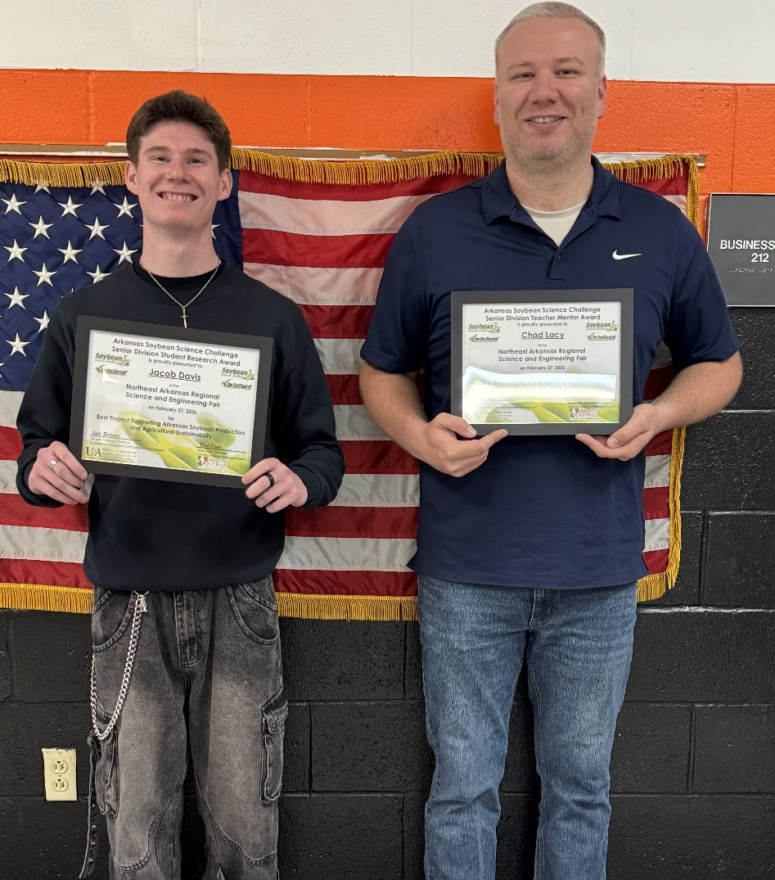

Northeast Arkansas Regional Science Fair Senior Division Jacob Davis, and Teacher-Mentor Chad Allen Lacy.

