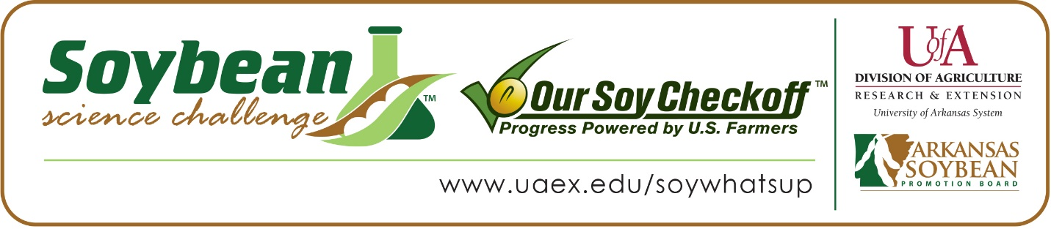
Ka’Lee Hanson wins 2024 Arkansas Soybean Science Challenge Award at
Southwest Arkansas Emerson High School STEM Night
Ka’Lee Hanson, age 16, a sophomore at Emerson High School in Emerson, Arkansas, won the Senior Division Soybean Science Challenge at the 2024 Southwest Arkansas Emerson High School STEM Night held at Emerson High School on April 18.
Ka’Lee received a $300 cash award provided by the Arkansas Soybean Promotion Board at the awards ceremony. Her science project, titled “Hydroponics Soybeans” also won first place in Plant Sciences at the Emerson STEM Night.
Amanda Watson, Ka’Lee’s teacher, won the $200 Soybean Science Challenge Teacher-Mentor Award. Watson believes the Soybean Science Challenge is a great opportunity for students to learn more about the soybean industry in Arkansas. “The Soybean Science Challenge helps to challenge my students to learn more about topics that they don’t know a lot about,” she replied.
Ka’Lee was thrilled to win the 2024 Soybean Science Challenge. “Winning the 2024 Soybean Science Challenge Senior Division Award is a real honor,” she said.
Watson was happy to learn of Ka’Lee’s award. “I am so excited for Ka’Lee’s hard work to be recognized,” she replied.
The part of the Soybean Science Challenge course that appealed most to Ka’Lee was learning about the soybean industry. “A key topic and sustainability issue covered in the course that I found most interesting and useful was learning how soybeans are grown and the amount that are grown,” she explained.
Ashlee Hanson, Ka’Lee’s mother, was surprised by, and proud of, her daughter’s award. “I was very surprised to hear she had won. I was very proud of her for working so hard and doing her best,” she stated.
“The Soybean Science Challenge provides an opportunity for Arkansas High School students to participate in scientific research that can impact the State of Arkansas as well as the world. Soybean Science Challenge student researchers learn about this important commodity crop and its many uses including feeding the world, development of biofuels and sustainable products. The Soybean Science Challenge helps students develop an understanding of the challenges and complexities of modern farming,” said Dr. Julie Robinson, Professor, and director of the program.
“The goal of the Arkansas Soybean Science Challenge is to engage students in “real- world” education to support soybean production and agricultural sustainability,” said Gary Sitzer, a former member of the Arkansas Soybean Promotion Board. “The program also rewards scientific inquiry and discovery that supports the Arkansas soybean industry.”
The Arkansas Soybean Science Challenge was launched in January 2014 to 9-12th grade science students and in 2021, a junior level award was added for grades 6-8. Students who successfully completed the online course were eligible to have their original soybean-related research projects judged at the 2024 Arkansas Science and Engineering Fairs.
Information on the 2024-2025 Arkansas Soybean Science Challenge will be available in summer 2024. For more information, contact Dr. Julie Robinson at jrobinson@uada.edu, Diedre Young at dyoung@uada.edu or Keith Harris at kharris@uada.edu.
The Cooperative Extension Service is part of the University of Arkansas System Division of Agriculture.

Ka’Lee Hanson, Emerson High School, Emerson, Arkansas; Teacher, Amanda Watson
Category: Plant Sciences
Project Title: Soybean Hydroponics
Abstract:
Soybeans are an important crop in America due to their many functions. My experiment tests which soybean seed grows the best in hydroponics. Hydroponics have many benefits including the minimization of space, weather, and weed issues in comparison to growing soybeans in the field. Using a hydroponic tank, I planted 3 different soybean seeds: food-grade, conventional, and herbicide-resistant. My hypothesis is that the largest of the three seeds (food-grade) would grow the tallest while the other two types would have similar height due to similarity of seed size. As predicted, the food-grade seeds grew the tallest. Surprisingly, the other two seeds had variation in growth with the conventional growing taller than the herbicide resistant. This information can help farmers make decisions about what crops to grow hydroponically.

