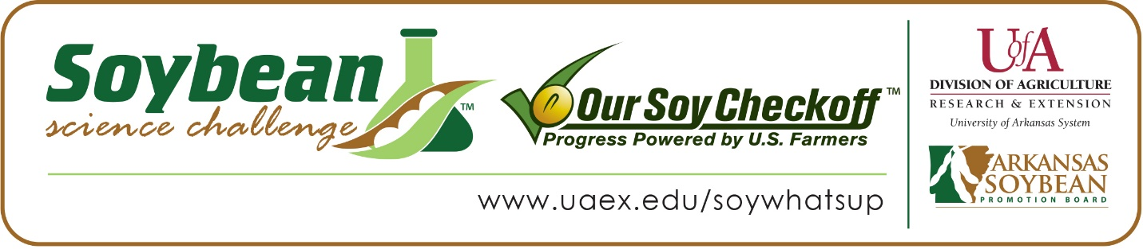

**Ka’Lee Hanson wins 2023 Arkansas Soybean Science Challenge Award at**

**Southwest Arkansas Regional Science Fair**

Ka’Lee Hanson, age 15, a freshman at Emerson High School in Emerson, Arkansas, won the Senior Division Soybean Science Challenge at the 2023 Southwest Arkansas Regional Science Fair held at Southern Arkansas University-Magnolia March 31.

Ka’Lee received a $300 cash award provided by the Arkansas Soybean Promotion Board at the awards ceremony. Her science project, titled “Hydroponics Soybeans” also won second place at the Emerson Science Fair in Agriculture/Environmental Science. She also placed third in Agriculture/Environmental Science, and third in the Conservation District Category at SAU.

Amanda Watson, Ka’Lee’s teacher, won the $200 Soybean Science Challenge Teacher-Mentor Award. Watson believes the Soybean Science Challenge is a great opportunity for students to learn more about the soybean industry in Arkansas.  “I wanted my students to participate in the Soybean Science Challenge because it opened them to more opportunities and made them aware of soybean production in Arkansas,” she replied.

Ka’Lee says it was exciting to win the 2023 Soybean Science Challenge. “I believe that it is an honor to be the winner of the Soybean Science Challenge of 2023, I worked really hard on the experiment that I conducted and felt it was a very interesting topic,” she said.

Watson was happy to learn of Ka’Lee’s award. “Ka’Lee is a hard-working student in and outside the classroom. She did a lot of background research on the topic of hydroponics and how it would affect the growth of the different types of soybeans. She started this project back in December and conducted the research for a while. I am very proud of her,” she replied.

Ka’Lee admitted she had very limited knowledge about soybeans before taking the Soybean Science Challenge online course. “I knew very little about soybeans before my participation in the Soybean Science Challenge. I enjoyed learning new information about this topic,” she said.

The part of the Soybean Science Challenge course that appealed most to Ka’Lee was learning about the soybean industry and biofuels. “A key topic and sustainability issue covered in the course that I found most interesting and useful was the fact that soybeans are used in hundreds of everyday products, and that they can be used as biofuels,” she explained.

Ashlee Hanson, Ka’Lee’s mother, is especially proud of her daughter’s award. “I was very excited for her. I was very proud of her doing something she had never done before. I am glad she challenged herself to try something new,” she stated.

“The Soybean Science Challenge provides an opportunity for Arkansas High School students to participate in scientific research that can impact the State of Arkansas as well as the world. Soybean Science Challenge student researchers learn about this important commodity crop and its many uses including feeding the world, development of biofuels and sustainable products. The Soybean Science Challenge helps students develop an understanding of the challenges and complexities of modern farming,” said Dr. Julie Robinson, Associate Professor and director of the program.

“The goal of the Arkansas Soybean Science Challenge is to engage students in “real- world” education to support soybean production and agricultural sustainability,” said Gary Sitzer, a former member of the Arkansas Soybean Promotion Board. “The program also rewards scientific inquiry and discovery that supports the Arkansas soybean industry.”

The Arkansas Soybean Science Challenge was launched in January 2014 to 9-12th grade science students and in 2021, a junior level award was added for grades 6-8. Students who successfully completed the online course were eligible to have their original soybean-related research projects judged at the 2023 Arkansas Science and Engineering Fairs.

Information on the 2023-2024 Arkansas Soybean Science Challenge will be available in summer 2023. For more information, contact Dr. Julie Robinson at [jrobinson@uada.edu](mailto:jrobinson@uada.edu) or Diedre Young at [dyoung@uada.edu](mailto:dyoung@uada.edu).

The Cooperative Extension Service is part of the University of Arkansas System Division of Agriculture.

**Ka’Lee Hanson. Emerson High School, Emerson, Arkansas; Teacher, Amanda Watson**

**Category: Plant Science**

**Project Title: Soybean Hydroponics**

**Abstract:**

This experiment was designed to test how long it takes for different types of soybeans to grow in hydroponics and the time it takes to grow. The hydroponic tank, the amount of water in the tank, and the grow light. I used 5 items, the 5 items I used were 1 grow light, aquaponic hydroponic system, soybean seeds (tofu, conventional, roundup; 10 seeds each), and two strings. I observed that the tofu soybeans grew the tallest in hydroponics, the conventional soybeans grew the second tallest, but they were the healthiest, and the roundup ready soybeans didn’t grow good at all. My hypothesis was that the tofu soybeans will grow the best in hydroponics because their seeds are bigger, my hypothesis was supported. The issue in my experiment was that the roundup ready soybeans didn’t really grow as well as I thought they would.

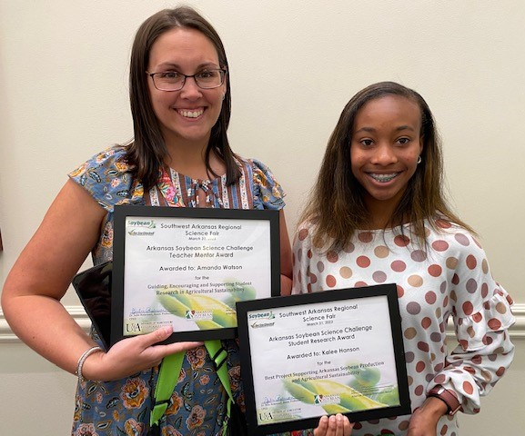

2023 Soybean Science Challenge Senior Division winner Ka’Lee Hanson and Teacher-Mentor Amanda Watson