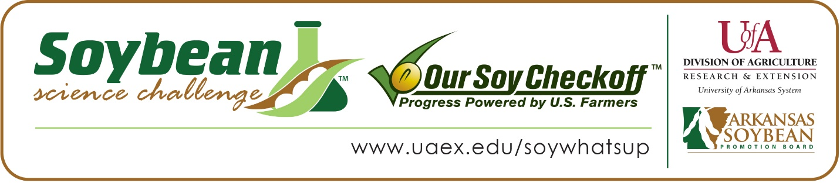

Ayla Buford wins 2022 Arkansas Soybean Science Challenge Award at

Southwest Arkansas Regional Science Fair
Ayla Buford, age 14, a freshman at Taylor High School in Taylor, Arkansas, won the Soybean Science Challenge at the 2022 Southwest Arkansas Regional Science Fair held at Southern Arkansas University-Magnolia April 1.
Ayla received a $300 cash award provided by the Arkansas Soybean Promotion Board at the awards ceremony. Her science project was titled “How drinks affect plant growth.”
Christy Hoyle, Ayla’s teacher, won the $200 Soybean Science Challenge Teacher-Mentor Award. Hoyle believes the Soybean Science Challenge is a great opportunity for students to learn more about the soybean industry in Arkansas.
Ayla says it was exciting to win the 2022 Soybean Science Challenge. “I believe that it is a true honor to be the winner of the Soybean Science Challenge of 2022 because the experiment that I conducted brought attention to the importance of soybeans across the world,” she said.
Hoyle was happy to learn of Ayla’s award. “Through the Soybean Science Challenge, Ayla gained increased knowledge and greater opportunity to research in the areas of plant, soil and agricultural sciences,” she replied.
Ayla admitted she had limited knowledge about soybeans before taking the Soybean Science Challenge online course. “I did not know that much about soybeans before my participation in the Soybean Science Challenge. I enjoyed learning new information about this topic,” she said.
The part of the Soybean Science Challenge course that appealed most to Ayla was learning about the soybean industry and biofuels. “A key topic and sustainability issue covered in the course that I found most interesting and useful was the fact that soybeans are used in hundreds of everyday products, and that they can be used as biofuels,” she explained.
“The Soybean Science Challenge provides an opportunity for Arkansas High School students to participate in scientific research that can impact the State of Arkansas as well as the world. Soybean Science Challenge student researchers learn about this important commodity crop and its many uses including feeding the world, development of biofuels and sustainable products. The Soybean Science Challenge helps students develop an understanding of the challenges and complexities of modern farming,” said Dr. Julie Robinson, Associate Professor and director of the program.
“The goal of the Arkansas Soybean Science Challenge is to engage students in “real- world” education to support soybean production and agricultural sustainability,” said Gary Sitzer, a former member of the Arkansas Soybean Promotion Board. “The program also rewards scientific inquiry and discovery that supports the Arkansas soybean industry.”
The Arkansas Soybean Science Challenge was launched in January 2014 to 9-12th grade science students and in 2022, a Junior level award was added for grades 6-8. Students who successfully completed the online course were eligible to have their original soybean-related research projects judged at the 2022 Arkansas Science and Engineering Fairs.
Information on the 2022-2023 Arkansas Soybean Science Challenge will be available in summer 2022. For more information, contact Dr. Julie Robinson at jrobinson@uada.edu or Diedre Young at dyoung@uada.edu.
The Cooperative Extension Service is part of the University of Arkansas System Division of Agriculture.

Ayla Buford, Taylor High School, Taylor, Arkansas; Teacher, Christy Hoyle
Category: AG/Earth/Environmental
Project Title: How drinks affect plant growth
Abstract: The science fair project I chose to do this year was about hydrogen’s peroxides effect on soybean plant growth. I chose to do this project because hydrogen peroxide is often used in pesticides on crops. I wanted to know if the plants were being positively or negatively affected by the substance. I had five different solution types that were to be given to fifteen plants each. The experiment was done in twenty-one days. I hypothesized that the 50% hydrogen peroxide and 50% water solution would cause the plants to grow faster than the other plants given different solutions. My hypothesis was proven incorrect. The results showed that the 75% hydrogen peroxide and 25% water solution grew the plants faster than the plants given the other solution types.
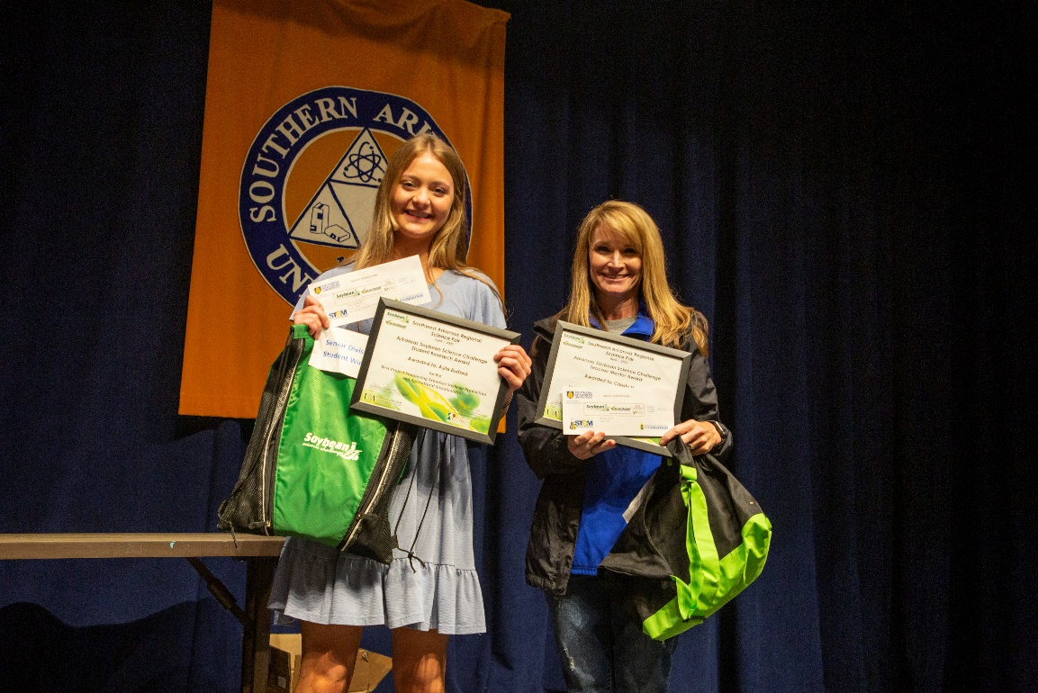
2022 Soybean Science Challenge Senior Division winner Ayla Buford and Teacher-Mentor Christy Hoyle

