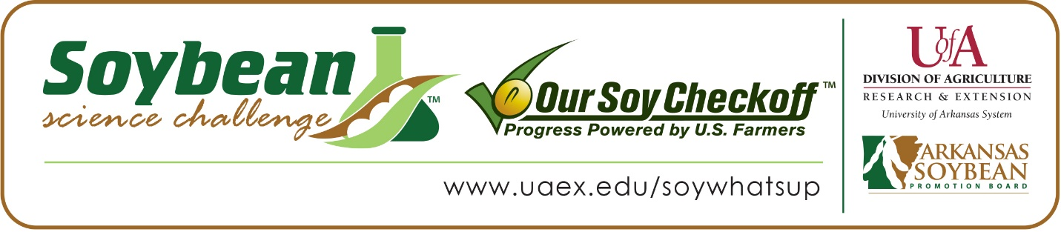

Alyssa Butler wins 2020 Arkansas Soybean Science Challenge Award at Virtual FFA Agriscience Fair
Alyssa Butler, 16, a junior at Carlisle High School in Carlisle, Arkansas has won the Soybean Science Challenge at the 2020 Virtual Agriscience Fair held May 4.
Butler received a $300 cash award provided by the Arkansas Soybean Promotion Board. Her science project titled “Greenhouse comparison of genetically similar soybean varieties and resistance to the Southern Root-Knot Nematode” also placed first in the Soybean Science Challenge at the Southwestern Energy State Science and Engineering Fair May 3.
Carly Bokker won the Soybean Science Challenge FFA Advisor Award. “Alyssa was very proactive and chose to do a research project in Soybeans. I knew the Soybean Science Challenge was very good learning material from my years of working with the Extension Service, so I was thrilled to support her in her work,” stated Bokker. Bokker also believes the Soybean Science Challenge is a wonderful program for her and her students. “I’ve gained knowledge of how the Soybean Science Challenge program works and ideas for future studies. The learning modules for the Soybean Science Challenge online are also a great teaching tool for me in the classroom. Being from a strong farming community, the material is timely and relevant to our local needs,” she said.
Butler was thrilled to win the Soybean Science Challenge. “I’m so thankful for the opportunity to compete and win the 2020 FFA Agriscience fair and for all the valuable resources and information I’ve earned along the way,” she said.

When Butler took the Soybean Science Challenge online course, the topics that sparked her interest most were the farming and the soybean research modules. “These two modules appealed to me because they gave me a better understanding of what growers and researchers go through to produce soybeans in Arkansas,” she replied.

Bokker had a strong knowledge of soybeans before finding out about The Challenge. “I have worked both as an Extension Agent and a Program Associate in research under Dr. Jeremy Ross, Extension Soybean Agronomist. I have a lot of knowledge from the production side, but on the teaching side, it is a constant learning curve to keep up with the changing technologies. In our Ag Education program at Carlisle High School, we grow 20 acres of either soybeans or corn each year on our school campus. Soybeans will always be a staple in my classroom,” she replied.
Alyssa’s parents, Nicole and Michael Emerson, were very excited for her and are proud of all the hard work and time that she has put into her project.

“The Soybean Science Challenge provides an opportunity for Arkansas High School students to participate in scientific research that can impact the state of Arkansas as well as the world. Soybean Science Challenge student researchers learn about this important commodity crop and its many uses including feeding the world, development of biofuels and sustainable products. The Soybean Science Challenge helps students develop an understanding of the challenges and complexities of modern farming,” said Dr. Julie Robinson, Associate Professor and director of the program.
“The goal of the Arkansas Soybean Science Challenge is to engage students in “real world” education to support soybean production and agricultural sustainability,” said Gary Sitzer a former member of the Arkansas Soybean Promotion Board. “The program also rewards scientific inquiry and discovery that supports the Arkansas Soybean Industry.”
The Arkansas Soybean Science Challenge was launched in January 2014 to 9-12th grade science students. Students who successfully completed the online course were eligible to have their original soybean-related research projects judged at the 2020 ISEF-affiliated Arkansas Science and Engineering Fairs and the Arkansas State FFA Agriscience Fair.
Information on the 2020-2021 Arkansas Soybean Science Challenge will be available in summer 2020. For more information, contact Dr. Julie Robinson at jrobinson@uaex.edu or Diedre Young at dyoung@uaex.edu.
The Cooperative Extension Service is part of the University of Arkansas System Division of Agriculture.

Alyssa Butler, Carlisle High School, Carlisle, Arkansas - Teacher: Carly Bokker
Category: Plant Science
Title: Greenhouse Comparison of Genetically Similar Soybean Varieties and Resistance to the Southern Root-Knot Nematode
Abstract:
The southern root-knot nematode (Meloidogyne incognita) is one of the most important yield-limiting plant-parasitic nematodes that affect soybeans (Glycine max) in Arkansas. One of the best management tools that farmers have is host resistance; however, limited information about the host is available. The objective of this study was to evaluate a greenhouse comparison of genetically similar soybean seed varieties. Soybean seed varieties with similar genetic backgrounds, all manufacturers claimed to be moderately resistant to root-knot nematodes, along with one susceptible check (Delta Grow 4880) and one resistant check (Forrest) were used to test nematode resistance and egg reproduction. Plants were planted in a randomized complete block design with five reps and artificially inoculated with 5,000 eggs per plant. Soybeans were rated at 48 days after inoculation; roots were processed to determine eggs per gram. Pioneer P45A45L, Pioneer P43A42X, Pioneer P46T59R and Forrest all were statistically different when compared to the susceptible check (Delta Grow 4880) for root gall ratings; P45A29L and Pioneer P43A42Z were the only two with significant differences in egg/gram root and egg reproduction factor. These varieties were confirmed to be moderately resistant when compared to the resistant check and would be good options for farmers’ fields with damaging populations of root-knot nematodes.
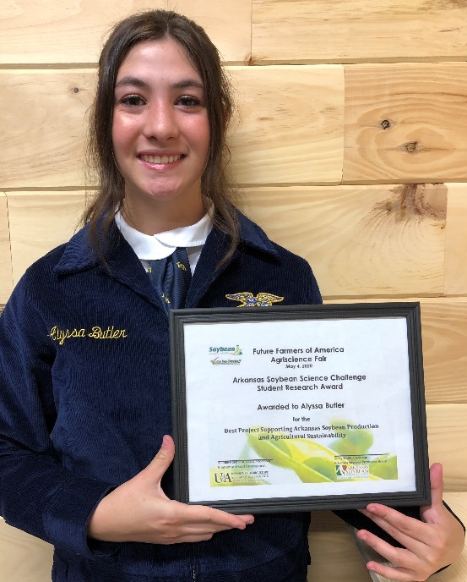 Alyssa Butler, 2020 FFA Agriscience Soybean Science Challenge Winner
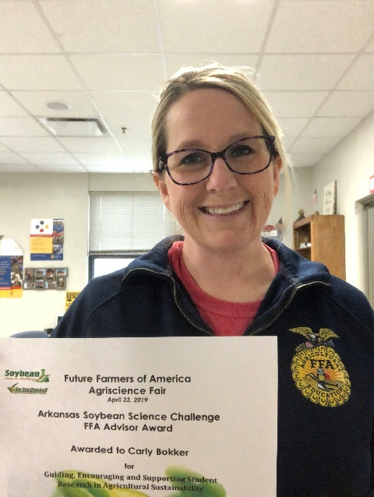 Carly Bokker, FFA Advisor

