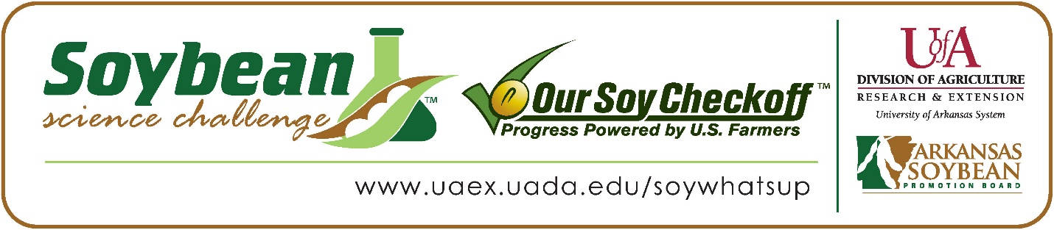

**Bentley Dawson wins the 2025 Arkansas Soybean Science Challenge Award at the Junior Division Ouachita Mountain Regional Science and Engineering Fair**

Bentley Dawson, age 13, an eighth grader at Genoa Central Junior High School in Texarkana, Arkansas, won the Soybean Science Challenge at the 2025 Junior Division Ouachita Mountain Regional Science and Engineering Fair held in Hot Springs, February 28.

Dawson received a $200 cash award provided by the Arkansas Soybean Promotion Board. His science project titled “Charcoal and Soybeans” also placed first in Plant Sciences.

Rita Martin, Bentley’s teacher, won the $100 Soybean Science Challenge Junior Division Teacher-Mentor Award. Martin noted she noticed the value of the Soybean Science Challenge from participating last year. “We participated in the Ouachita Mountain Regional Science fair last year and had a student win this award, so I encouraged all my students to consider doing a project involving soybeans,” she replied.

Bentley said winning the 2025 Soybean Science Challenge was a great moment for him. “Winning has motivated me to expand my research into other soybean related projects,” he said.

Lindsey Dawson, Bentley’s mother, was extremely proud of his award. “I was so excited to see his hard work recognized. He hadn’t really thought about an agricultural career, however, after he started his research, it intrigued him to learn more. He would like to continue research to help farmers develop healthier crops,” she replied.

The part of the Soybean Science Challenge course that appealed most to Bentley was learning about soybean production. “One of the most interesting things I learned in this course was discovering how soybeans are grown and processed. It helped me to understand soybean and agricultural issues better,” he explained.

Rita Martin shared what she learned through her student taking the SSC online course. “I really gained much more knowledge about soybeans and their importance for worldwide nutrition. Recently I helped pack meals for an organization called *Feed My Starving Children* and a big component in the meal we packed was dried soybeans. After participating in the Soybean Challenge with my students I realized just how much protein we were providing these children that would be receiving these meals,” she stated.

“The Soybean Science Challenge provides an opportunity for Arkansas junior high and high school students to participate in scientific research that can impact the State of Arkansas as well as the world. Soybean Science Challenge student researchers learn about this important commodity crop and its many uses including feeding the world, development of biofuels and sustainable products. The Soybean Science Challenge helps students develop an understanding of the challenges and complexities of modern farming,” said Dr. Julie Robinson, Professor, and director of the program.

“The goal of the Arkansas Soybean Science Challenge is to engage students in “real- world” education to support soybean production and agricultural sustainability,” said Gary Sitzer, a former member of the Arkansas Soybean Promotion Board. “The program also rewards scientific inquiry and discovery that supports the Arkansas Soybean Industry.”

The Arkansas Soybean Science Challenge was launched in January 2014 for 9-12th grade science students, and a regional Junior Division award was added in 2021. Students who successfully completed the online course were eligible to have their original soybean-related research projects judged at the 2025 ISEF-affiliated Arkansas Science and Engineering Fairs.

Information on the 2025-2026 Arkansas Soybean Science Challenge will be available in summer 2025. For more information, contact Dr. Julie Robinson at [jrobinson@uada.edu](mailto:jrobinson@uada.edu) or Keith Harris at [krharris@uada.edu](mailto:krharris@uada.edu), or Diedre Young at [dyoung@uada.edu](mailto:dyoung@uada.edu).

The Cooperative Extension Service is part of the University of Arkansas System Division of Agriculture.

**Bentley Dawson, Genoa Central Junior High School, Texarkana, Arkansas; Teacher, Rita Martin**

**Category: Plant Sciences**

**Project Title: Charcoal and Soybeans**

**Abstract:**

The average soybean survival rates each year are usually below 80 percent. I tested my hypothesis by analyzing how the amount and type of charcoal added to soybean plants affects the health of the soybeans. The soybeans were planted in biochar, activated charcoal, and normal soil. Each sample was observed for 24 days to determine the health and survival rates. Data was recorded for each sample health and height each day. When comparing the three soils: Biochar grew 32% more sprouts compared to activated charcoal, and 53% more sprouts than normal soil. The seeds that had biochar added to their soil grew healthier sprouts and had a higher survival rate. The study showed activated charcoal to have a higher survival rate and a healthier plant than normal soil alone. Biochar had the most germinated seeds, the best survival rate, and the healthiest plants.

2025 Ouachita Mountain Regional Science and Engineering Fair Junior Division Soybean Science Challenge Teacher-Mentor Rita Martin and Soybean Science Challenge Winner Bentley Dawson.