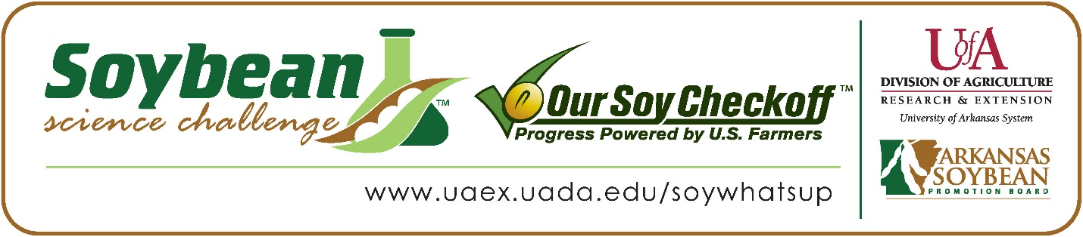

**Siddharth Snidharan wins 2023 Arkansas Soybean Science Challenge Award at Central Arkansas Regional Science and Engineering Fair**

Siddharth Snidharan, 15, a freshman at Central High School in Little Rock won the 2023 Soybean Science Challenge Regional Award at the Central Arkansas Regional Science and Engineering Fair held at the University of Arkansas-Little Rock, March 3.

Siddharth received a $300 cash award at the regional fair. The award was provided by the Arkansas Soybean Promotion Board. His science project titled “Deciphering the radioprotective effects of the soy isoflavone genistein in lung cells” also placed first in Biochemistry, Best of Fair, and is an ISEF Finalist.

Patrick Foley, Siddharth’s teacher, won the $200 Soybean Science Challenge Teacher-Mentor Award. “I appreciate the support and acknowledgement that the Soybean Science Challenge has offered me,” he stated.

Siddharth discovered that the SSC online course is packed with information. “I learned that the interactive video lessons like the Davis virtual field trip covered issues like nematode management, and sustainable soy farm practices like crop rotation, soil testing, and harvesting. water and nutrient management were also exciting. This field trip explained the techniques that help farmers improve efficiencies, how to yield more crops and produce sustainable soy.” he stated.

Siddharth was thrilled to receive the Soybean Science Challenge Award. “I felt very excited and honored to become the 2023 winner of the Soybean Science Challenge. All the hard work I had done for my project was recognized, and I felt motivated to pursue my research with soybeans in the future. I also felt very delighted that I was able to demonstrate the potential biochemical effects of soybean in cells, which can contribute to the benefits of consuming soybeans and soy products,” he replied.

Siddharth’s parents, Vijayalakshmi Mohanseenivasan and Sridharan Soundararajan were delighted with Siddharth’s award. “We were extremely happy for Siddharth to win this award. He is a very determined student and came up with the idea of working with the soy isoflavones for his science fair project since soy products such as Edamame, Tofu and Tempeh are his favorites,” they replied.”

Patrick Foley also acknowledged Siddharth’s commitment. “Siddharth chose his project of his own accord!  He wanted to do a project involving the biochemical properties of soybeans and pursued it at UAMS,” he explained.

The part of the Soybean Science Challenge course that appealed most to Siddharth was farming. “I liked all the modules of the course; however, my favorite part was the nematode research, which was well explained in the Davis Farms Virtual Field Trip. The virtual field trip provided a lot of information that was very exciting,” he replied.

Siddharth discussed what he gained from the Soybean Science Challenge. “Participation in the Soybean Science Challenge gave me the opportunity to know about information that I was not aware of before. The Soybean Science Challenge course enriched my knowledge about the soybean plant growth, life cycle, its staging, time of harvesting and management of the disease control. Importantly, I learned about how soybeans play an important role in Arkansas economic growth and the impact it has on the farmers. Nevertheless, this challenge has super motivated me to do more research on soybeans in the future.” he explained.

“The Soybean Science Challenge provides an opportunity for Arkansas high school students to participate in scientific research that can impact the State of Arkansas as well as the world. Soybean Science Challenge student researchers learn about this important commodity crop and its many uses including feeding the world, development of biofuels and sustainable products. The Soybean Science Challenge helps students develop an understanding of the challenges and complexities of modern farming,” said Dr. Julie Robinson, Associate Professor, and director of the program.

“The goal of the Arkansas Soybean Science Challenge is to engage students in “real- world” education to support soybean production and agricultural sustainability,” said Gary Sitzer a former member of the Arkansas Soybean Promotion Board. “The program also rewards scientific inquiry and discovery that supports the Arkansas soybean industry.”

The Arkansas Soybean Science Challenge was launched in January 2014 to 9-12th grade science students. Students who successfully completed the online course are eligible to have their original soybean-related research projects judged at the 2023 ISEF-affiliated Arkansas Science and Engineering Fairs.

Information on the 2023-2024 Arkansas Soybean Science Challenge will be available in summer 2023. For more information, contact Dr. Julie Robinson at [jrobinson@uada.edu](mailto:jrobinson@uada.edu) or Diedre Young at [dyoung@uada.edu](mailto:dyoung@uada.edu).

The Cooperative Extension Service is part of the University of Arkansas System Division of Agriculture.

**Siddharth Snidharan, Little Rock Central High School, Little Rock, Arkansas; Teacher: Patrick Foley**

**Category: Biochemistry**

**Project Title: Deciphering the radioprotective effects of the soy isoflavone genistein in lung cells**

**Abstract:**

Radiation-induced lung disease is a potential challenge for thoracic cancer survivors who received radiotherapy. Search for drugs that can radiosensitize cancer cells while protecting the normal cells is currently going on. Genistein, the major biologically active soy isoflavone possesses potent antioxidants and anticancer properties with minimal side effects. This project was aimed to decipher the molecular mechanisms involved in the radioprotective effects of Genistein in normal lung cells and to demonstrate the radiosensitizing effects in cancer cells.

WI38 (Normal) and A549 (Cancer) cells were used. Effects of genistein on antioxidant activity, and TBHP-induced reactive oxygen species (ROS) were measured by DPPH assay and DCFDA assay. Cells was exposed to 4 Gy gamma irradiation and cell viability (MTT assay), intracellular ROS generation, and protein expression of SOD2, Catalase, GPx, molecular docking of Caspase 3 and protein expression of capase3,7 and 9 (Western Blotting) were also studied.

Genistein exhibited a dose dependent free radical scavenging activity. Pretreatment of WI38 cells with genistein significantly decreased TBHP-induced intracellular ROS levels. Genistein pretreatment (20 pM) significantly prevented cell death, reduced intracellular ROS levels, and maintained the protein levels of SOD2, catalase, and enzymes of the apoptotic pathway after irradiation. Interestingly, genistein either alone or in combination with radiation significantly decreased cell viability in lung cancer cells.

In conclusion, the ability of genistein to have a protective effect against radiation in normal cells and a cytotoxic/radiosensitizing effect in cancer cells suggested that it may be considered as a radioprotective drug with radiosensitizing effects.

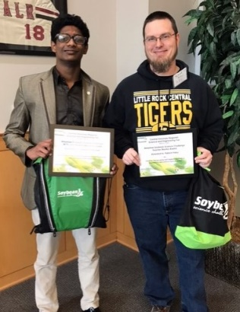

Central Arkansas Regional Science and Engineering Fair Senior Division Winner Siddharth Snidharan on the left and Teacher-Mentor Patrick Foley on the right.