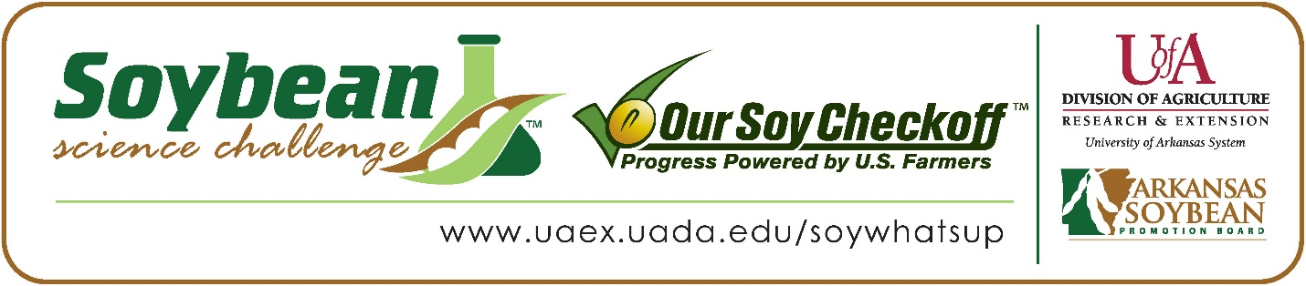

Rebekah Caffey wins 2022 Arkansas Soybean Science Challenge Award at Central Arkansas Regional Science and Engineering Fair
Rebekah Caffey, 17, a junior at Central High School in Little Rock won the 2022 Soybean Science Challenge Regional Award at the Central Arkansas Regional Science and Engineering Fair held at the University of Arkansas-Little Rock, March 4.
Caffey received a $300 cash award at the regional fair. The award was provided by the Arkansas Soybean Promotion Board. Her science project titled “The Effects of Defoliation and Fungicide Treatment” also placed first in Earth and Planetary Sciences at regional.
Mary Maris, Caffey’s teacher, won the $200 Soybean Science Challenge Teacher-Mentor Award. “I've had students enter The Challenge in the past, and I think it is a great way for them to learn about the many uses for this crop which is so important to our state,” she stated.
Maris also learned that the SSC is packed with resources. “I learned that there are many resources available for students who wish to research soybeans, and I will encourage future students to participate in the Soybean Challenge,” she stated.
Caffey was thrilled to receive the Soybean Science Challenge Award. “To be the winner of the 2022 Soybean Science Challenge is very cool! I definitely feel like my project could be improved, but more than anything, this is such an awesome learning experience! I learned a lot about soybeans and how much soybeans do for us,” she replied.
Mr. and Mrs. Jerald Caffey, Rebekah’s parents, were delighted with Rebekah’s award. “We were very proud of Rebekah; she worked really hard on her project. We remember she even said she was working on two different projects at once,” they replied. Her mother commented on Rebekah’s dedication, “I don’t know much about soybeans but it was really amazing to see how Rebekah has such a passion for them and to use them in her research.”
Mary Maris also acknowledged Rebekah’s commitment. “Rebekah is a student in my AP Chemistry class. Her independent research project is not a class requirement, but something she chose to do on her own. She is studying the effect of metalaxyl fungicide on the mass of soybeans and the role of defoliation,” she explained.
The part of the Soybean Science Challenge course that appealed most to Caffey was Module 2: Food. “I really enjoyed learning about all the different purposes of soybeans, but especially it being grown for nutrition. I found this very interesting because I garden and would love to grow soybeans and learn more about how they impact the human diet. It is also very insightful to learn about the harvesting of soybeans for oil extraction and other consuming purposes,” she replied.
Caffey also shared how the SSC online course has been a great learning tool. “Through the Soybean Science Course, I gained a great learning opportunity about soybeans. I expanded valuable knowledge like how to grow and harvest them, and other cool facts,” she stated.
“The Soybean Science Challenge provides an opportunity for Arkansas high school students to participate in scientific research that can impact the State of Arkansas as well as the world. Soybean Science Challenge student researchers learn about this important commodity crop and its many uses including feeding the world, development of biofuels and sustainable products. The Soybean Science Challenge helps students develop an understanding of the challenges and complexities of modern farming,” said Dr. Julie Robinson, Associate Professor and director of the program.
“The goal of the Arkansas Soybean Science Challenge is to engage students in “real- world” education to support soybean production and agricultural sustainability,” said Gary Sitzer a former member of the Arkansas Soybean Promotion Board. “The program also rewards scientific inquiry and discovery that supports the Arkansas soybean industry.”
The Arkansas Soybean Science Challenge was launched in January 2014 to 9-12th grade science students. Students who successfully completed the online course are eligible to have their original soybean-related research projects judged at the 2022 ISEF-affiliated Arkansas Science and Engineering Fairs.
Information on the 2022-2023 Arkansas Soybean Science Challenge will be available in summer 2022. For more information, contact Dr. Julie Robinson at jrobinson@uada.edu or Diedre Young at dyoung@uada.edu.
The Cooperative Extension Service is part of the University of Arkansas System Division of Agriculture.

Rebekah Caffey: Little Rock Central High School, Little Rock, Arkansas; Teacher: Mary Maris
Category: Earth and Planetary Science
Project Title: The Effects of Defoliation and Fungicide Treatment
Abstract: When legumes are planted, pesticides used for the disinfection of the seeds can be harmful to the rhizobium sp., decreasing the number in the rhizosphere so, it may be detrimental to the amounts of atmospheric nitrogen fixed. In this experiment, the fungus Rhizoctonia solani would have been used to treat two separate soybean crops and then the use of two different fungicides would be used to treat the fungus. Unfortunately, the Rhizoctonia solani was not grown in time for this science fair date. However, local store-bought fungicides were treated on soybeans to compare and conclude which local fungicide would be best. Both Captain Jack’s Neem oil and Arbor bio protectant were treated on soybeans. The two fungicide treatments were sprayed on soybeans as needed for four weeks. Of the soybean treatments, none showed a significant increase in germination when treated. The measurements taken weekly were too close to not be significant. However, it was difficult to conclude due to extenuating circumstances such as temperature, environment and at home growing of soybeans. Therefore, the null hypothesis was accepted, and the hypothesis was rejected. The P value was 0.37506 and the F statistic value was 0.9177 concluding that there was no statistical difference.
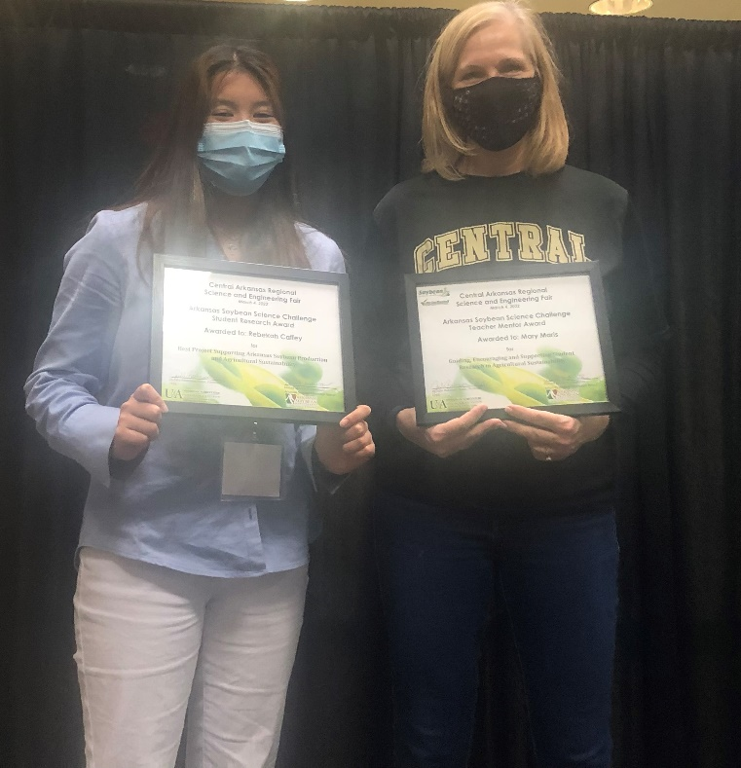
Central Arkansas Regional Science and Engineering Fair Winner Rebekah Caffey on the left and Teacher-Mentor Mary Maris on the right.

