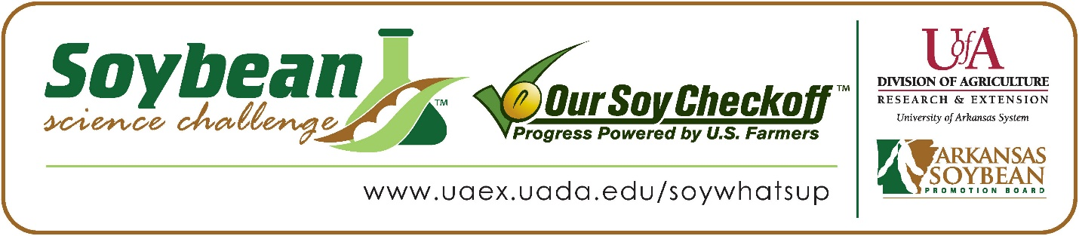
Andrew Weiss and Jake Sanders win 2026 Arkansas Soybean Science Challenge Junior Division Award at the Northeast Arkansas Regional Science Fair
Andrew Weiss, 12, and Jake Sanders, 13, 7th graders at Paragould Junior High School in Paragould, Arkansas, won the Soybean Science Challenge Junior Division award at the 2026 Northeast Arkansas Regional Science Fair held at Arkansas State University on February 27.
Weiss and Sanders split a $200 cash award provided by the Arkansas Soybean Promotion Board. Their science project was titled ‘Aqua Airflow’.
Jennifer Langston, Weiss and Sander’s teacher, won the $100 Soybean Science Challenge Junior Division Teacher-Mentor Award. Langston stated that the Soybean Science Challenge is a great way for students to learn. “Participating in the Soybean Science Challenge gives my students in Paragould an opportunity to engage in meaningful real-world science that directly connects to our local community and economy. Northeast Arkansas, including Greene County, is a major producer of soybeans, and learning about a crop that is grown right here makes The Challenge immediately relevant and authentic for students. Through The Soybean Science Challenge, students apply science concepts and experimental design in a hands-on way rather than learning them in isolation. They practice thinking and working like scientists by asking questions, designing investigations, collecting and analyzing data, and communicating their findings,” she replied.
Weiss and Sanders were thrilled to win the 2026 Junior Division Soybean Science Challenge. “I am thankful for the opportunity to participate,” Sanders said. Weiss commented that he was grateful that he and his partner were chosen. “I am very grateful and glad you chose me and my partner,” he replied.
Mr. and Mrs. Miller, Andrew’s grandparents, were proud to see Andrew receive the award. “We were overwhelmed but not overly surprised. Andrew has the ability to go way above expectations. To say we are proud is an understatement,” they responded. Thomas Sanders, Jake’s father, agreed. “I am very proud of my son Jake’s accomplishment,” he stated.

Weiss and Sanders found learning about soybeans and agriculture through the online course to be useful. “I gained more knowledge about soybean development” explained Jake. Andrew was impressed with the myriad of uses soybeans can be used for. “I enjoyed learning about the many uses of soybeans in the world,” he stated.
Langston feels that the Soybean Science Challenge is a great program for students. “In addition to strengthening their understanding of science standards, The Challenge builds critical skills such as problem solving, collaboration, and scientific reasoning. Most importantly it helps students see how science connects to real-world problems, local careers in agriculture, sustainable farming practices, and increased engagement and interest in STEM pathways that are meaningful to their lives and community,” she replied.

“The Soybean Science Challenge provides an opportunity for Arkansas junior high and high school students to participate in scientific research that can impact the State of Arkansas as well as the world. Soybean Science Challenge student researchers learn about this important commodity crop and its many uses including feeding the world, development of biofuels and sustainable products. The Soybean Science Challenge helps students develop an understanding of the challenges and complexities of modern farming,” said Dr. Julie Robinson, Professor, and director of the program.

“The goal of the Arkansas Soybean Science Challenge is to engage students in “real- world” education to support soybean production and agricultural sustainability,” said Gary Sitzer, a former member of the Arkansas Soybean Promotion Board. “The program also rewards scientific inquiry and discovery that supports the Arkansas soybean industry.”
The Arkansas Soybean Science Challenge was launched in January 2014 to 9-12th grade science students and in 2021, added grades 6-8 for the junior level award. Students who successfully completed the online course were eligible to have their original soybean-related research projects judged at the 2026 ISEF-affiliated Arkansas Science and Engineering Fairs.
Information on the 2026-2027 Arkansas Soybean Science Challenge will be available in summer 2026. For more information, contact Dr. Julie Robinson at jrobinson@uada.edu or Diedre Young at dyoung@uada.edu, or Keith Harris at krharris@uada.edu.
The Cooperative Extension Service is part of the University of Arkansas Division of Agriculture.
Andrew Weiss and Jake Sanders, Paragould Junior High School, Paragould, AR. Teacher: Jennifer Langston
Category: Plant Science
Title: Aqua Airflow
Abstract
The purpose of this experiment is to see how the speed of the fan will affect the number of rotations the fan spins. If The speed of the fan changes, then the wind powered water lift should spin faster, because the fan is set to the highest settings. Obtain a completed K'nex wind powered lift, put a piece of tape on the end of a blade then face the fan at a 90-degree angle, get a timer, turn the fan to the third speed level and count the rotations per minute, start your timer for 1 minute, repeat this process 2 more times. Next turn the fan to the first speed and count the rotations per minute after you start the 1-minute timer repeat 2 more times. The wind powered water lift has been around for many centuries. They were simple, well-constructed, and dependable. At first, they were mostly wood, but metal varieties became increasingly common. Almost every farm had one. Some people, unable to afford a professional windmill, fashioned their own using manufactured versions as models. The historian T. Lindsey Baker writes that "the first commercially successful self-governing [or self-regulating] American windmill" was developed in New England in the mid-1850s, by a salesman named John Burnham and a machinist named Daniel Halladay. In conclusion, our hypothesis, If the speed of the fan changes, then the wind powered water lift should spin faster, because the fan is set to the highest setting supported, the highest setting had more rotations per minute.
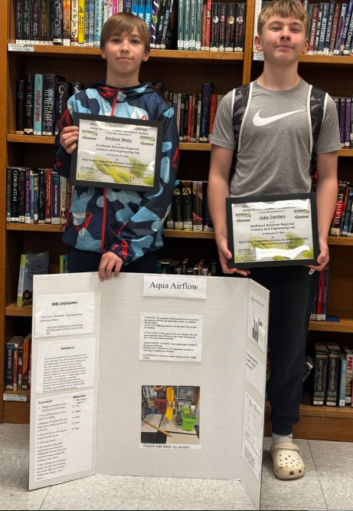

Soybean Science Challenge Junior Division Team Winners Andew Weiss and Jake Sanders and Teacher-Mentor Jennifer Langston

