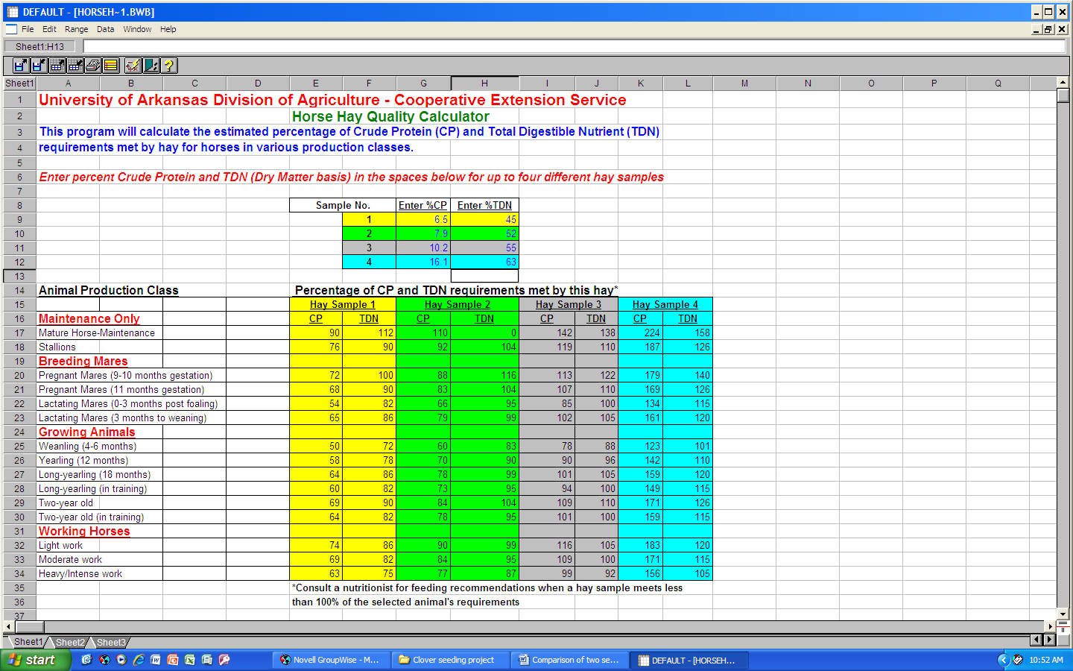

***Enter the crude protein and TDN values from up to four hay tests in this block. Use the Dry Matter test values.***

***Estimated percent of animal requirement will be shown here for each hay sample entered***