Yes! Please send me more information about the Extension Homemakers program,
I am interested in.
_______ Joining an Extension Homemakers Club
_______ Forming an Extension Homemakers Club
_______ Becoming an E.H. member-at-large

Name ______________________________________ Phone ________________

Address __________________________________________________________

City _____________________________________________ Zip _____________

Extension Homemaker Clubs

In Pope County

Crow Mountain
Meeting time: 2nd Tuesday
1:00 p.m.
Contact person:
Ida Ruth Jones 968-4277
Dover
Meeting time: 3rd Monday
1:00 p.m.
Contact person:
Lena Lay 331-2472

Economy
Meeting time: 3rd Friday
1:30 p.m.
Contact person:
Ruth Teal 641-7639
London
Meeting time: 2nd Tuesday
1:00 p.m.
Contact person:
Judy May 293-3278

Sunnyfield
Meeting time:1st Tuesday
1:00 p.m.
Contact person:
Glenda Anderson 967-4390

There are currently five clubs with about 50 members in Pope County.

We invite you to join in that number by joining an existing club or getting a new group started in your area! Send in the attached form indicating your interest or,

For more information contact:
Pope County Extension Service
105 West “B” St.
Russellville AR 72801
Phone: (479) 968-7098
OR
Darla Watts
E. H. Council President
223-9209

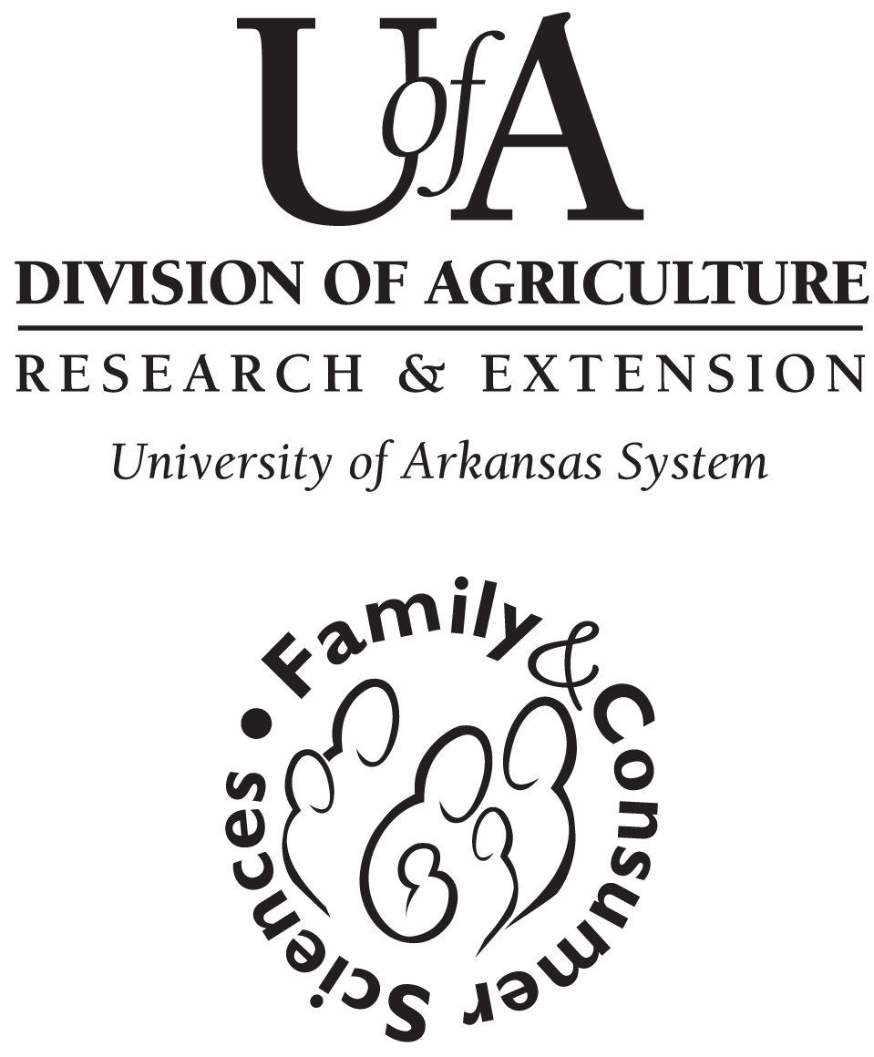

Pope County

Extension
Homemakers
Clubs

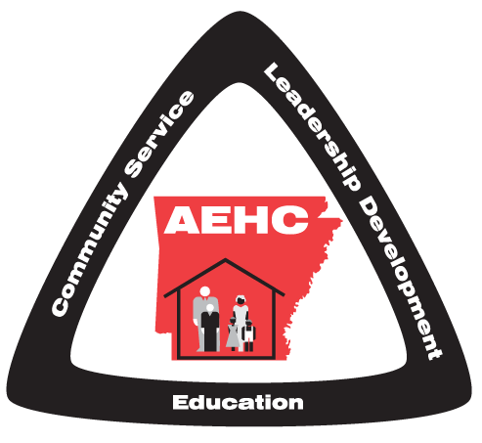

"The Arkansas Cooperative Extension Service offers its programs to all eligible persons regardless of race, color, sex, gender identity, sexual orientation, national origin, religion, age, disability, marital or veteran status, genetic information, or any other legally protected status, and is an Affirmative Action/Equal Opportunity Employer."

What are Extension

Homemaker Clubs?

An EH Club is a group of people who meet regularly and learn together. The subjects for the meetings are determined by what the members want to know. Each month, designed leaders from each club attend a leader training meeting conducted by the county Extension agent – Family and Consumer Sciences, who is a faculty member of the University of Arkansas Service. Some-times, other resource people assist or conduct the training. The leaders then teach the lesson to the other club members at their regular club meetings.

Clubs have elected officers and education chairmen. Many clubs have community service projects. Membership-at-Large is available to persons who do not have a club in their neighborhood or are unable to meet because of scheduling conflicts. A member-at-Large may participate in county, district, state, and national educational activities.

Who are EHC members?

We have people just like you! We work in Pope County. Shop in the same stores, and sit next to you at church and at ball games. We like to learn everything from A to Z to better ourselves, family, neighbors and our community. We are young homemakers, working moms, grand-mothers and retired men and women.

How much does it cost?

Almost nothing! Your major invest-ment can be your time in learning and sharing information. There is a yearly membership fee. You can attend out-of-town meetings; this is your decision.

Who can join?

ANYONE – This program is open to all eligible persons regardless of race, color, national origin, religion, gender, age, disability, martial or veteran status, or any other legally protected status.

What Do We Have to Offer?

Education
You get the latest information on what’s new for your home and family in the following areas.
- Family Resource Management
- Nutrition, Health and Wellness
- Family & Human Development
- Leadership Development
- Special Community Projects
- Membership/Public Relations

Leadership Development

Extension Homemakers Club members develop skills by partici-pating in a wide variety of club, county, district and state activities.
Place
StampHere

Pope County Cooperative Extension Service
105 West “B” Street
Russellville, AR 72801
Place
Stamp
Here

Pope County Cooperative Extension Service
105 West “B” Street
Russellville, “AR 72801

Community Service

As an Extension Homemaker Club member, you help identify and plan community projects that will benefit local individuals and families such as:

Pillows for breast cancer patients
Blankets for Baby Safety Shower
Knitted caps for AR Childrens Hospital
Baby blankets for UAMS
and lots of other county projects and individual com-munity service projects from each club.

What are we doing this year?
Monthly Leader Training

*Seasonal Color Analysis
*Slow Cooker Cooking
*Nutrition Myths & Food Trends

A newsletter keeps all members posted on upcoming activities.

