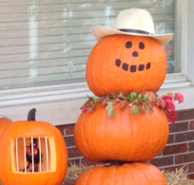

◆ Pumpkins: More Than Just Decoration
◆ Halloween Costumes, Treats and Entertaining
◆ Spooktacular Recipes with Pumpkins
Issue 1
October 2015
Volume
24



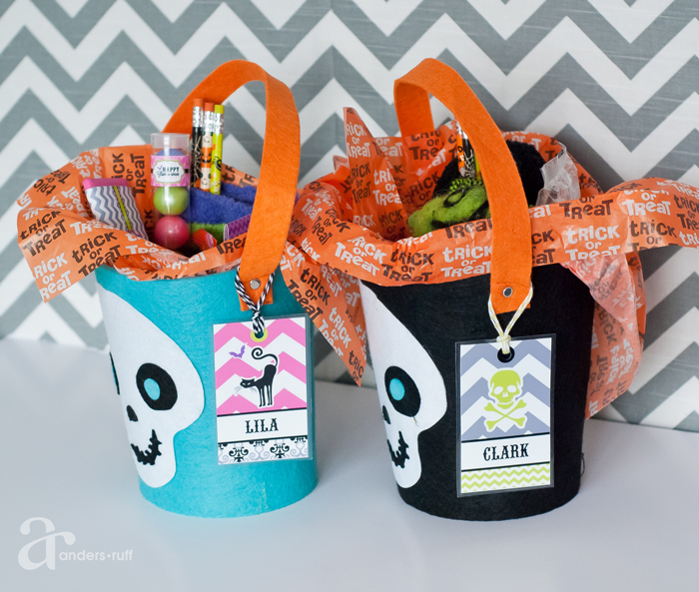


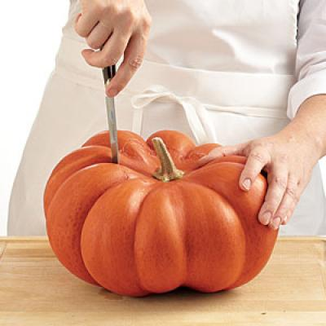
Make Your Halloween

SPOOKTACULAR

Pumpkins: More Than Just For Decorations
Fall has arrived and everywhere you look, pumpkins are decorating lawns and entryways. While the most popular use of pumpkins is for decorations, did you know that pumpkins are wonderful for cooking and are a nutritional powerhouse.
Not only do pumpkins provide us with fall decorations, they also give us an alternative to the usual winter vegetables. Did you know that one serving of pumpkin supplies enough vitamin A for the entire day? It also contains potassium, folate, and calcium. Since the vegetable has a water content of 90%, it is low in calories, with only 38 calories per serving.
When choosing your pumpkin for cooking, choose small, immature pumpkins. They provide the best flavor. Smaller pumpkins are more tender and less stringy. Choose pumpkins between 5-8 pounds.
Also, look for a pumpkin with 1-2 inches of stem left. If the stem is too low, it will decay quickly. Also, avoid those with blemishes or soft spots.
To determine the size pumpkin needed, keep in mind that one pound raw, untrimmed pumpkin will equal one cup finished pumpkin purée. (For instance, a 10-pound pumpkin will yield roughly 10 cups of pumpkin purée.)
pumpkin pulp. If your pulp begins to turn dark during the cooking stage, this is normal. Just use it within 36 hours. Pumpkin freezes well if you plan to use it later.
University of Arkansas, United States Department of Agriculture and County Governments Cooperating
The Arkansas Cooperative Extension Service is an equal opportunity/equal access/affirmative action institution. If you require a reasonable accommodation to participate or need materials in another format, please contact your County Extension office as soon as possible. Dial 711 for Arkansas Relay.
Measure cooled purée into one-cup portions; place in rigid freezer containers, leaving 2-inch headspace, or pack in zip closure bags. Label, date and freeze for up to one year.
This pulp can be used in making pumpkin pie, breads, muffins and even soups. Use the same amount in any recipe calling for solid pack canned pumpkin.
making purée. If you’ve ever made purée from any other squash, you can follow the same process.
Select a ripe and firm, mid-size pumpkin. Cut it open and remove the seeds and fibrous strings. Line a large baking pan with aluminum foil (for easy clean-up). Place pumpkin pieces onto baking pan. Bake in oven at 375°F for 1 to 1 ½ hours, until pulp is soft. Remove pulp from rind with a spoon and discard rind. Blend the pulp until smooth in a blender, food processor or mixer. (For thicker purée, put pulp into cheesecloth and squeeze out excess water.)
roasted pumpkin seeds. Don’t throw the seeds away when carving your jack-o-lantern. Try roasting them as a snack. Simply wash the seeds and spread them in a single layer on a cookie sheet to dry. Roast at 375°F for 20-30 minutes or until they are dry. Then dot with margarine and brown for 5-10 minutes. Stir often until toasted. Sprinkle with salt and any other seasoning you like; cool and serve.
Effortless, Frugal Halloween costumes
We are days away from October 31st and you have yet to find a costume; you are also unwilling to splurge on a one-day event. Don’t worry! We have you covered.

Here are a few last minute ideas that are frugal and will help you keep your money in your wallet.

horror doll. Inspired by Halloween 2, all that is needed for this costume is a long white nightgown. Pull your hair into two pony tails and draw red or pink lips. Then use black liner for your eyes to finish the look.

hippie. Search your parent’s closet for the perfect pieces. See if they have bell bottoms, a tie-dye shirt and a head band.
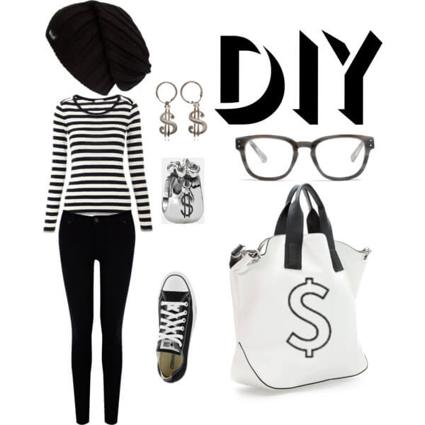
nerd. Grab a few books, a pair of glasses and suspenders. Apply white tape to the bridge of your glasses and push them higher off your nose often.
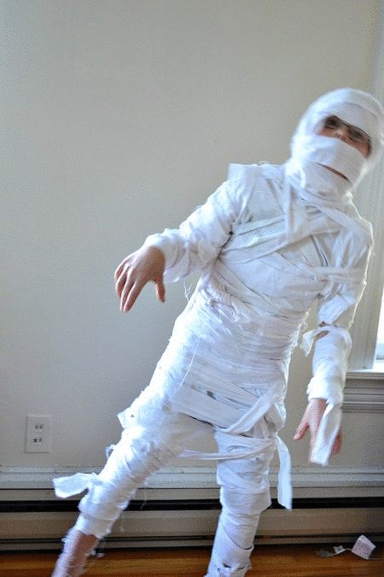
thief. This costume requires a ski mask, black gloves and black attire. Include a laundry bag full of cloths and draw a dollar sign on it to complete the costume.
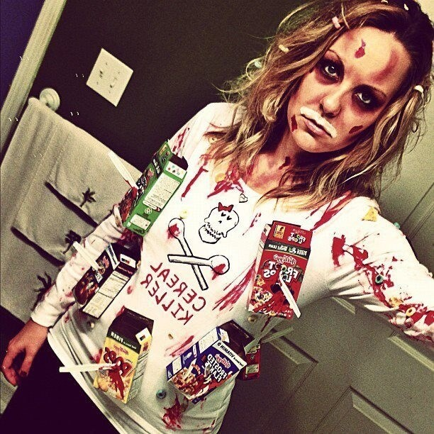
mummy. A good mummy costume can be completed with one roll of toilet paper. Start with an outfit of white clothing and begin to wrap toilet paper around different sections of your body. Complete the outfit with makeup and a distant look on your face.
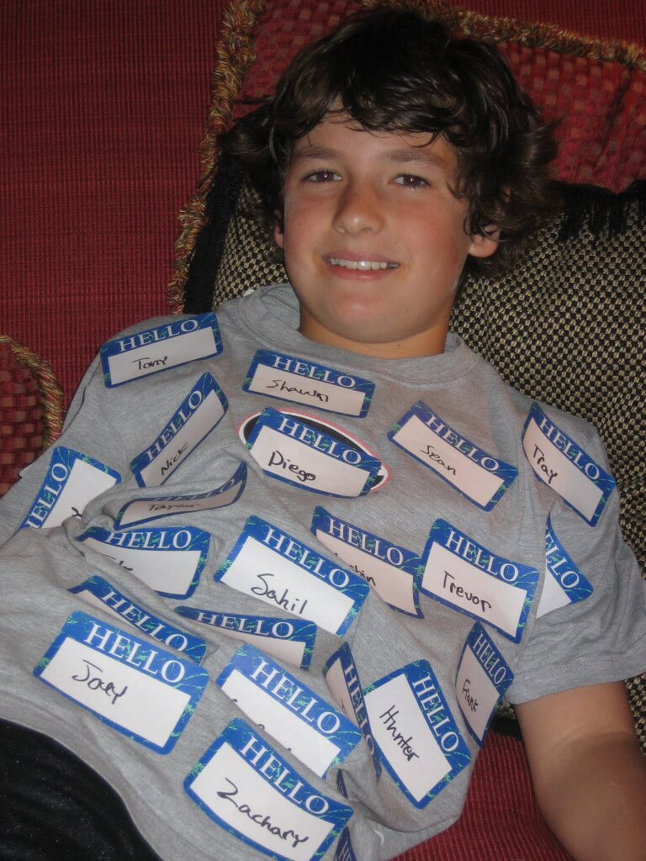
cereal killer. Almost done with that box of cereal? Good, because you’re going to need it. All that is needed is an empty box of cereal and a cardboard knife. Wrap the knife in gray duct tape to simulate a silver knife. Pierce the box of cereal with the knife and tape into place. Then draw red blood on the box.
Identity Thief. For this costume, you need a package of name tags. Write a different name on each tag and tape them to your body. You now have the identity of each of those people. You are an identity thief.
Making the Treats Less Tricky
Tired of handing out the same boring candy every year? Rather than heading out to the store to buy a big bag of candy, why not look at alternative treats that you can give out, serve to your goblins at home, or take to parties that are healthier and fun.
- fruit snacks. While most nutritionists would recommend real fruit as a healthier option, since fruit snacks are still sugary and bad for a child’s teeth, they are healthier than taffy or many other candies. Be sure to read the label at the store and choose the fruit snacks with high vitamin C content.
- pumpkin seeds. While not your typical treat, pumpkin seeds are festive handouts that go well with Halloween. Pumpkin seeds are rich in zinc, iron and magnesium. They are also a significant source for protein and can provide trick-or-treaters with a snack that is fun to munch on as they go door-to-door.
- dark chocolate covered raisins. They are slightly healthier than their regular counterparts with less fat content, while still offering the benefits of antioxidants and flavonols.
- string cheese. Kids love string cheese because it’s tasty and fun to pull, twist and eat, while parents love it because it is rich in calcium. Another health benefit is its protein content. Try to find nonfat or low-fat versions.
- cereal bars. Look for whole grain varieties and avoid heavily sweetened bars. Avoid those processed around nuts (allergies).
- non-food treats. Children will also enjoy non-food treats, small toys and pocket-sized games
° glow sticks
°plastic rings, necklaces & bracelets
°funny halloween glasses or false teeth
°pencils/pencil toppers with fancy erasers
°stickers, including reflective safety
°rub-on or stick-on temporary tattoos
°crayons/coloring tablet/coloring book
°bubbles, whistles, bouncy balls, etc.
°coupons from a yogurt/ice cream store
- Halloween Party Popcorn. Combine popcorn with your choice of the following ingredients. By mixing candy with popcorn, you cut back on the total amount of candy offered. Serve with a scoop from a large bowl. Or, fill a self-closing sandwich bag with popcorn mixture for each child.
°raisins and other dried fruit
°candy corn
°nuts (watch for allergies)
°gummy worms
°orange/black candies or jelly beans
- Bony Fingers. Pour popcorn into clear plastic gloves (the type you wear in the kitchen when preparing food). Tie the ends of gloves with orange and black ribbon.
Select a theme and focus more on fun and less on food. Get the family up and moving to use the calories they have consumed. Activities could include dunking for apples, walking through a haunted house, going on a hayride, decorating pumpkins….
While trick-or-treating is a great time to show off your cool costume and earn some serious candy, consider budget-friendly alternatives for items you’ll only use for a couple of hours – like your treat bags. Be creative and dye an old pillow case or decorate it to match your costume.
Halloween Entertaining
Why not host a Halloween party? Entertaining is a great way to bring family and friends together to have fun and celebrate an occasion. Throwing a party doesn’t mean you have to spend a ton of money.
decorations: To capture the true spirit of Halloween, you want your house to feel spooky. Cover your couches in old white linens and splatter them with red paint or food color. Cover your glass and wood tables with black tablecloths. Other ideas might include draping spider webs from the ceiling fan to each wall, turn your pictures so they are crooked or falling down, put red tissue paper over the top of the globes of some lights for an eerie effect, and use tiny tea lights and candles all over the room.
food: Put tags to identify the food using a spooky font. Use names like Slimy Hands, Witches Brew, Monster Toes, Deviled Eyeballs, Spooky Spiders, etc.
Some ideas:
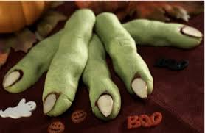

Slimy Hands: Green gelatin poured into vinyl gloves. Chill until set. Peel off gloves and lay on tray. (A finger or two may need to be pieced back on but that just adds to the effect.)
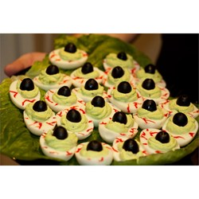
Witches Brew with Worms: Combine 1 gallon softened orange sherbet and 1 quart chilled pineapple juice in a punch bowl; stir well. Add 1 liter chilled lemon-lime soda; stir until sherbet is almost dissolved. Decorate bowl with gummy worms.
Deviled Eyeballs: Boil 12 eggs in large pot until done. Rinse under cold water & let the eggs cool completely. Peel and slice in half lengthwise. Remove yolks from eggs and place in bowl. Mix in 1 Tbsp. sweet pickle relish, 1 Tbsp. mayonnaise, 1 pinch celery salt, 1 Tbsp. prepared yellow mustard, and 2 drops green food coloring, or as needed. Spoon this filling into the egg whites and place on a serving tray. Round the top of the filling, using a spoon. Place an olive slice on each yolk to create the center of the eye. Dab a tiny bit of mayonnaise in the center of the olive as a finishing touch.

Monster Toes: Heat oven to 350°F. Cut a wedge into the end of each cocktail wiener to make a flat toenail. Cut 6-8 flour tortillas into strips about 4-inches long and ½ inch wide. Discard the ends. Soften the strips in the microwave between damp paper towels for 10-30 seconds. Roll each wiener in a tortilla strip around one end and secure with a toothpick. Place on cookie sheet. Bake 7-8 minutes. Remove from oven, then fill the toenail with ketchup or mustard. Remove toothpicks before serving.
Spooky Spiders: Squirt 10 crackers evenly with about ½ tablespoon cheese spread; top each
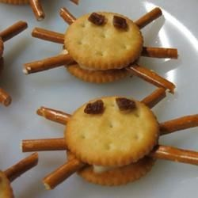
cracker with another to make sandwiches. Poke 6 pretzel sticks into the cheese, 3 on each side, to make 6 legs. Squirt two dots of cheese onto the top of the sandwich, and stick 2 raisin eyes on each snack.
Spooktacular Recipes
Try some of the following recipes using pumpkin purée for your Halloween celebration this year.
Pumpkin Roll
3 eggs
1 cup sugar
1 cup chopped nuts
½ cup pumpkin purée
½ tablespoon lemon juice
¾ cup flour
2 teaspoons cinnamon
1 teaspoon baking powder
1 teaspoon ginger
½ teaspoon nutmeg
½ teaspoon salt
4 tablespoons margarine
6 ounces light cream cheese
½ teaspoon vanilla extract
1 cup powdered sugar
Cream eggs and sugar; beat 5 minutes. Add next 9 ingredients; mix well. Grease and flour a 15x10-inch jelly roll pan. Pour ingredients in pan. Bake in 350°F oven for 20 minutes or until toothpick inserted in center comes out clean. Sprinkle powdered sugar on towel; place baked cake on towel. Place in refrigerator until cool. Once cooled, remove from refrigerator and spread remaining four ingredients over cake; roll up. Sprinkle with additional powdered sugar if desired. Chill until serving time.
Light Pumpkin Pie
This pumpkin pie saves 151 calories and 12 grams of fat per slice from the traditional version and tastes identical!
1 cup ginger snaps
1 (16 ounce) can pumpkin
½ cup egg whites (about 4)
½ cup sugar
2 tablespoons pumpkin pie spice
1 (12 ounce) can evaporated skim milk
1 small container fat-free whipped topping (optional)
Preheat the oven to 350 degrees F. Grind the cookies in a food processor. Lightly spray a 9-inch glass pie pan with vegetable cooking spray. Pat the cookie crumbs into the pan evenly. Mix the rest of the ingredients in a medium-sized mixing bowl. Pour into the crust and bake until knife inserted in center comes out clean, about 45 minutes. Store in the refrigerator. Allow to cool. Slice in 8 wedges. Optional: Serve each wedge with fat-free whipped cream.
Nutrients per serving: Each Slice: Calories: 165; Sodium: 70 milligrams; Carbohydrate: 32 grams; Dietary Fiber: 2 grams; Protein: 6 gram; Fat: 1.5 grams; Cholesterol: 1.5 milligrams.

Pumpkin Pie Pudding
1 (3.4 ounce) package instant vanilla pudding mix
1 (12 fluid ounce) can evaporated milk (2% or skim)
1 (15 ounce) can 100% pure pumpkin
1 tablespoon pumpkin pie spice
Beat pudding mix and evaporated milk according to package directions in large bowl; refrigerate for 5 minutes. Add pumpkin and pumpkin pie spice; mix well. Refrigerate 10 minutes or until ready to serve.
Pumpkin Pie Dip
15 ounces pumpkin purée
1 (8 ounce) container whipped topping, thawed
1 (1.5 ounce) package low-fat vanilla instant pudding mix
1 teaspoon pumpkin pie spice
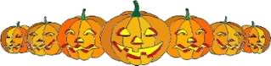
Cream together all ingredients with an electric mixer until well combined and fluffy. Chill in the fridge until ready to serve. Serve with vanilla wafer cookies or graham crackers.


If you have any questions, please feel free to call me at 870.779.3609, email Chadley@uaex.edu, or visit Room 215 in the Miller County Courthouse, 400 Laurel, Texarkana, AR.

Carla Hadley, County Extension Agent-Staff Chair/Family & Consumer Sciences
Follow me on Facebook at www.facebook.com/ Miller CountyFCS or twitter #MillerCountyFCS
CMH:jds

