THE EHC CONNECTION
Vol. 23, Issue 2 April, 2016

In This Issue

AEHC Conference 2
Ozark Retreat……………………2
Election of Club Officers………..2
Officer Installation………………2
Program Planning…………….….3
Things to Remember…………….3
Memorial………………………...3
Recipe……………………………4

Johnson County Extension Office
129 Sevier Street
P. O. Box 590
Clarksville, AR 72830
479-754-2240

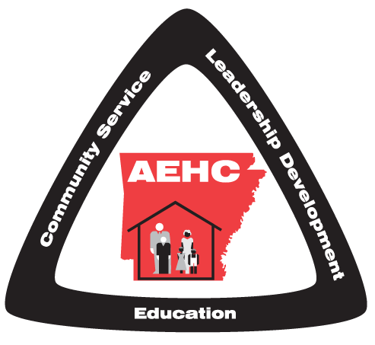

Dear EHC Member:

Spring is showing up everywhere. Please read the newsletter carefully as there is information about lots of upcoming activities.

Plans are underway for the AEHC Conference in Hot Springs. This year the Cultural Arts Contest is handmade receiving blankets which will be donated to Arkansas Children’s Hospital. Each delegate attending the State Meeting is to bring one. However, you are allowed to bring more than one.

It is time to conduct county and club election of officers. We will also have a planning meeting to prepare the county yearbook. Plan to be there!

Taylor Hastings
County Extension Agent-
Family & Consumer Science

All meetings and activities announced in this newsletter are open to eligible persons without regard to race, color, national origin, religion, gender, age disability, marital or veteran status, or any other legally protected status. Persons with disabilities who require alternative means for communication of program information (large print, audio tapes, etc.) should notify the county Extension office (or other appropriate office) as soon as possible prior to the activity..


AEHC Conference

June 7-9, 2016
Hot Springs Convention Center

AEHC-“Stepping Up for Education”

The 2016 AEHC conference should be another great one. If you plan to attend, registration ends April 29th. The Cost is $30 to register and lunches are $20. This year there will be a silent auction, game night, talent night, and Memorial Service

Things to bring:
∗ Table decorations for Tuesday and Wednesday Luncheons
*Red Shirt to support AEHC on Tuesday
*Your Talent! One entry per county due by May 15th
* Handmade receiving blankets for Arkansas Children’s Hospital-Cultural Arts exhibit contest

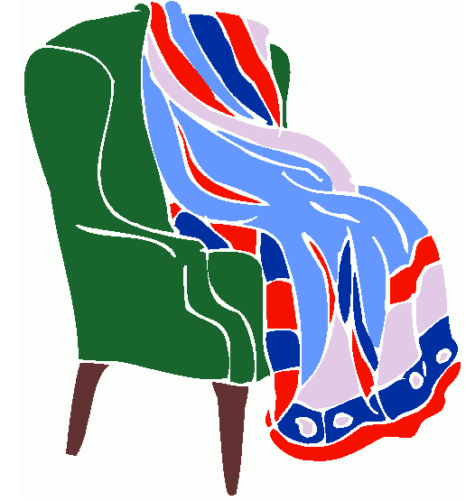
AEHC Cultural Arts: This year’s project is handmade receiving blankets for Arkansas Children’s Hospital for families whose infants have passed away. The dimensions are 36” by 36”. Colors should be pink, blue, yellow, green or white. No prints. Materials should be light weight fleece or flannel. Edges can be finished with surging or crocheting. Flannel can be hemmed.



Election of Club Officers

Clubs should hold officer elections at your March or April meetings. May 2nd EHC officer list is due to the Extension Office. New club officers will take office on July 1.

2016 Ozark Folk Center Retreat
November 2-4, 2016 will be the dates for the Ozark Retreat. Classes are designed to teach basic skills of the craft and provide exposure. The list of classes will be presented at the Extension Homemakers State convention. Please get with your presidents for more information. It’s not too early to reserve your room, save the date or deposit money. Those who have not previously registered the prices are Single: $380, Double: $310, Triple $294, and Quad $285. Those who live locally and not require lodging: $237 for meals, entertainment and workshops. Deposit of $75 due by August 14. Balance due Oct. 1.


Officer Installation

New Officer Installation will be held at 10am at the First Security Community Room Tuesday, June 28th. County Officers for 2016-2018, and all Club Presidents will be installed. Other EH Club officers will be recognized at this time. PLEASE encourage all club members to attend and support those who have accepted the responsibility of Leadership.



Program Planning

April 21st will be the Program Book Planning Day. This will be held at 2pm at the Extension Office. All are encouraged to come and bring your ideas for the next program years. Planning topics will include “Program Features”,” Helpful Hints” and “Thought for the Month.”

Things to remember:

* Tuesday, May 3, Board of Directors Meeting, 10am at the EHC office.
* June 3rd EHC dues and membership list due
* July 5th EHC financial report due
*FAIR August 22nd-27th

In Memory of Betty Oliver

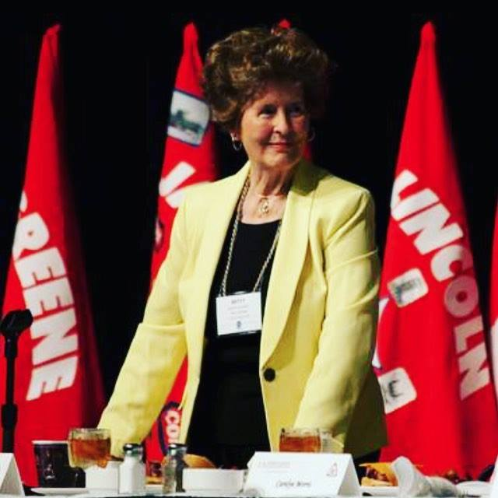

On April 8th, 2016 Mrs. Betty Oliver passed away at her home. This lady was such a gifted, beautiful and hardworking woman. She will be truly missed.
“In so many ways, Betty was the embodiment of our extension mission in Arkansas.” -Dr. Windham

For Oliver, working with AEHC was “just getting back to her roots,” -Melody Curtis

“an excellent first boss, mentor, friend and almost family member. She cared so much about all of us…. She will be sorely missed.” -Janet Carson

In 2014, she was honored by the Arkansas Gerontological Society for her volunteer services to those 65 and older. That same year, she learned that across the entire University of Arkansas System, she was the person with the longest active service. It’s a milestone she achieved when the university’s contract with longtime Athletic Director Frank Broyles expired. It’s a milestone of which she was particularly proud.

Look for recipes to bake, poach or grill fish like the Extra Special Fish Nuggets, as these cooking methods generally add less fat than frying. Use fish often in meals as it is good for your heart and brain. The crumb coating in this diabetic recipe adds flavor but little fat and sodium to the mild cod. Serve the nuggets with a lemon wedge, steamed green beans and cole slaw.

Extra Special Fish Nuggets
Nonstick spray
16 ounces firm white cod or other firm textured fish ¼ cup dry bread crumbs
1 tablespoon Dijon mustard 2 tablespoons Parmesan cheese, grated
1 teaspoon chives ¼ teaspoon paprika
Spray baking dish with nonstick spray. Rinse fish under cold water, pat dry. Cut fish into 1½-inch pieces. Place fish in bowl. Add mustard and chives, and mix lightly to coat. Combine bread crumbs, cheese and paprika in a plastic bag. Add fish and shake fillets to coat with bread crumb mixture.

Microwave instructions Arrange fish in shallow microwave-safe pie plate or baking dish. Cover with paper towel and microwave on high for 3 to 4 minutes or until fish flakes separates easily.
Conventional oven instructions Preheat oven to 450 degrees F. Arrange fish in a large shallow baking dish. Bake about 10 minutes per inch thickness of fish or until fish is opaque when flaked. Fillets may need to be turned halfway through baking.
Makes 4 servings. Nutrition information per serving: 138 calories, 2g fat, 6g carbohydrates, 22g protein, 292mg sodium.

Recipe taken from Celebrate! A Healthy You, University of Missouri Extension, Linda Rellergert, Nutrition Specialist

