2017 Competition General Rules
Updated 1/17/17
Quick links:
- Design Rules
- Disputes
- General Scoring
- Obstacle Course
- Challenge
- Engineering Notebook

On Competition Day there will be two Pool Events. The competition will comprise three classes: Middle School, High School, and Open class.

Definitions:
Middle School Stock Class
Middle School is defined as less than and including eighth (8th) grade. All students participating must be in eighth grade (including homeschool equivalent) or lower.
High School Stock Class
High School is defined as ninth through twelfth (9th-12th) grades.
Open Class
Open Class is not separated by grade.

Competition Day Rules:

Vehicle Compliance:
Each SeaPerch ROV must be presented for a compliance check during check-in on Friday night, and approved by prior to the team competing in the pool events.

Pool Access:
Only two team members are allowed on the pool deck in the competition area during an event.
All team members must wear shoes with rubber soles on the pool deck.
The 12V power system will be available for all that wish to use it. This system is designed to work with the alligator clips in the SeaPerch kit. Each lane will have its own power connection.
- The vehicle MAY NOT be dragged via the tether.
- The vehicle may be reset by the teams during the competition
- The vehicle MAY NOT be dragged via the tether.
- The ROV may be worked on by the teams during the competition

Vehicle Design Rules
Teams are encouraged to think outside the box and change the shape and configuration of their SeaPerch ROV.

Stock Class (High School and Middle School)
- Teams may utilize materials (quantity and components) equivalent to one SeaPerch kit.
- Teams have a budget of $20.00 in addition
  - It is the actual value of the modifications that must be $20 or less.
  - Donated material will be assessed at what the cost would be to procure the material.
  - The $20 limit is for cost of the materials utilized on the final competition vehicle.
  - Reasonable spare parts (one set of thrusters (3) and one controller) are not included in this budget.
  - Proof of budget compliance should be made available to the judges upon request.
- 3D printed parts will be costed out at $0.05 per gram.
- All motors must be waterproofed.
- Hooks and attachments MAY NOT be added/removed between competition rounds.
- Additional NON-stock motors may be utilized for actuation or other non-propulsion uses.
- Teams may only utilize stock SeaPerch motors for propulsion (Jameco Electronics P/N 232022).
- Teams may only utilize three (3) thrusters.
  - A thruster is defined as a means of propulsion for the SeaPerch, normally but not limited to a motor and propeller assembly.
- Teams will design for and utilize a 12-volt power source.
  - Power source other than the included kit battery or venue supplied power is not permitted.
- ROV thruster controls shall use simple switches only, no power conditioning or pulse-width modulation (PWM) controls are allowed in Stock Class. Use of a fixed or variable resistor to reduce voltage is acceptable.
- ROVs shall fit thru an 18" hoop.

Open Class
Vehicles should consist of the parts and components utilized within the SeaPerch kit to the maximum extent possible and shall be subject to the following:
- Teams have no budget limit. (Budgets should be tracked for presentation to Judges upon request)
- Hooks and attachments MAY NOT be added/removed between competition rounds.
- Teams may only utilize stock SeaPerch motors for propulsion. (Jameco Electronics P/N 232022)
- NON-stock motors may be utilized for actuation or other non-propulsion uses.
- Teams will design for and utilize a 12-volt power source. A 10-Amp Max fuse shall be used for safety. Power source other than the included kit battery or venue supplied power is not permitted.
- ROVs shall fit thru an 18" hoop.

Redress, Challenges and Disputes
Sportsmanship is expected at all times. Should a protest or dispute occur during the competition it is the intent to resolve the grievance at the time it occurs, and the ruling by the lead Judge shall be final.
A team that wishes to have an issue considered shall send the student team captain and one additional student member (2) to the lead judge for discipline in question, with the inquiry or question. The lead judge will render a decision on the issue, and this decision is final. The same issue may not be brought to the judge a second time by any member of the team. Adults may not approach the lead judge on the pool deck regarding any perceived issues.
In the event that a vehicle is inadvertently interfered with during a competition, or a malfunction of a vehicle's parts (i.e., the motor) occurs that is beyond the design and construction, the lead pool judge will have the sole authority to provide the team with time to fix their vehicle and to allow them to compete later in the round. Malfunctions will be evaluated on a case-by-case basis.
Teams may not question the legality of other competing vehicles; it is the SeaPerch Technical Director's role to determine if vehicles meet the entry and compliance requirements.
Unsportsmanlike conduct is grounds for the disqualification of a team. Team members and advisors are responsible for the conduct of all members and adults accompanying the team.
Sportsmanship is expected at all times. Should a protest or dispute occur during the competition it is the intent to resolve the grievance at the time it occurs, and the ruling by the lead Judge shall be final.

Overall and Class Scoring

Individual Events
Each event will be scored in accordance with its published rubric. Teams will then be ranked, by their score, both within their class and overall.

Combined Scores
Each team's rank in the individual events will be added together and then ranked in order to determine the overall Class winner and overall Stock winner
Here is a simplified scoring sheet used at regionals (it will need to be modified for your event):
Scoring.xls

Breaking Ties
Scoring ties will only be broken where it is required to determine trophy places. (i.e., ties will not be broken when ties do not affect the top three results in any event or class overall)
Obstacle Course ties to the 100th of a second will be broken by the faster time in the secondary run.
Challenge ties to the 100th of a second to the same point total will be broken by rerunning a portion of the course. The winner will have 1/100th of a second removed from their time, thus breaking the tie.
Class ties will be broken based upon the best performance in the following priority:
1) Challenge
2) Engineering Notebook
3) Obstacle

Competition Events

The Obstacle Course
An underwater remotely operated vehicle (ROV) must be able to maneuver successfully under its own power. If a vehicle cannot maneuver to the appropriate location to perform its task, the vehicle is of no use. Consideration of optimal maneuverability as well as control and speed should be given when constructing your SeaPerch (thruster placement and orientation, tether attachment, buoyancy and ballast, etc) and control box.
The submerged obstacle course involves large rings (18" minimum diameter), oriented in any direction, through which the vehicles must travel. Teams must navigate their ROV through the obstacle course, surface, then re-submerge and return through the course to the end.
Scores for this round will be based on the fastest time for successfully navigating the obstacle course.
There are five (5) -18" diameter hoops in the obstacle course. The course will be on the bottom of the pool with the hoops at various heights above the pool floor. Final configuration of hoop orientation and heights will not be revealed until Nationals.
Obstacle Course Rubric Obstacle Course Rules
Click the image below for course information.
Course build guide updated.
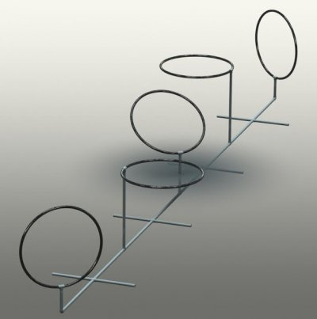

The Challenge
The 2017 Challenge was tailor-made for this year's prospective Nationals site. Due to pool glare concerns the challenge will be located closer to the competitors than in the past.
The challenge consists of an 'Origin' where 3 rings and 3 cubes will be located within a fixture. Each of these objects will need to be transported to the 'Platform' for differing amounts of points.
Scoring: Maximum number of points in the shortest amount of time. The clock stops when the team identifies they are done, surfaces and touches the wall with the vehicle. Teams may stop the clock at any time, but it will not be restarted. Teams must inform the judges at the time if they wish to stop the clock and lock in their scoring. Point scoring will be tallied upon completion. Points scored and knocked off are not counted.
Course Build Documents
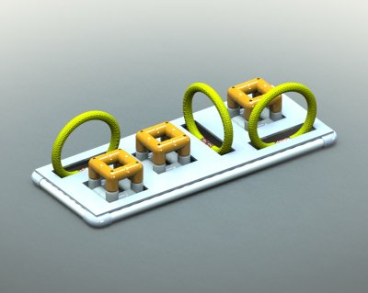

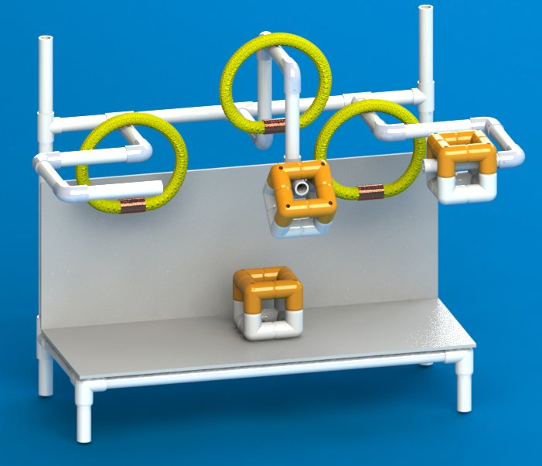

Scoring
Rings:
Rings can be placed on the platform for 1 point
Rings can be placed on the upper spikes for 2 points
Rings can be put on the Zig-Zags for the following points:
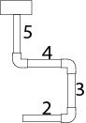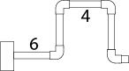
-only one ring scores per Zig-Zag (additional rings will not be scored)
-Rings on fittings score the lower of the point options
Cubes:
Cubes can be placed on the platform for 1 point (stacking gains an additional point)
Cubes can be put on the upper spikes for 2 points
Cubes hung in the Zig-Zags double the ring points (no ring no points)
RUBRICS!

The Engineering Notebook
** UPDATED 2/23/2017 **
In order to more closely align with the engineering aspects of the SeaPerch National Challenge the Engineering Notebook challenge has replaced the Poster competition.
Due to space limitations at this year's National Challenge venue, teams will not be allowed to bring posters/trifolds boards.
Using an Engineering Notebook provides a good learning experience allows students to demonstrate their understanding of engineering principles and design concepts.
The Engineering Notebook is used to measure the team’s ability to document the engineering design process used to design and modify their SeaPerch to meet the pool challenges. The Engineering Notebook is not intended to document the construction of the standard SeaPerch ROV.
Each team will submit their Engineering Notebook online as a PDF file.
Teams should use a physical notebook throughout the SeaPerch project to document the engineering design process and specific steps they take in designing and modifying the SeaPerch ROV to complete the National SeaPerch Challenge pool events. Since teams may have started the project before they knew about the Engineering Notebook Challenge, they may have to create the notebook from notes and discussions among team members. The Cover/Title page can optionally be created electronically.
The physical notebook can consist of hand sketches, photos, computer-aided design (CAD) drawings, handwritten notes, and graphs. Photos, CAD drawings, and other computer generated entries should be taped to the notebook page and labeled.
The SeaPerch Engineering Notebook will be submitted electronically as a Portable Document Format (PDF) file. The physical notebook pages can be scanned or photographed and inserted into a single PDF file. This can be accomplished using presentation or word processing software such as Google Slides, Microsoft PowerPoint, OpenOffice Impress, Apple Keynote, Google Docs, Microsoft Word, OpenOffice Writer, or any other program that is capable of saving or printing documents in the PDF format.
Required Content, Format, and Limitations:
The SeaPerch Engineering Notebook should include:
1. Front matter
A. Cover/Title Page
a) Project Title
b) Team Number and Team Name
c) Photo of final ROV
d) Date the notebook was completed
B. Team Information Page
a) School or club name
b) School district (if applicable)
c) City and State
d) Name and email address of teachers, coaches, mentors, and advisors (or team leader if the POC is a student)
e) Team member names, grade levels, and role in the project. Use first names only for students. If two or more students have the same first name, use an identifying letter following the first name.
C. Table of Contents Page
a) List page title or description and page numbers.
b) Reference citations of research such as books, articles, and website addresses.
2. Engineering Design Process
A. Provide details of each step taken in the engineering design process using the SeaPerch Challenge pool events as the project problem/goal.
B. Provide sketches, drawings, charts, and other graphics and written documentation describing solution and design concepts, design iterations, tests performed, and test results.
C. Include engineering and scientific terms and concepts to demonstrate that the team understands the challenges of constructing and operating an underwater ROV.
D. All pages should be numbered and listed in the Table of Contents.
Format and Limitations
- Must be submitted online as a Portable Document Format (PDF) file.
- PDF files must use the following naming convention: Division_SchoolName_TeamName, example: MS_Wabash_Robonuts.pdf (Divisions: OC = Open Class, HS = High School, MS = Middle School).
- Must be no more than 6MB in size.
- Must be formatted as 8-1/2” x 11” pages.
- Must be no more than 24 pages including the title, information, and table of content pages.
- The PDF file may not contain videos, animated GIFs, or other dynamic content.
Engineering Notebook Guide (Updated 02-23-2017)
Engineering Notebook Rubric (Updated 02-23-2017)

