Media Contact: Mary Hightower mhightower@uaex.edu 501-671-2126
April 17, 2017

Re-Imagining your community/region is theme of June conference

By the U of A System Division of Agriculture

Fast Facts
- The Breakthrough Solutions Conference and Art Show will show tools needed to succeed in 21st century global economy.
- Registration deadline is May 24
- Info: www.uaex.edu/breakthrough-solutions

(648 words)
LITTLE ROCK – The man whose transformative work helped Des Moines, Iowa, earn the headline “How America’s Dullest City Got Cool,” will be the keynote speaker for the 2017 Breakthrough Solutions Conference and Art Show, June 7-8 in Little Rock.

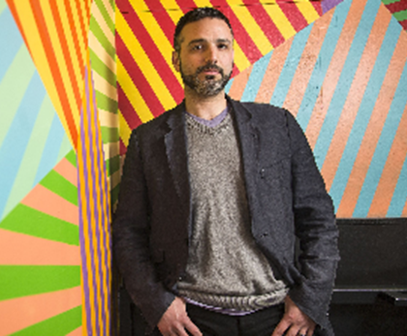

Zachary Mannheimer, the founder of the Des Moines Social Club, will be speaking June 8, at 9:15 a.m., as part of “Re-imagining Your Community/Region in the 21st Century Economy.” The conference is hosted by the Cooperative Extension Service, whose Breakthrough Solutions program is successfully transforming communities across Arkansas. Conference participants will hear and share stories community development successes and learn new tools and tactics for helping lift their own communities.

Under that provocative headline last year, “Politico” magazine wrote that over the last decade and a half, “Des Moines has transformed into one of the richest, most vibrant, and yes, hip cities in the country … Its downtown – previously desolate after 5 p.m. – has come alive, with 10,000 new residents and a bevy of nationally recognized restaurants.”

At its heart is the non-profit Des Moines Social Club, an arts and educational space in a renovated art deco firehouse that offers exhibit and working space for artists across all disciplines – a venue that draws more than 25,000 people a month.

“In a time when many people and businesses can locate anywhere, creating a high quality of place is critically important for communities and regions to remain viable and even prosperous,” said Mark Peterson, professor of economic and community development for the University of Arkansas System Division of Agriculture.

“The Des Moines Social Club uses arts to engage the community and recruit and retain young people, which has hosted more than 5,000 arts related events and seen more than 1 million patrons since its opening in 2014,” he said.

Mannheimer now focuses on rural areas, helping them create amenities that people are seeking to grow vibrant communities. He will be sharing the tactics and successes in his talk: “’Creative Placemaking – Economic Development for the Next Generation.”

Through the conference’s two days, workshops will zoom in on eight critical issues:
- Developing Broadband Infrastructure for Your Area,
- 21st Century Creative Placemaking,
- Micro-Manufacturing,
- Creating Extraordinary Tourism Experiences,
- Engaging Your Community for Maximum Impact,
- Reinventing a Festival, a Leadership Program, and an RFP Response,
- Robots, Technology, and Innovation – Threats and Opportunities for Our Jobs and Workforce, and
- They Won’t Come If They Don’t Have a Place to Live - Housing for Your Workforce.

Participants will also hear the metamorphosis taking place in six Arkansas communities during the high-energy ignite sessions.

June 7 pre-conference workshops
To kickstart the conference two half-day pre-conference workshops will be held on June 7 to address two critical community economic development issues, both of which can help your community be successful in the 21st century economy:

- “Re-Imagining Your Community in the 21st Century Economy – Step by Step” will provide a practical, hands-on approach to re-imagining your community, five critical elements of a 21st century community, a hands-on exercise with a powerful tool, two compelling community examples, and funding options.

- “Developing Cultural Competence – Becoming an Effective Leader Across Cultures and Boundaries” will provide insights and valuable tools to understand cultures and foster practices and policies that will enable you to move forward together in your community or region. This is critical because many 21st century communities have multiple cultures, and the most successful communities are those who have the ability to engage and involve citizens from across the spectrum of the community.

Finally, the First Annual Breakthrough Solutions Art Show will take place on the day of the conference, providing an opportunity for citizens and leaders to express and describe how they would re-imagine / envision their community or region in the next 10 years. The Breakthrough Solutions Partners invite you to join us for a great learning experience as we learn how to create vibrant 21st century communities and regions.

The early bird registration deadline is May 24, so act now. More information on these events is available at www.uaex.edu/breakthrough-solutions. Contact
Kaitlyn Baker kbaker@uaex.edu, 501-671-2072 if you have questions.

The University of Arkansas System Division of Agriculture offers all its Extension and Research programs and services without regard to race, color, sex, gender identity, sexual orientation, national origin, religion, age, disability, marital or veteran status, genetic information, or any other legally protected status, and is an Affirmative Action/Equal Opportunity Employer.

# # #

