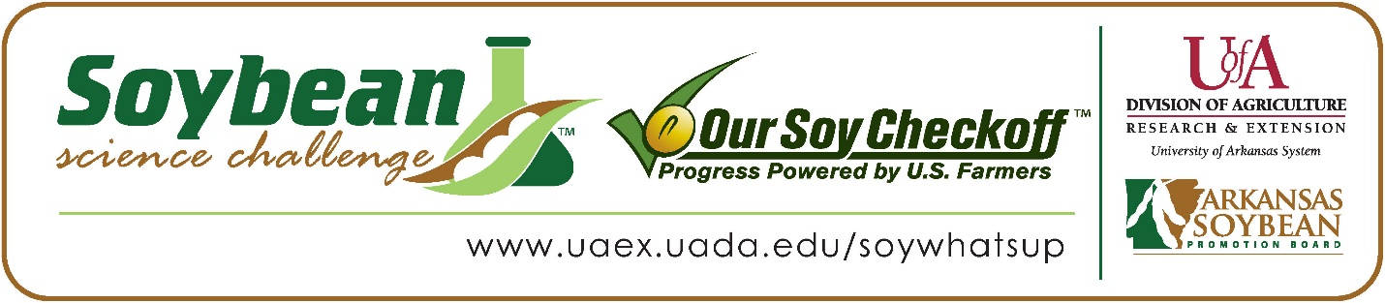

Zane Morris wins 2024 Arkansas Soybean Science Challenge Award at the Junior Division Ouachita Mountain Regional Science and Engineering Fair
Zane Morris, age 16, an eighth grader at Genoa Central Junior High School in Texarkana, Arkansas, won the Soybean Science Challenge at the 2024 Junior Division Ouachita Mountain Regional Science and Engineering Fair held in Hot Springs, March 13.
Morris received a $200 cash award provided by the Arkansas Soybean Promotion Board. His science project titled “Best brown for beans” also placed first in Earth and Environmental Science.
Rita Martin, Zane’s teacher, won the $100 Soybean Science Challenge Junior Division Teacher-Mentor Award. Martin noted she immediately noticed the value of the Soybean Science Challenge. “I decided to have my student participate in the Soybean Science Challenge after I had helped a 9th grade student with her registration who had grown soybeans. Mrs. Young informed me that other agricultural projects were also eligible, so I encouraged Zane Morris, my 8th grade student, to get involved with the course requirements. I really appreciate the monetary award that goes with this program because it allows students to see that their hard work can have tangible results. The more other students see that the hard work of their peers on their science projects pays off, the more likely they are to choose an agricultural project, and more specifically soybeans for their project next year,” she replied.
Zane said winning the 2024 Soybean Science Challenge was a great moment for him. “I was very proud and excited to win the Soybean Science Challenge,” he said.
Clai and Lacy Morris, Zane’s parents, were extremely proud of his award. “We were very proud to see his interest in Arkansas agriculture, witness him do the extra work, and in the end see him awarded for his efforts,” they replied.
The part of the Soybean Science Challenge course that appealed most to Zane was learning about farmers themselves. “One of the most interesting things I learned in this course was listening to the farmers talk about their everyday challenges and experiences,” he explained.
Rita Martin shared what she learned through her student taking the SSC online course. “I have gained a lot of knowledge about the production of soybeans in Arkansas and about the nutritional value of adding it to my diet. “My student also learned, other than the outcome of his project, an important life skill in having to complete the video course about soybeans. Being able to watch the presentations and gain the knowledge to pass the tests in a timely fashion is a great skill, and I appreciate the fact that this is a requirement for the competition,” she replied.
“The Soybean Science Challenge provides an opportunity for Arkansas junior high and high school students to participate in scientific research that can impact the State of Arkansas as well as the world. Soybean Science Challenge student researchers learn about this important commodity crop and its many uses including feeding the world, development of biofuels and sustainable products. The Soybean Science Challenge helps students develop an understanding of the challenges and complexities of modern farming,” said Dr. Julie Robinson, Associate Professor, and director of the program.
“The goal of the Arkansas Soybean Science Challenge is to engage students in “real- world” education to support soybean production and agricultural sustainability,” said Gary Sitzer, a former member of the Arkansas Soybean Promotion Board. “The program also rewards scientific inquiry and discovery that supports the Arkansas Soybean Industry.”
The Arkansas Soybean Science Challenge was launched in January 2014 to 9-12th grade science students. Students who successfully completed the online course were eligible to have their original soybean-related research projects judged at the 2024 ISEF-affiliated Arkansas Science and Engineering Fairs.
Information on the 2024-2025 Arkansas Soybean Science Challenge will be available in summer 2024. For more information, contact Dr. Julie Robinson at jrobinson@uada.edu, Diedre Young at dyoung@uada.edu or Keith Harris at kharris@uada.edu.
The Cooperative Extension Service is part of the University of Arkansas System Division of Agriculture.

Zane Morris, Genoa Central Junior High School, Texarkana, Arkansas; Teacher, Rita Martin
Category: Earth and Environmental Science
Project Title: Best brown for beans
Abstract: In my experiment, I was investigating what animal manure was the best fertilizer for bean plants. I live by farm fields, and we constantly drive by the fields and see the farmers planting, cultivating, fertilizing, or harvesting their crops. I believe that my project's results could be useful for farmers. My results could show them what manure is the best fertilizer. This information could help their crops grow taller, faster, and healthier. For my procedure, I first planted the seeds and watered them. I watered them with 7 squirts of water every day. Once the seeds had germinated and were growing, I applied the manure tea. Each plant was assigned a specific manure. I experimented with pig, horse, cow, chicken, and rabbit manure. One cup was left as a control. I predicted the rabbit manure plant would grow the tallest. I then measured their heights. I continued to apply the manure tea and measured their heights every 3 days.

After I had collected several measurements, I subtracted the first measurement from the last measurement to find the total growth. My results showed that the pig manure was the best fertilizer, with a total growth of 8 inches. This proves my hypothesis wrong. Even though my hypothesis was incorrect, I still completed my objective, which was to find the best manure for bean plants.

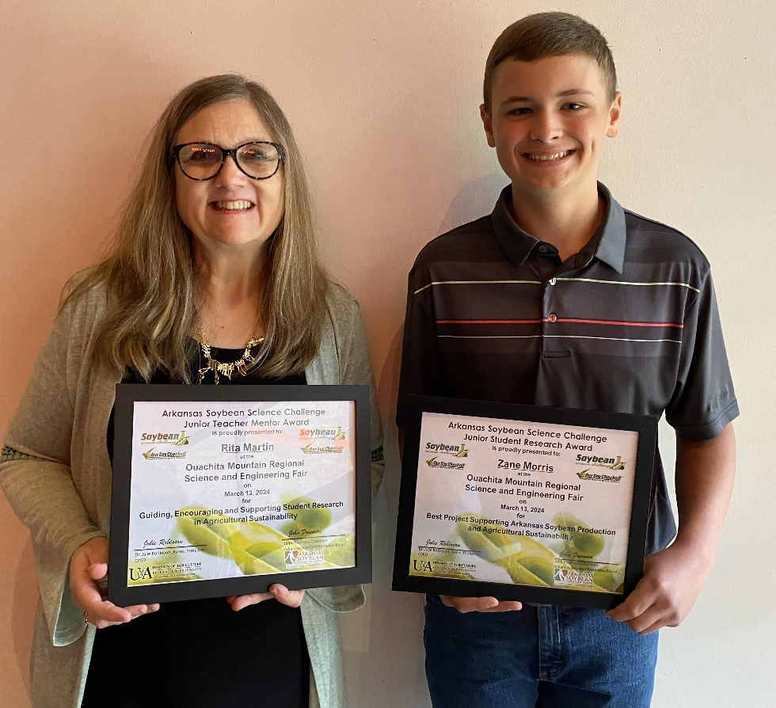
2024 Ouachita Mountain Regional Science and Engineering Fair Junior Division Soybean Science Challenge Winner Zane Morris and Teacher-Mentor Rita Martin

