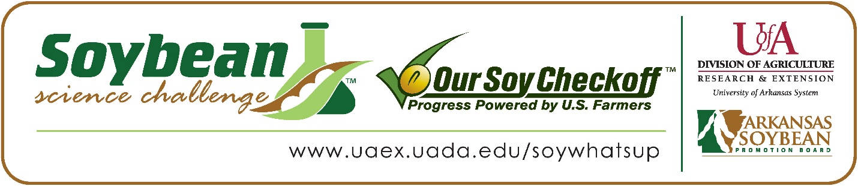

Jana Abuelem wins 2024 Arkansas Soybean Science Challenge Second Place Award at Arkansas State Science and Engineering Fair
Jana Abuelem, 15, a junior at Pulaski Academy won the 2024 Soybean Science Challenge Second Place Award at the Arkansas State Science and Engineering Fair at Central Arkansas University-Conway March 30.
Jana received a $500 cash award for her SSC Second Place finish at State. Awards were provided by the Arkansas Soybean Promotion Board. Her science project titled “Effects of caffeine on Glycine max proteogenomics” also won the Arkansas Energy and Environmental Quest Award and is an ISEF Finalist.

Katie Parsons, Jana’s teacher, won the $200 State Soybean Science Challenge Second Place Teacher-Mentor Award. Parsons stated that the Soybean Science Challenge is a great way to learn about this important crop. “Soybeans are a critical crop not just for the State of Arkansas but for the United States. The support students receive from the Soybean Science Challenge helps them not only to learn how to ask and answer scientific questions, but also how to use science to help those who rely on soybeans as their crop and income. Applying what we have learned through research is a key part of the scientific method,” she explained.
Jana said it wonderful to receive Second Place in the State Soybean Science Challenge. “I am extremely grateful that the judges appreciated this project’s idea and the efforts invested in this project by my principal investigator and teacher. This award motivates me to take my research to the next level – finding the specific caffeine concentration that benefits soybean seeds,” she replied.
Shireen Khalaf, Jana’s mother, was very proud to see her receive the award. "When they announced that Jana had won the Second-Place state award, I was delighted that her hard work was recognized, and I said to her, “Congratulations! Your hard work paid off,” she stated.
Jana expounded on how she prepared for the Soybean Science Challenge. “For the State Science Fair, I had strengthened my presentation from Regional Science Fair to show more confidence in the study’s analyses and conclusions. Additionally, I focused slightly more on the greater implications of my study, tying it into suggestions for the use of caffeine (through leftover coffee grounds) in soybean production. This consideration better prepared me for questions from the Soybean Science Challenge judges, especially since I had also participated in the Regional Soybean Science Challenge,” she replied.
“The Soybean Science Challenge provides an opportunity for Arkansas junior high and high school students to participate in scientific research that can impact the State of Arkansas as well as the world. Soybean Science Challenge student researchers learn about this important commodity crop and its many uses including feeding the world, development of biofuels and sustainable products. The Soybean Science Challenge helps students develop an understanding of the challenges and complexities of modern farming,” said Dr. Julie Robinson, Professor, and director of the program.
“The goal of the Arkansas Soybean Science Challenge is to engage students in “real- world” education to support soybean production and agricultural sustainability,” said Gary Sitzer, a former member of the Arkansas Soybean Promotion Board. “The program also rewards scientific inquiry and discovery that supports the Arkansas Soybean Industry.”
The Arkansas Soybean Science Challenge was launched in January 2014 to 9-12th grade science students. Students who successfully completed the online course were eligible to have their original soybean-related research projects judged at the 2024 ISEF-affiliated Arkansas Science and Engineering Fairs.
Information on the 2024-2025 Arkansas Soybean Science Challenge will be available in summer 2024. For more information, contact Dr. Julie Robinson at jrobinson@uada.edu, Diedre Young at dyoung@uada.edu or Keith Harris at kharris@uada.edu.
The Cooperative Extension Service is part of the University of Arkansas System Division of Agriculture.
Jana Abuelem, Pulaski Academy, Little Rock, Arkansas; Teacher: Katie Parsons
Category: Plant Sciences
Title: Effects of caffeine on Glycine max proteogenomics
Abstract: Glycine max (soybeans) hold significant agricultural and economic value in Arkansas and around the globe. Although caffeine is proven to be a soil fertilizer, it could inflict the opposite effect on the seed itself, hindering the overall growth of the plant. This study evaluated the effects of caffeine on Glycine max radicle growth (measuring its fresh and dry weight, water content, and color) and on its proteogenomics. It was hypothesized that if soybeans are exposed to higher concentrations of caffeine when irrigated, then its protein levels and DNA transcription will increase due to greater stress on the seed itself. An experimental design was used to split 364 seeds into four groups of 91 seeds and irrigate with caffeine solutions of 0.0, 0.2, 0.4 or 0.8 mg/ml. After nine days, germinated seeds were studied morphologically and proteogenomically. The morphological data for the radicle color rejected the null hypothesis (p=NaN). The morphological data for the water content also rejected the null hypothesis.

