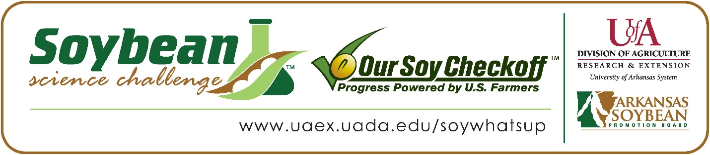
Bennet Chen wins 2024 First Place Arkansas Soybean Science Challenge Award at Arkansas State Science Fair
Bennet Chen, 14, a freshman at Little Rock Central High School in Little Rock, Arkansas won the Soybean Science Challenge First Place award at the Arkansas State Science Fair held at the University of Central Arkansas-Conway March 30.
Chen received the $1,000 cash award for the First-Place finish at State. The award was provided by the Arkansas Soybean Promotion Board at the award ceremony. His science fair project titled “Forecasting the future: a predictive modeling approach to deciphering climate change’s impact on county level soybean yields” also took First Place in Environmental Science and was awarded an ISEF Finalist position at the Arkansas State Science Fair.

Tarsha Parker, Chen’s teacher won the $300 First Place Soybean Science Challenge Teacher-Mentor Award. She believes the Soybean Science Challenge is a wonderful opportunity for students to earn recognition for their work. “Bennet gained confidence and reassurance in his abilities to properly communicate his thoughts and findings about his project. It also helped him to realize the importance of his research to make a difference in society. He beamed so much more after placing in the State Science Fair. He amazed himself,” she stated.
Chen was honored that his project was chosen to win the Soybean Science Challenge. “I am so thrilled and honored to be the First-Place winner of the State Soybean Science Challenge, and I hope that my research will be beneficial to the farmers who help support this wonderful program,” he replied.
Mr. and Mrs. Chen, Bennet’s parents, were excited he won the Soybean Science Challenge Award. “We felt very excited to hear that Bennet won the awards, especially after he spent a lot of time and hard work on it,” they stated.
Parker talked about Chen’s dedication “Bennet selected a project that addressed a real-world problem. The fact that he thought deeply to select a project that could have an impact on society is impressive. His desire to make a change with his research coupled with his dedication and diligence to do what was needed to create a solution is award worthy,” she stated.

Working with the Soybean Science Challenge gave Bennet a new appreciation for agriculture. “Working on my project has absolutely given me a new perspective on agriculture and the agriculture industry, and it has shown me that agriculture is not just about farming, but it is about the scientists, engineers, and inventors that help find new ways to plant crops, make the machinery working, and come up with new irrigation methods for agriscience. Before this project, I had known about soybeans used in food, such as tofu or in vegetable oil. However, because of this project and the Soybean Science course, I learned about the variety of other uses that soybeans have in the various aspects of our daily lives,” he explained.

“The Soybean Science Challenge provides an opportunity for Arkansas high school students to participate in scientific research that can impact the state of Arkansas as well as the world. Soybean Science Challenge student researchers learn about this important commodity crop and its many uses including feeding the world, development of biofuels and sustainable products. The Soybean Science Challenge helps students develop an understanding of the challenges and complexities of modern farming,” said Dr. Julie Robinson, Professor, and director of the program.
“The goal of the Arkansas Soybean Science Challenge is to engage students in “real- world” education to support soybean production and agricultural sustainability,” said Gary Sitzer a former member of the Arkansas Soybean Promotion Board. “The program also rewards scientific inquiry and discovery that supports the Arkansas Soybean Industry.”
The Arkansas Soybean Science Challenge was launched in January 2014 to 9-12th grade science students. Students who successfully completed the online course were eligible to have their original soybean-related research projects judged at the 2024 ISEF-affiliated Arkansas Science and Engineering fairs.
Information on the 2024-2025 Arkansas Soybean Science Challenge will be available in summer 2024. For more information, contact Dr. Julie Robinson at jrobinson@uada.edu, Diedre Young at dyoung@uada.edu or Keith Harris at kharris@uada.edu.
The Cooperative Extension Service is part of the University of Arkansas System Division of Agriculture.

Bennet Chen: Little Rock Central High School, Little Rock, Arkansas; Teacher-Tarsha Parker
Category: Environmental Science
Project Title: Forecasting the future: A predictive modeling approach to deciphering climate change’s impact on county level soybean yields.
Abstract:
Given climate change’s widespread impact on weather, it is vital to determine its effects on soybeans, a versatile crop, through yield predictions, to help tackle America’s food insecurity problem. This study aimed to compare weather and fertilizer factors against US soybean yields to determine if and which factors contributed to better yields, and to create a predictive model to forecast soybean yields. The hypothesis was that there would be a statistically significant correlation between at least one weather variable and soybean yields. This study separated NOAA weather data and USDA fertilizer data into 7 variable categories and grouped those variables into high, midrange, and low yield scenarios to compare against each other through ANOVA tests. The statistically significant variables(p-value<0.05), which included all temperature and fertilizer variables, were made into a multiple linear regression model comparing against soybean yields. Then, a new model was created with the variables which contributed to the yield’s variance, which were days over 32.22° Celsius, potash usage, and phosphate usage. This model yielded an r^2 value of 0.365 when predicting county-level yields and 0.665 for yearly overall yields. Over time, the model proved remarkably accurate, with the trendline of averaged predicted yields versus averaged actual yields within decimals away from y=x(y=0.999x+0.05). Using this model, the government and farmers can forecast future yields for better preparation. Overall, this project highlighted the significance of fertilizer usage and rising temperatures on the amount of soybean yields.
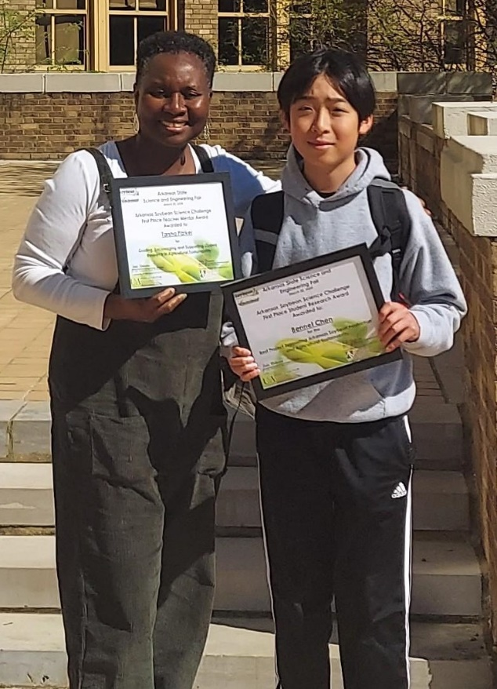

Arkansas State Science Fair First Place Soybean Science Challenge winner Bennet Chen, and Teacher-Mentor Tarsha Parker

