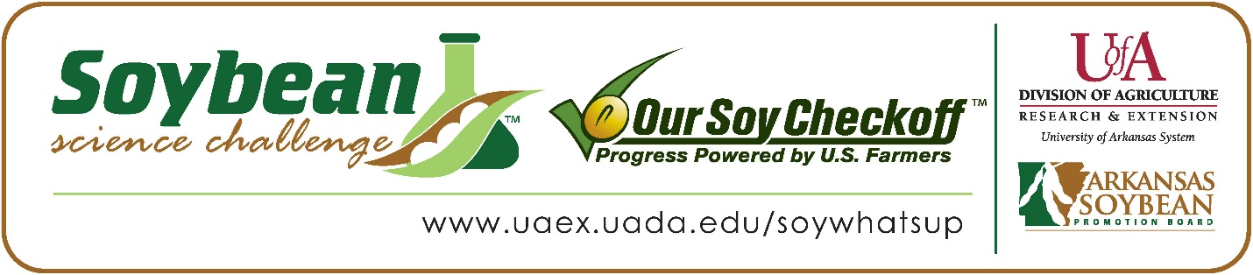

Alice Dong wins 2024 Arkansas Soybean Science Challenge Award at ASMSA-West Central Arkansas Science Fair
Alice Dong, 17, a junior at Arkansas School for Mathematics, Sciences, and the Arts (ASMSA) in Hot Springs won the Soybean Science Challenge at the 2024 West Central Science Fair held at ASMSA, February 23.
Dong won the $300 cash award provided by the Arkansas Soybean Promotion Board at the awards ceremony. Her science fair project titled “Effects of ALAN on soybean phenology and chlorophyll levels” also received first place in Plant Science.

Dr. Lindsey Waddell, Dong’s teacher, won the $200 Soybean Science Challenge Teacher Mentor Award. She believes the Soybean Science Challenge helps to motivate students to do better. “An external recognition like that provided by the Soybean Science Challenge can be very important in motivating students to stay involved in research and to take on something even more challenging,” she replied.
Alice was honored that her project was chosen to win the Soybean Science Challenge. “I’m thankful to the hard-working farmers within this state for this award. Growing soybeans, an important crop, contributes to both the economy and to combating world hunger. The effort that I have expended conducting my research cannot equivalate to the backbreaking work that farmers do,” she explained.
Alice’s parent, Lianghong Chen, was happy that Alice won the Soybean Science Challenge Award. “I felt proud that she was able to achieve something to win an award in,” Chen stated.
The part of the Soybean Science Challenge course that appealed most to Alice was the sustainability of farming and learning about the farmers themselves. “Some of the key soybean topics that I found most interesting was the fact that farmers in Arkansas have a self-imposed tax to promote soybeans and that the variety of soybean, edamame, is harder to grow and care for compared to other varieties. Another topic that I learned within the course that I found useful was that soybeans play a major role in nitrogen fixation and crop rotation,” she replied.

“The Soybean Science Challenge provides an opportunity for Arkansas high school students to participate in scientific research that can impact the State of Arkansas as well as the world. Soybean Science Challenge student researchers learn about this important commodity crop and its many uses including feeding the world, development of biofuels and sustainable products. The Soybean Science Challenge helps students develop an understanding of the challenges and complexities of modern farming,” said Dr. Julie Robinson, Associate Professor, and director of the program.
“The goal of the Arkansas Soybean Science Challenge is to engage students in “real world” education to support soybean production and agricultural sustainability,” said Gary Sitzer, a former member of the Arkansas Soybean Promotion Board. “The program also rewards scientific inquiry and discovery that supports the Arkansas Soybean Industry.”
The Arkansas Soybean Science Challenge was launched in January 2014 to 9-12th grade science students. Students who successfully completed the online course are eligible to have their original soybean-related research projects judged at the 2024 ISEF-affiliated Arkansas Science and Engineering fairs.
Information on the 2024-2025 Arkansas Soybean Science Challenge will be available in summer 2024. For more information, contact Dr. Julie Robinson at jrobinson@uada.edu , Diedre Young at dyoung@uada.edu, or Keith Harris at kharris@uada.edu.
The Cooperative Extension Service is part of the University of Arkansas System Division of Agriculture.

Alice Dong, Arkansas School for Mathematics, Sciences and the Arts, Hot Springs, AR. Teacher-Dr. Lindsey Waddell
Category: Plant Sciences
Project Title: Effects of ALAN on soybean phenology and chlorophyll levels
Abstract:
Research question: How does artificial light at night affect (ALAN) soybean growth and chlorophyll content?
Hypothesis: Soybeans exposed to ALAN treatment since planting will demonstrate higher chlorophyll levels, and delayed phenological development compared to soybeans not exposed to ALAN.
Methods: Soybeans are grown from seeds and exposed to natural sunlight. Samples were exposed to ALAN under two LED shop lights from 1800 to 0600 hours. Controlled samples were covered during that time. Phenological changes were recorded. At the end of the trial, final height and areas of leaves were measured. Vacuum filtration and spectrophotometer were used to measure chlorophyll levels.
Conclusion: The hypothesis was not supported.

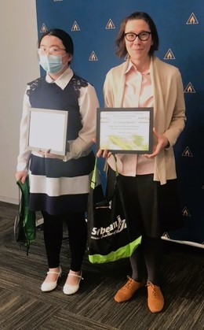

ASMSA West Central Arkansas Science Fair Soybean Science Challenge winner Alice Dong, and Teacher-Mentor Dr. Lindsey Waddell.

