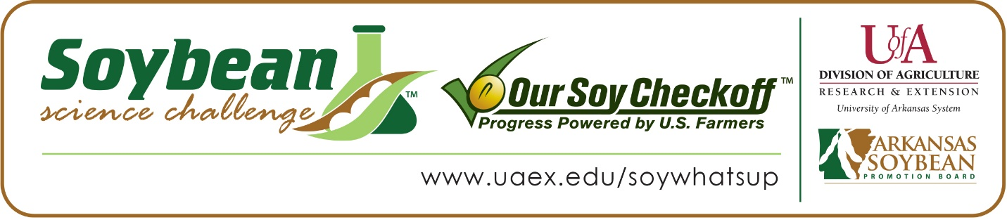

Sydney Fuller wins 2024 Arkansas Soybean Science Challenge Award for Southeast Arkansas
Sydney Fuller, 15, a sophomore at Stuttgart High School in Stuttgart, Arkansas, won the Soybean Science Challenge award for Southeast Arkansas Science Fair at the University of Arkansas-Monticello on March 7.
Fuller received a $300 cash award provided by the Arkansas Soybean Promotion Board. Her science project titled “Effects of soil nutrients on plant growth” also placed first in Environmental Science.
Katherine Yancy, Sydney’s teacher, won the $200 Soybean Science Challenge Teacher- Mentor award. Yancy said it was a great idea for Sydney to participate in the Soybean Science Challenge. “Presenting her findings in the project challenge allowed Sydney to develop her presentation skills. She has learned how to communicate complex ideas clearly and persuasively, while also engaging her audience effectively,” she explained.
Sydney says winning the regional Soybean Science Challenge Senior Division Award was an honor. “I am grateful for my teacher and my family for helping me in this project,” She replied.
Mr. and Mrs. Fuller, Sydney’s parents, were proud that Sydney won the Senior Division Regional Soybean Science Challenge Award. “We know how hard she worked on this project and were proud to see her efforts rewarded,” they stated.
Yancy, Sydney’s teacher, discussed what Sydney learned by competing in the Soybean Science Challenge. “Through her involvement in the soybean science project, she has gained insight into the importance of agriculture and environmental science. She has developed a greater appreciation for these fields, and it may have even sparked an interest in her pursuing related career paths in the future,” she explained.
Sydney learned a lot while working on his project. “I enjoyed learning about crop rotation and how it benefits the soil,” she replied.
“The Soybean Science Challenge provides an opportunity for Arkansas junior high and high school students to participate in scientific research that can impact the State of Arkansas as well as the world. Soybean Science Challenge student researchers learn about this important commodity crop and its many uses including feeding the world, development of biofuels and sustainable products. The Soybean Science Challenge helps students develop an understanding of the challenges and complexities of modern farming,” said Dr. Julie Robinson, Professor, and director of the program.
“The goal of the Arkansas Soybean Science Challenge is to engage students in “real- world” education to support soybean production and agricultural sustainability,” said Gary Sitzer, a former member of the Arkansas Soybean Promotion Board. “The program also rewards scientific inquiry and discovery that supports the Arkansas Soybean Industry.”
The Arkansas Soybean Science Challenge was launched in January 2014 to 9-12th grade science students and in 2021, a junior level award was added for grades 6-8. Students who successfully completed the online course were eligible to have their original soybean-related research projects judged at the 2024 ISEF-affiliated Arkansas Science and Engineering Fairs.
Information on the 2024-2025 Arkansas Soybean Science Challenge will be available in summer 2024. For more information, contact Dr. Julie Robinson at jrobinson@uada.edu , Diedre Young at dyoung@uada.edu, or Keith Harris at kharris@uada.edu.
The Cooperative Extension Service is part of the University of Arkansas System Division of Agriculture.

Sydney Fuller, Stuttgart High School, Stuttgart, Arkansas; Teacher, Katherine Yancy
Category: Environmental Science
Project Title: Effects of soil nutrients on plant growth
Abstract: The experiment sought to determine whether plants can grow with less soil and cheaper substances, in this case, pine saw dust. The purpose of this project was to try and provide information about how certain soil characteristics, especially soil nutrient composition affects plant growth. Miracle Grow potting soil and pine sawdust were mixed into five separate treatments with different amounts of soil and sawdust, 0%-100% for two separate experiments.
The plant growth was measured in centimeters and watered as needed. The soil nutrient composition was measured at the beginning and at the end of the experiment with commercial LaMotte NPK test kit, following the testing instructions.
The plant growth results in the two trials were very different as is shown in the graphs and tables. The nutrients in the soil decreased from 100% treatment to 0% treatment. The nutrients in the soil were also different from beginning to end in both experiments, showing that the plants were taking the nutrients from the soil.
There’s really no way to tell which soil overall supported the plants’ growth the best since both trials show very different results. However, the plants did utilize the nutrients as shown by the decrease of nutrients over time. The differences in the two trials could be attributed to root stress or the short duration of the experiment.

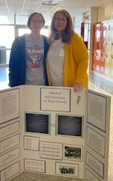

Southeast Arkansas Regional Science Fair Senior Division Winner Sydney Fuller and teacher-mentor Katherine Yancey.

